Transformation of Quadratic Graphs

Directions: Complete this study guide as you move through the lesson. By taking notes, you are more likely to remember what you are learning. The completed study guide can be used to complete practice activities and to prepare for quizzes and exams. Be sure to save each study guide so you can access it when you need it.

Essential Vocabulary

As you encounter these mathematical terms from within the lesson, enter the meaning and an example (or two) for each of the terms. You can even draw a picture. If there are other unfamiliar words you find, enter them in the blank spaces provided.

parent function | parabola
vertex form | quadratic function

A Review of the Parent Quadratic Function

- Looking at the graphs of $f(x)$ and $g(x)$, explain how $f(x)$ and $g(x)$ are related.

This is the graph of $f(x)=x^{2}$.  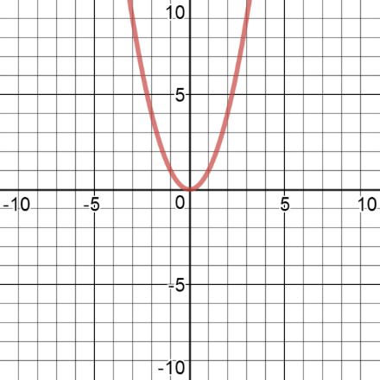 | This is the graph of $g(x)={-x}^{2}$.  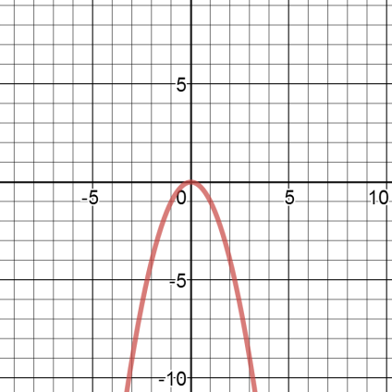

- Graph the parent function, $f(x)=x^{2}$ and the function $h(x)={2x}^{2}$ on the same coordinate plane. Then compare the characteristics of the two curves.

