The Urantia Book Fellowship
Workshop Proposal Form
International Conference 2023
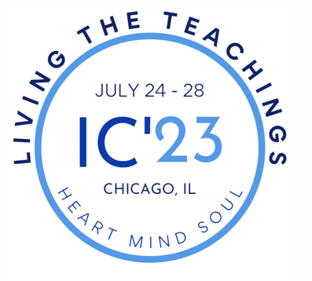
The Urantia Book Fellowship is planning the workshop program for the
International Conference 2023 (IC23). The theme for IC23 is:

Living the Teachings: Heart, Mind, and Soul

Living the teachings
How can students of the Urantia Book translate knowledge and understanding into personal spiritual growth and loving services to others?
Heart
Heart is about relationships, love, goodness, and service

Strong characters are not derived from not doing wrong but rather from actually doing right. Unselfishness is the badge of human greatness. The highest levels of self-realization are attained by worship and service. The happy and effective person is motivated, not by fear of wrongdoing, but by love of right doing. 140:4.6 (1572.6)
Mind
Mind is about knowledge, truth, learning, wisdom, understanding, insight, and skills

When reason once recognizes right and wrong, it exhibits wisdom; when wisdom chooses between right and wrong, truth and error, it demonstrates spirit leading. And thus are the functions of mind, soul, and spirit ever closely united and functionally interassociated. Reason deals with factual knowledge; wisdom, with philosophy and revelation; faith, with living spiritual experience. Through truth man attains beauty and by spiritual love ascends to goodness. 103:9.10 (1142.1)
Soul
Soul is about finding God, inner life, prayer, worship, and meditation

The supreme value of human life consists in growth of values, progress in meanings, and realization of the cosmic interrelatedness of both of these experiences. And such an experience is the equivalent of God-consciousness. Such a mortal, while not supernatural, is truly becoming superhuman; an immortal soul is evolving. 100:3.6 (1097.3)

We invite and will consider workshop proposals on any topic. We will, however, reserve most of our time slots for workshops directly related to our three themes of heart, mind, and soul.

Some things to consider as you formulate your proposal and plan your workshop:

- How will you use The Urantia Book to inform your workshop?
- How will your workshop benefit individual truth seekers or organizations involved in serving the revelation?
- How will you actively engage workshop participants?
- What methods of teaching and presentation will you use?
- What are your learning objectives and desired outcomes for your participants?
- How will you organize and structure your workshop and how much time will be spent on each segment?
- What level of experience with The Urantia Book will your workshop presume or require?
Workshops Schedule

Tuesday 10:15 AM - 12:15 PM 2:00 PM - 4:00 PM
Wednesday 10:15 AM - 12:15 PM 2:00 PM - 4:00 PM
Thursday 10:15 AM - 12:15 PM 2:00 PM - 4:00 PM

There will be multiple workshops scheduled during each of the six time slots. Workshops can be presented twice during this schedule to allow more attendees to experience each workshop. In rare instances, a single workshop can span two consecutive time slots if a workshop requires more than two hours. If you are interested in giving a workshop, please complete the workshop proposal form and send it to David Schlundt, the program chair for IC-23 (david.schlundt@urantiabook.org).

International Conference 2023 WORKSHOP PROPOSAL FORM
Please send to david.schlundt@urantiabook.org

Your name: ____________________________________________ Date: ______________

Email: _____________________________________ Phone: _________________________

Address: _____________________________________________________________

_____________________________________________________________

- Name of Presenter(s):

- Title of Workshop:

- Which theme or themes of the conference will your workshop address? (check all that apply)
- Heart
- Mind
- Soul
- Something else

- Provide a summary of the workshop including its relevance to the theme of the Session:

- What are your desired outcomes for your participants? What will they learn?

- What level of experience with The Urantia Book will the workshop presume or require?
(check all that apply)

- New readers
- Intermediate
- Advanced

- What methods of teaching and presentation will you use, and how will you structure your Workshop?

- Will you require any specific room arrangement? What equipment will you need?

- Would you be willing to present your workshop twice, allowing more people who are interested to attend?
- Yes
- No

Please send your completed form to david.schlundt@urantiabook.org. Please put “IC23 Workshop Proposal from [your name]” in the subject line.

Please free to contact David Schlundt at (615) 337-0218, if you have any questions regarding submitting your proposal.

Thank you!

Your International Conference 2023 Planning Team

Monday, July 24th – Friday, July 28th

Oak Brook Hills Resort and Conference Center

3500 Midwest Rd, Oak Brook, Illinois (near Chicago)

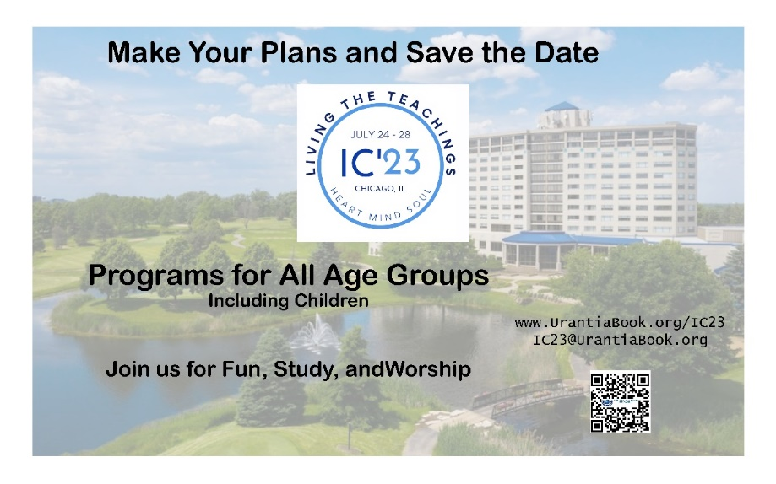

Click here for more information on IC23

