Appendix A

Area Office on Aging of Northwestern Ohio Funding Formula Factors
for
Older Americans Act Title III

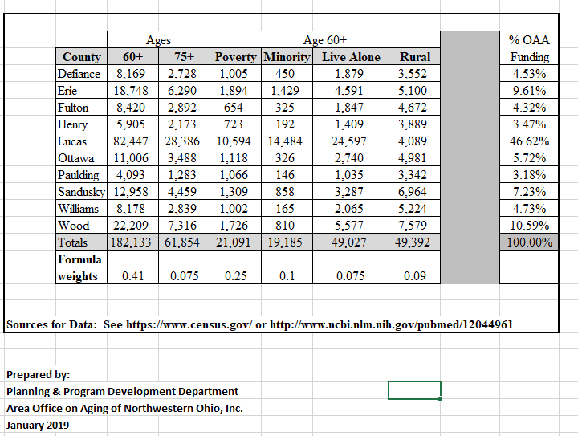

Appendix B
Budget Templates
(Available in MS Excel)

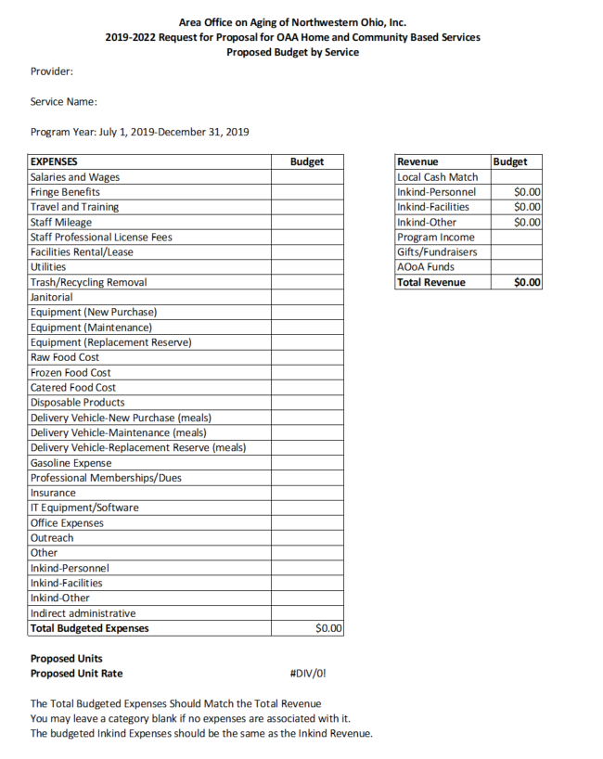
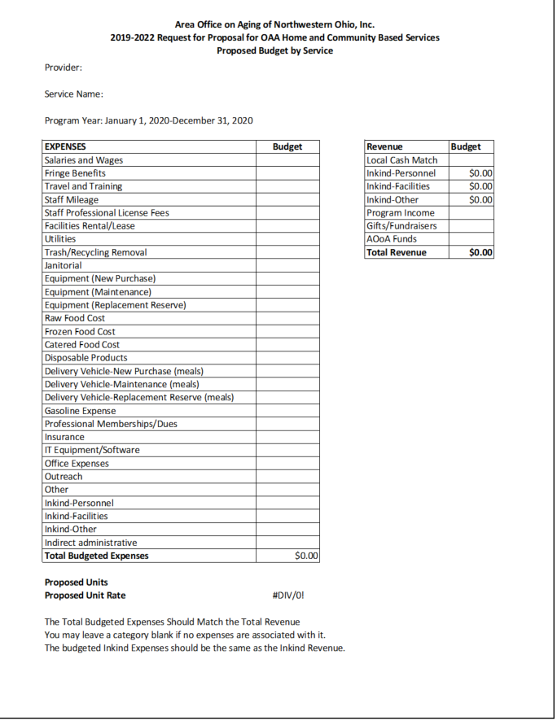
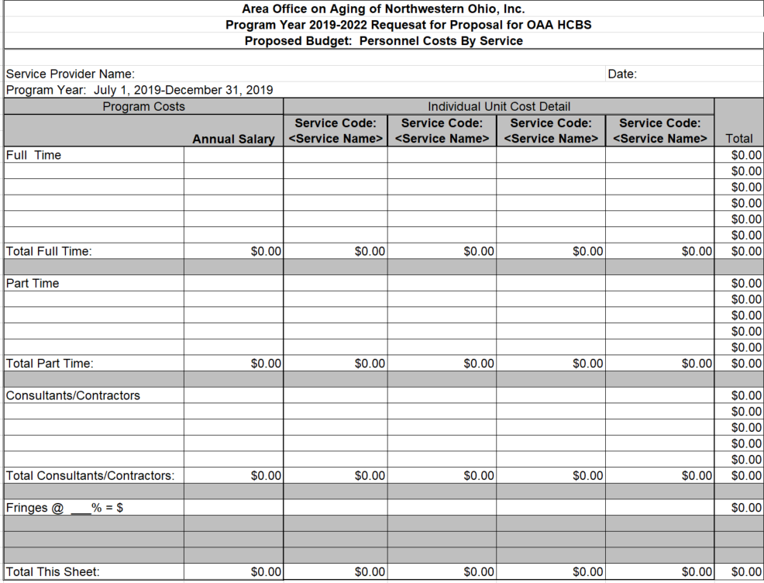
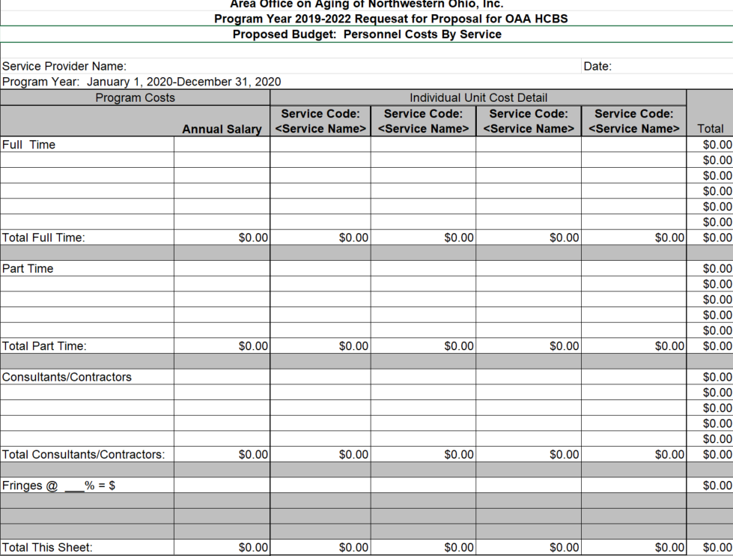

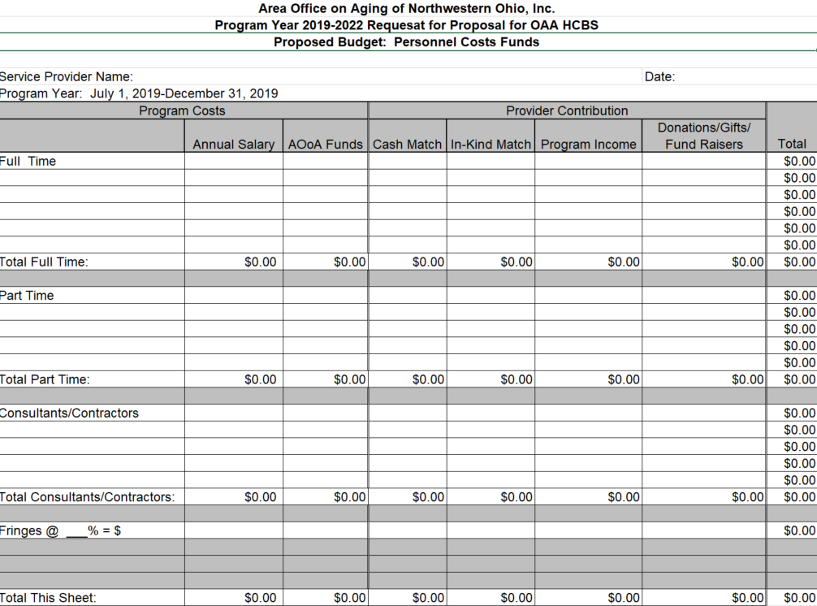
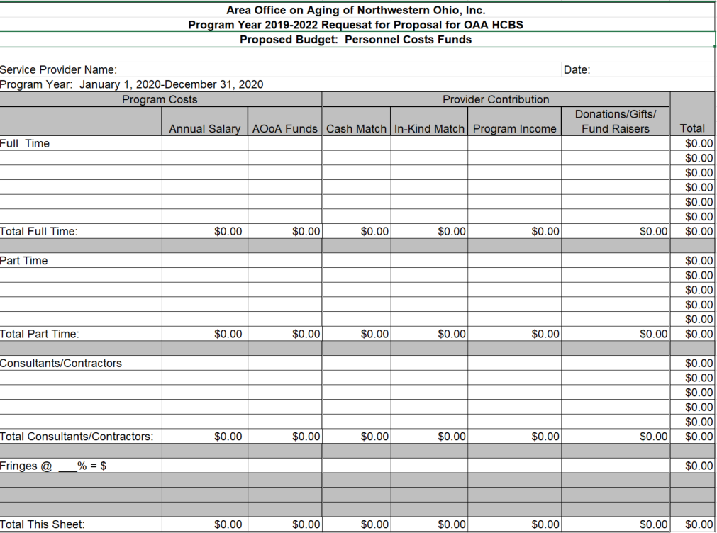
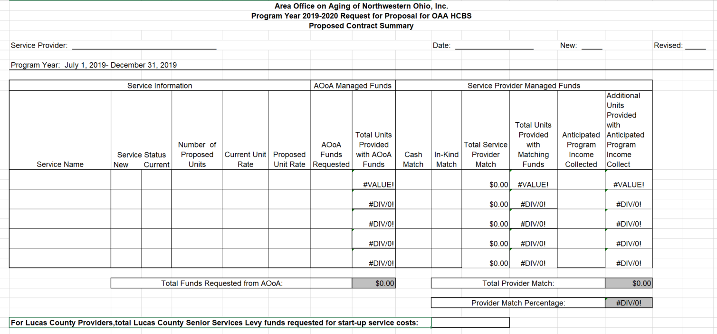
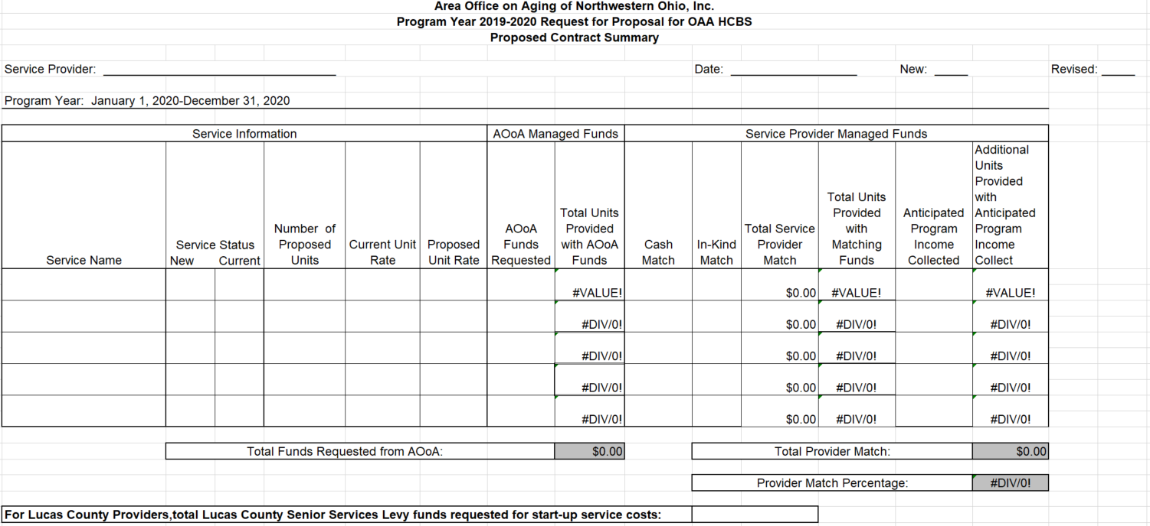
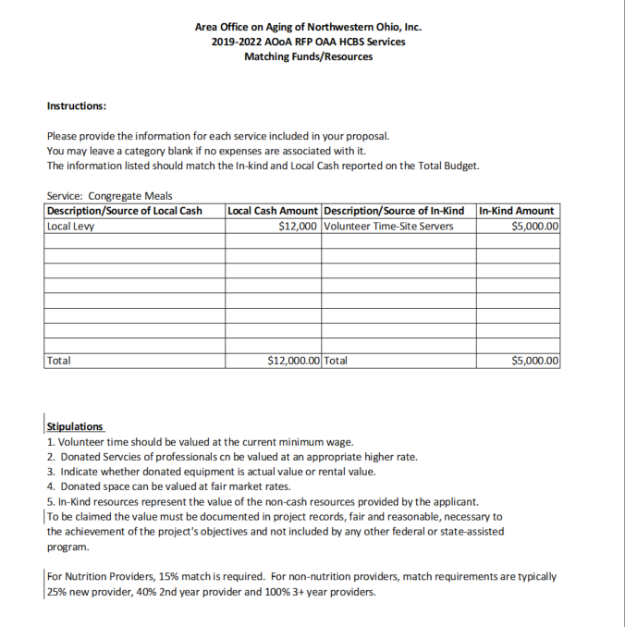
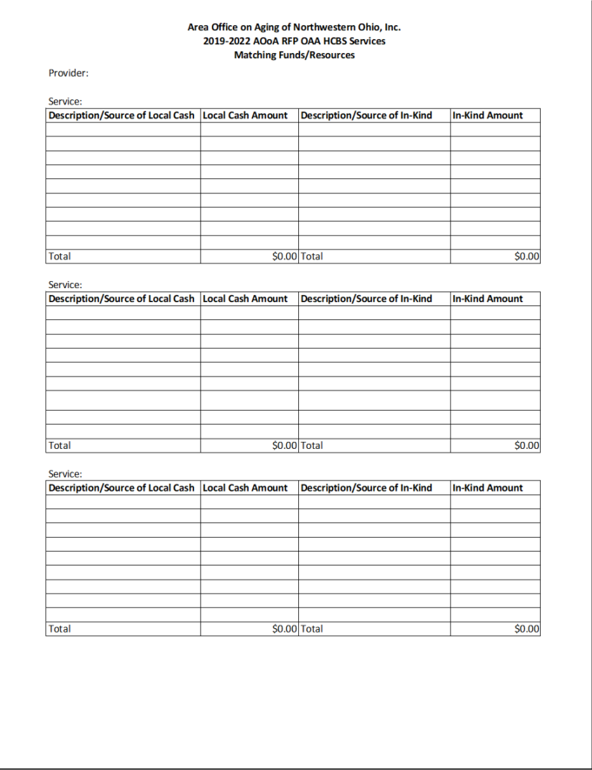
Appendix C
2019-2022 Strategic Area Plan Identified Unmet Needs, Goals and Objectives

Census Information:
County | 60+ | 75+ | 85+ | Rural 60+ | Males (60+) | Females  (60+) | Living Alone (60+) | Minority  (60+) | LEP 65+
Defiance | 8,169 | 2,728 | 794 | 3,552 | 3,700 | 4,469 | 1,879 | 450 | 37
Erie | 18,748 | 6,290 | 1,956 | 5,100 | 8,726 | 10,022 | 4,591 | 1,429 | 11
Fulton | 8,420 | 2,892 | 900 | 4,672 | 3,822 | 4,598 | 1.847 | 325 | 54
Henry | 5,905 | 2,173 | 682 | 3,889 | 2,641 | 3,264 | 1.409 | 192 | 11
Lucas | 82,447 | 28,386 | 8,597 | 4,089 | 35,687 | 46,760 | 24,597 | 14,484 | 570
Ottawa | 11,066 | 3,488 | 1,002 | 4,981 | 5,171 | 5,895 | 2,740 | 326 | 23
Paulding | 4,093 | 1,283 | 355 | 3,342 | 1,842 | 2,251 | 1,035 | 146 | 2
Sandusky | 12,958 | 4,459 | 1,355 | 6,964 | 5,787 | 7,171 | 3,287 | 858 | 94
Williams | 8,178 | 2,839 | 922 | 5,224 | 3,655 | 4,523 | 2,065 | 165 | 7
Wood | 22,209 | 7,316 | 2,151 | 7,579 | 9,922 | 12,287 | 5,577 | 810 | 103
Totals | 182,133 | 61,854 | 18,714 | 49,392 | 80,953 | 101,240 | 49,027 | 19,185 | 912
Basic Demographics: 2010 Census

Access to Information and Advocacy Services (ADRN, priority populations and elder abuse):
The network of senior centers is an important partner in providing access to information and advocacy services. As shown in the map, above, although Senior Centers are generally well-distributed throughout the AOoA region, the western part of Lucas County is not well-served. In addition there are four counties in the region (Erie, Fulton, Henry, and Paulding) that have only a single senior center site. These counties have smaller populations, but the spread of service availability is a concern, especially given high levels of satisfaction and impact among people who visit senior centers and utilize their services.

Two studies of older adults’ satisfaction with senior center services and their impact were conducted by Scripps Gerontology Center at Miami University. One focused exclusively on the senior centers in Lucas County, while the second covered the remaining 9 rural counties in Northwestern Ohio. The findings from these studies provide a baseline against which future progress can be measured and may be used by AOoA to allocate scarce resources in the future.

Both studies found that senior centers in counties served by AOoA are providing services with which consumers are highly satisfied. According to the final report, “The centers are also having an important impact on the lives of local older adults above and beyond the services they provide.” However, there were statistically significant differences between satisfaction and impact between some Lucas County senior center and between counties and senior centers in rural communities. High-performing senior centers could be used to identify best practices. In both studies, participants indicated that they would like more choices. In addition, each senior center serves a unique clientele. Therefore, each center should strive to understand the communities and individuals it is serving and tailor offerings as much as possible.

But not all older adults visit senior centers. Therefore, additional outreach efforts are needed and partnerships with other community organizations should be pursued. At external stakeholder discussions, the public library and parks systems were particularly interested in deepening partnerships with AOoA.

With respect to services provided by AOoA outside of senior centers, a few gaps were identified by internal and external stakeholders. For example, competency arose as a concern, especially when providing information and services to priority populations. There have been challenges connecting with non-English speakers, people from different religious backgrounds, and those who identify as LGBTQ. During development of this strategic plan, AOoA sought to incorporate feedback from priority populations and attempted to reach groups of older adults via community partnerships. This approach had limited success, indicating that working through community intermediaries may not be the best approach to ensuring that services are readily available and utilized by people from all backgrounds. AOoA is committed to diversity, equity, and inclusion and has identified several strategies to improve connection with priority populations.

Providing a consistent, person-centered intake and referral process was identified as a challenge. Working across traditional silos, assessing for a variety of needs, and providing a high-quality customer experience were identified as strategies. Internal stakeholders identified a need to streamline the intake forms and questionnaires used to obtain services so the information collected goes beyond the immediate need a person is seeking help with and so that they are more person-centered. In addition, AOoA seeks to develop a process for home repair consumers to be assessed by a Social Worker or Nurse prior to receiving home repair services, to identify the consumer’s other needs.

There are waiting lists for some services, which are clear indications of unmet needs. Eliminating waiting lists is likely not possible given the current funding environment, but prioritizing waiting lists is one way AOoA can ensure that resources are well-targeted. This includes utilizing Social Workers or Nurses to assess certain cases, and prioritizing self-neglect APS consumers.

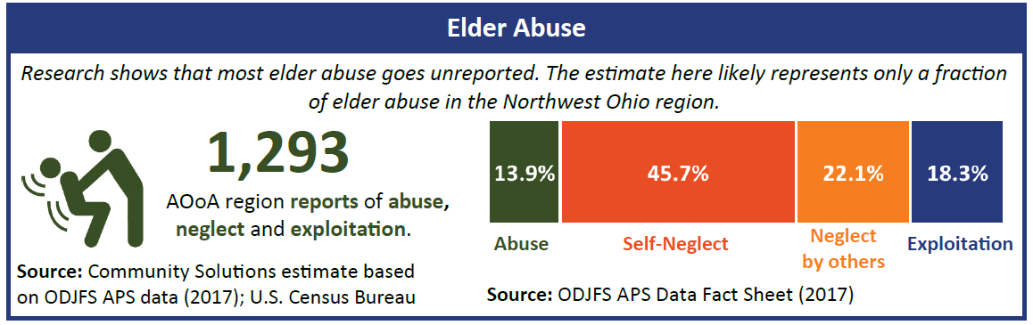

Regarding elder abuse, self-neglect is of particular concern. Home-delivered meals providers interact with many home-bound older adults, who are particularly difficult to reach with information, advocacy, and services, and are at increased risk for social isolation and self-neglect. Requiring contracted home delivered meal programs to spend a set amount of time with each consumer and utilizing these drivers as a way to distribute existing information resources should help.

Population Health (nutrition, health and wellness, dementia, substance abuse and addiction):
As described above, chronic disease, substance use disorders, dementia, and nutrition are key health issues facing older adults in Northwestern Ohio. Like in communities across the country, most older adults in the AOoA service area have health insurance. However, data indicates that there are opportunities to expand the coverage of individuals by Medicaid.

There is a need to expand training in evidence-based practices relating to chronic disease prevention and management, and to expand these services to all 10 counties. Evidence-based arthritis management is particularly important, especially because arthritis is the most common chronic disease impacting older adults in Ohio and managing pain has been a contributing factor to the opioid crisis.

Mental health of older adults was identified as an area of opportunity. This includes gathering additional data and information about mental illness among older adults, partnering across levels of government and among community partners, and improving services to victims of self-neglect who are referred to APS and Job and Family Services.

In the area of nutrition, congregate and home delivered meals are an important aspect of the Older Americans Act. In general, AOoA is meeting needs within the region as well as can be expected given limited resources. However, year-round access to fresh fruits and vegetables was identified as an issue. While farmer’s markets operate during the summer months, solutions must be found to provide fresh produce to older adults throughout the year.

Caregiving (caregiver support and kinship care)
According to estimates by The Center for Community Solutions, 42 percent of older adults in the 10-county region are at risk for not being able to afford the paid long term care they are likely to need. These individuals make too much to qualify for Medicaid services, but too little to be able to private pay for needed long-term care. As people grow older, they are more likely to live with a disability. The percent of the population living with a disability jumps from 25 percent for those ages 65-74 to 49 percent of those over age 75, according to data from the U.S. Census Bureau. External stakeholders described the physical, financial, and emotional toll that unpaid family caregiving can create. All groups agreed that additional support for caregivers is needed.

Data show that nationwide, the majority of caregiving is provided by un-paid family caregivers. As the population continues to age, those who are already over age 60 themselves are caring for relatives who are even older. The Area Office on Aging identified several objectives relating to unpaid family caregiving that can be placed into two broad categories: 1. Supports for current unpaid family caregivers, and 2. Encouraging family members to provide care for their aging or disabled loved ones. Strategies include helping individuals to prepare to become caregivers, helping individuals navigate the process of becoming paid caregivers, providing rest and respite opportunities in new ways, and helping older adults prepare for their caregiving needs.

Cultural competency, especially for priority populations, was a key concern when considering caregiving. AOoA identified strategies aimed at increasing the availability of in-home care provided by those who are from priority populations themselves, especially those who identify as LGBTQ, the Muslim Community and speakers of Spanish.

Caregiver rest and respite opportunities were identified by internal and external stakeholders as a significant gap in the AOoA service area. Many family caregivers described feeling lonely and isolated. AOoA seeks to develop a Caregiver Refresh Center to provide a physical location where a family caregiver can receive services and be connected to adult day care, counseling, caregiver support groups, or be matched with a respite volunteer and other services.

In addition to caregivers who are supporting aging loved ones, AOoA is committed to providing assistance to older adults who are caregivers for children. Opportunities for multi-generational services and supports was identified as an unmet need, especially as it relates to intergenerational meal services.

Civic Engagement (volunteerism and older workers):
More than one-in-four older adults in the AOoA region are participating in the labor force, meaning they are either employed or looking for work. This includes more than 60 percent of those ages 60-61 and 46 percent of individuals ages 62-64. Although workforce participation falls off as age increases, there are still a growing number of people over age 75 who continue to work. In the aftermath of the Great Recession, there is anecdotal evidence that people are extending their careers out of financial necessity. However, several external stakeholders spoke of a lack of respect for the strengths and experience that older adults bring to the workforce by employers and professional colleagues.

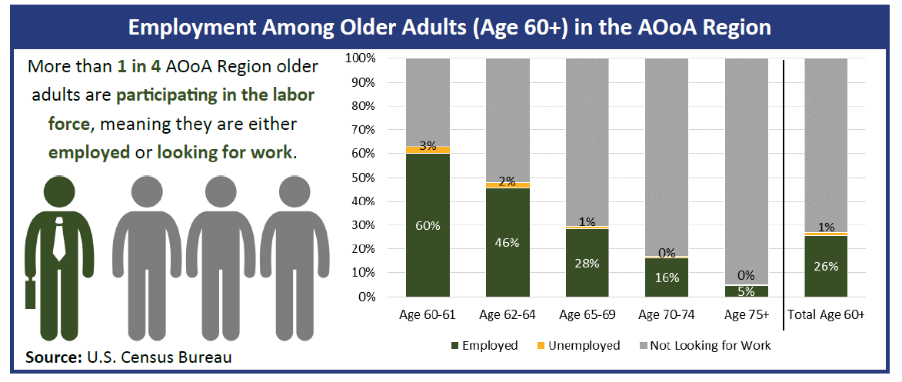

For those who are not in the workforce, civic engagement can help combat loneliness. Nationwide, more than 1-in-4 older adults report being lonely. Thirty-one percent of older adults in the AOoA region live alone.
Volunteers are seen as an asset to be tapped to meet growing community needs. There was an emphasis on establishing peer-to-peer volunteer services so that older adults work with each other, and to continue to work with partners in communities of interest to encourage volunteerism among older adults and identify appropriate volunteer opportunities that are well-matched to older adults’ interests and experience. More information in this areas is needed. In addition, AOoA seeks to work with the Red Cross and other partners to develop an emergency volunteer reception center and to recruit, train, and place disaster assessment volunteers.

Aging in Place (HCBS, transportation, housing, workforce shortage and safety needs):

There remain significant unmet needs for individuals who are homebound or socially isolated. Home-delivered meal programs provide one connection that has been found to be effective in improving health outcomes for individuals who have little contact with the outside world. AOoA seeks to leverage the personal contact from home-delivered meal services and mandate that drivers spend a certain amount of their day in meaningful interactions with consumers. Drivers are seen as a possible conduit of information for home-bound older adults.

All but one of the counties in the AOoA region are considered rural. Therefore, the proximity to neighbors, services, and amenities is of concern, which is exacerbated by a lack of affordable transportation options, especially for those who don’t drive. Mobility managers and one-call/one-click mobility navigation could help, but such services will need to be developed, and funding identified.

Throughout the region, there is a shortage in home-health aides, which puts stress on homecare providers, consumers, and the entire aging system. Partnering with universities to address labor supply issues, while encouraging unpaid family caregivers to reduce demand was presented as a two-pronged approach to this situation. Studying and collecting best practices could help, as would an awareness and education campaign focused on the current and emerging need for direct care workers. AOoA is also committed to helping family caregivers become Independent Providers.

Given the limited resources of AOoA, public-private partnerships must be leveraged to expand and improve services for those aging in place. This includes diversifying funding sources by seeking additional philanthropic support and identifying new business lines.

Goals and Objectives

- ACCESS TO INFORMATION AND ADVOCACY SERVICES:
Older Ohioans, adults with disabilities and their caregivers will be able to make person-centered decisions through seamless access to information and advocacy services.

- Objective 1: Address isolation by improving access for older adults to senior centers, community facilities, technologies and opportunities where socialized environments exist or can be created.
  - Strategy 1: Encourage older adults to utilize Senior Center and common/community facilities
    - Sub-strategy 1: Consider discontinuing funding those existing senior centers that have chronic low participation so those resources can be used to fill the identified senior center gaps.
    - Sub-strategy 2: Use existing service level quantitative data and qualitative satisfaction survey and consumer impact data to drive which agencies and programs are funded and at what levels in the next RFP, including having this data serve as a baseline for future continuous improvement outcome incentive payments.
    - Sub-strategy 3: Study participant satisfaction and impact of services provided at senior centers for a Senior Center contemporary rebrand to attract younger older adults.
    - Sub-strategy 4: Identify gaps in access to senior centers and focal points within the community.
    - Sub-strategy 5: Identify creative intergenerational service options occurring in Senior Centers and Community Centers then advocate the importance of a Community Center approach among Senior Centers (Child and Adult Care Food Program, Summer Feeding Program, etc.)
  - Strategy 2: Identify local existing community-based opportunities that can be engaged to reduce risks of isolation among older adults.
  - Strategy 3: Partner with lifelong learning programs (library systems, Senior Centers, Community Centers, etc.) using technology solutions to increase opportunities for socialization and decrease isolation among homebound seniors.
    - Sub-Strategy 1: Explore innovative programs to address isolation with the homebound.
    - Sub-strategy 2: Encourage and utilize volunteer efforts to support individuals who may be isolated (e.g., first responders, RSVP, faith-based, etc.)
    - Sub-Strategy 3: Develop training for home delivered meal drivers to engage consumers in more socialization and health and safety checks.
    - Sub-Strategy 4: Include per-person/ per-day guidance in the RFP about how long home delivered meals drivers should engage with consumers and encourage bidders to allow drivers adequate time in their planning.
    - Sub-Strategy 5: Distribute the Well-Connected Program Catalogue to home delivered meals consumers.

Outcome: More older adults are utilizing their local senior centers or common/community settings as evidenced by the increase in annual attendance.
- Objective 2: Access to Information, Develop standards and measures for quality and performance regarding operation, information, and resources for a consistent front-door experience for customers.
  - Strategy 1: Increase access to easy-to-understand information about services needed by older adults.
    - Sub-Strategy 1: Expand services to older adults in Western Lucas County.

- Objective 3: Priority Populations, Ohio’s Aging Network will be aware and focused on the unique needs of our older adult priority populations to deliver person-centered, culturally sensitive services and supports.
  - Strategy 1: Establish and implement a plan that increases awareness and focus among the aging network about the unique needs of our older adults’ priority populations (e.g. rural, low-income, low-income minority, limited English proficiency, Holocaust survivors, LGBTQ, disabled.)
    - Sub-Strategy 1: Train AOoA staff in how to be culturally competent when working with priority populations, and seek potential AOoA Advisory Board members, as well as, hire AOoA staff who represent the diversity of consumers.
    - Sub-strategy 2: Conduct periodic evaluations of activities and projects including the effectiveness of services provided to individuals with priority populations.
    - Sub-Strategy 3: Help senior centers provide bilingual outreach and programming.
    - Sub-Strategy 4: Initiate, with The University of Toledo’s Minority Business Development Center and other organizations serving the Latino, Muslim and LGBTQ communities, for exploratory meetings focused on how best to meet home care needs that are culturally appropriate.

Outcome: Ohio’s Aging Network is culturally competent as evidenced by members of Ohio’s older adult priority populations who are receiving services in the manner that align with and respect their unique needs.

- Objective 4: Advocacy: Heighten awareness of the needs and priorities of Ohio’s older adults and people with disabilities with community, government, non-profit and private sector entities to achieve inclusion in decision-making opportunities that inform policies, infrastructure development processes, and strategic plans.
  - Strategy 1: Advocate for increased funding and flexibility of funding to allow federal, state and local funding to be used in ways which better meet local needs.
  - Strategy 2: Advocate for an increase in the Medicaid Waiver adult day and personal care rate, i.e. home health aides.
  - Strategy 3: Advocate for state to lift Moratorium on New Program for All-inclusive Care for the Elderly (PACE) Site.
  - Strategy 4: Advocate to restore the Senior Community Services Block Grant to prior levels.
  - Strategy 5: Advocate for the emerging needs of older adults or new trends in the AOoA service area.

Outcome: The number of older adult-related action items included in other state plans will increase.

- AGING IN PLACE:
Enable older Ohioans, persons with disabilities and their caregivers to be active and supported in their homes and communities.
- Objective 1: Care Management, Provide comprehensive person-centered assessment and care services and supports that anticipates and addresses current and emerging needs as they arise.
- Sub-strategy 1: Study and collect traditional and innovative best practices regarding recruitment and retention of direct care workers occurring in other states to determine whether efficiencies may be realized and quality of services may be increased (e.g., creation of an orientation and on-going training plan to be administered by the AAAs that provides high quality training for direct care workers; creation of a co-op among providers to keep a pool of direct care workers’ creation of a watch list; creation of a single assessment to ease the burden of the older adult responding to repeat question; revisit/enhance “What Matters Most” for use in home and community based settings.)
- Sub-strategy 2: Identify new business lines and grant opportunities in case management and nutrition and engage consultant to help in building capacity to pursue grant opportunities.
- Sub-Strategy 3: Engage consultant to identify grant opportunities to expand and diversify funding.

- Objective 2: Workforce Capacity, Establish strategies that aim to increase and sustain the capacity of the direct care workforce and focus on increasing the interest in professional and non-professional careers that serve older adults.
- Strategy 1: Utilize existing workforce development and volunteerism programs to augment the direct care workforce.
    - Sub-strategy 1: Explore mentoring opportunities, matching older adults to younger direct service workers, to teach basic on-the-job housekeeping and personal care services.
- Strategy 2: Working with Ohio Department of Aging, develop non-Medicaid independent provider consumer directed care service.
- Strategy 3: Create education communication campaign and advocate for the need for home care workers.
    - Sub-strategy 1: Create and implement an awareness and education communication campaign to generate awareness about the current and emerging high need for caring and direct care workers for older adults.
- Strategy 4: Expand and implement innovative approaches to the workforce shortage, which could include advocating for streamlining consumer-direction processes, and planning geographically for best and most efficient use of existing staff.

Outcome: After strategically evaluating the foundational issues of direct care workforce shortages, careers and professions that serve and support older adults will be more attractive and/or economically viable.

- Objective 5: Long-term Care Planning, Advocate for the importance of long-term care planning for older Ohioans to support their choice to age-in-place.
  - Strategy 1: Connect lower income older adults with the benefits for which they are likely eligible by doubling the number of benefits counseling units provided during a year.
  - Strategy 2: Ask PSA-1 if they are willing to share their long-term care planning program materials and explore the possibility of implementing a similar long-term care planning program in northwest Ohio.

Outcome: The potential impacts associated with older Ohioans’ under-planning for long-term care needs are known and policy-level changes are under consideration to mitigate the future impacts to Ohio and to our older adult population.

- Objective 6: Transportation, Participate in alignment efforts that aim to achieve sufficient community transportation options (multi-modal) and a supportive infrastructure available for older adults in Ohio.
  - Strategy 1: Research, and advocate for the use of transportation best practices (mobility navigation, transportation coordination, etc.) at the local and regional levels. Identify opportunities for partnership with community organizations and transportation providers and strengthen as needed the AAAs.
- Sub-Strategy 1: Hire mobility navigators to implement one-call/one-click mobility navigation.
- Sub-Strategy 2: Hire consultant to assess Lucas County’s readiness to implement one-call, one-click mobility navigation system, identify community gaps and develop implementation plan timeline.
- Sub-strategy 3: Explore alternative back-up transportation provider for senior centers that can quickly be activated when a senior center’s driver is off sick/on vacation or when a senior center’s van is in the repair shop so consumer’s transportation needs continue to be met.
- Sub-strategy 4: Explore the possibility of increasing shared non-medical transportation to be able to provide more trips for the same cost.
- Sub-strategy 5: When an individual requests medical transportation, the AOoA will screen for other social and health service needs, as well as, enroll where appropriate in medical transportation program.

Outcome: Older Ohioans and individuals with disabilities in need of transportation are better positioned to receive services as evidenced by an increase in annual total units reported.

- Objective 7: Housing, Advocate for programs and interventions that support safe and affordable housing enabling older adults and persons with disabilities to age in place.
  - Strategy 1: Promote, advocate and pilot programs that provide for the safety and well-being of older Ohioans and persons with disabilities and their rights to age-in-place in the places that they call home and to stay in their communities of choice.
    - Sub-strategy 1: Pilot innovative programs (e.g., CAPABLE) that utilize various professions (e.g., occupational therapy, first responders, home modification experts) to provide in-home assessments and identifies modifications that are needed to allow client to remain in home.
    - Sub-strategy 2: Develop a process for home repair consumers to be assessed by a Social Worker or Nurse prior to receiving home repair services, to identify the consumer’s other needs and determine where they should be placed on the waiting list.
    - Develop strategy to have more AOoA service coordinators in senior apartment complexes.
Outcome: Safe and affordable housing units for older adults are a community priority due to the Aging Network’s advocacy as evidenced by an increase in the number of interventions completed.

- POPULATION HEALTH:
Educate and empower older Ohioans, adults with disabilities and their caregivers to live active, healthy lives to maintain independence and continue to contribute to society.
- Objective 1: Chronic Disease Management and Prevention, Take steps to promote and offer interventions that assist older adults in prevention of chronic disease as well as assist older adults who are living with chronic diseases to reduce and control symptoms that would otherwise alter the quality of their lives.
  - Strategy 1: Enhance education, awareness, and promotion of health and wellness programs and expand the capacity of sites and trainers to deliver these programs.
    - Sub-strategy 1: Determine where needs exist to expand the number of training sites and take steps to grow sites and trainers in those communities.
  - Strategy 2: Take steps to promote and offer interventions that assist older adults in prevention of chronic disease.
  - Strategy 3: Obtain training on evidence-based arthritis management services and provide services in all 10 counties.
  - Strategy 4: Facilitate public-private partnerships, such as with pharmacies, to expand evidence-based wellness opportunities including home medication.

Outcome: More older Ohioans have heightened awareness of strategies to prevent and manage chronic diseases as evidenced by the increased number of training sites and increased number of attendees.

- Objective 2: Nutrition, Take steps to address food insecurity and malnutrition in older adults.
  - Strategy 1: Develop public-private partnerships to provide Senior Farmers Market and wholesale produce in Lucas County from November through May.
  - Strategy 2: Focus on gaps in the community malnutrition setting utilizing recommendations, where appropriate, of the Malnutrition Prevention Commission, to better understand and address older adult needs.
  - Strategy 3: Maximize use of current nutrition services programs
    - Sub-strategy 1: Explore and establish the options for innovative congregate and intergenerational meal sites (collegiate dining, senior centers, café style, and restaurants.)
  - Strategy 4: Apply for a grant to continue providing produce packages to grandparents and relatives raising children along with cooking demos.
  - Strategy 5: Ask hospital discharge planners to refer older adults who are food insecure.
  - Strategy 6: Expand choices for home-delivered meals.

Outcome: An increased number of at-risk older adults are being prioritized and receiving services as evidenced by improved indicators during annual reassessments.

- Objective 3: Mental Health, Take steps to increase the awareness of the need for mental health resources and services for older Ohioans.
  - Strategy 1: Partner with state, local and/or community entities to address specific mental health needs of our older adults (e.g. County Behavioral Health Authorities).
  - Strategy 2: Develop non-Medicaid homecare program waiting list prioritization policy that includes self-neglect APS consumers.
  - Strategy 3: Implement warm hand-off between Lucas County Jobs & Family Services Adult Protective Services for referral to be made to the AOoA’s in-home care programs for case management, where appropriate for APS self-neglect cases that still need help after they are done working with them for 45 days.

Outcome: Older adults will have improved access to the resources and services they need to manage mental health concerns as evidenced by increased utilization of programs and referrals to appropriate services.

- CAREGIVERS:
Ohio's caregivers have access to resources and services to enable them to continue to provide care for their loved ones.
- Objective 1: Caregiver Support, Provide meaningful education and heighten awareness on caregiving issues.
  - Strategy 1: Research and assess the effectiveness of current interventions and explore best practices to develop a full-service caregiving solution.
    - Sub-Strategy 1: Provide assistance to family caregivers seeking to become paid independent providers.
    - Sub-Strategy 2: Develop way of measuring success, at the regional level, in retention and growth of unpaid family caregiving.
    - Sub-Strategy 3: Implement outreach campaign to encourage younger generations to be ready and step into family caregiver roles.
  - Strategy 2: Pilot promising interventions that benefit caregivers (e.g. technology-based solutions or other emerging innovations, evidence-based and evidence-informed training programs for caregivers, etc.)
  - Strategy 3: Support MemoryLane Care Services in implementing Dementia Capable Community grant.

Outcome: Caregivers will utilize information, resources and education opportunities abut caregiving as evidenced by attendance statistics of caregiver education and referral numbers.

- Objective 1: Increase the capacity of respite opportunities statewide.
  - Strategy 1: Research, identify and strengthen volunteer opportunity to address respite needs (e.g. Senior Companion Program, collegiate programs and state agencies.)
  - Strategy 2: Explore and identify traditional and non-traditional sources which may provide additional support for respite services and caregiver support (e.g. OSU Social Worker field placement Respite program).
    - Sub-Strategy 1: Develop a Caregiver Refresh Center or Caregiver Respite Center to provide a physical location family caregivers can go to in order to be receive and be connected with adult day care, counseling, caregiver support groups, being matched with a caregiver volunteer respite volunteer and other respite services as well as socialization and recreation services and possibly massage therapy in Lucas County.

Outcome: Caregivers will have the resources they need to access respite care as evidenced by an increase in the number of respite-related service units in the annual State Program Report.

- Objective 3: Kinship Care, Support older adults in kinship situations to better care for themselves and their young loved ones.
  - Strategy 1: Outreach to partners, peer advocates and social service agencies to identify and share needs of kinship caregivers (e.g. educational supports, food assistance) and match existing or new community solutions to address the needs where appropriate.
    - Sub-Strategy 1: Explore partnerships and programming to improve services for kinship caregivers including intergenerational dining opportunities, intergenerational transportation, and fresh produce.
  - Strategy 2: Strengthen kinship caregiver support through advocacy and use of existing or new caregiver programs.
    - Sub-strategy 2: Educate front door staffs (AAA and ADRN sites) on kinship resources and referrals.

Outcome: Older adults in kinship situations are receiving services which better equip them for care for themselves and their young loved ones.

- CIVIC ENGAGEMENT:
Recognize and value older adults' knowledge, social and economic contributions and establish opportunities for engagement in their communities.
- Objective 1: Volunteerism, Engage more older adults as well as Ohioans of all ages in volunteer activities that support both older adults and community needs.
  - Strategy 1: Adding a volunteer coordinator in Napoleon Branch Office.
  - Strategy 2: Continue to work with partners in volunteerism/civic engagement communities of interest to ensure that older Ohioans are included in program design and decision-making as well as implementation.
    - Sub-Strategy 1: Increase number of RSVP volunteers from 400 to 700.
    - Sub-Strategy 2: Engage volunteers in developing emergency volunteer reception center.
    - Sub-Strategy 3: Add Retired Senior Volunteer Patrol Program into another municipality.
  - Strategy 3: Establish a best practices inventory of the types of volunteer opportunities in which older adults are serving.
    - Sub-strategy 1: Form focus groups of older adults on employment after age 60 and volunteerism to gain knowledge about older adult experiences, needs, and wishes.

Outcome: More older Ohioans are serving in volunteer capacities as evidenced by an increase in Ohio’s percentage and state ranking of older adults who volunteer as reported by the Corporation for National and Community Service and other volunteer community organizations.
Goal 6. Quality Improvement:
Older Ohioans, persons with disabilities and caregivers will receive quality services.
- Objective1: Move from compliance-driven quality assurance focus to continuous quality improvement focus model.
  - Strategy 1: Work toward obtaining NCQA Accreditation for LTSS-Case Management.
  - Strategy 2: Incorporate quality improvement into quality assurance structural compliance review process for certified waiver providers and annual monitor for OAA providers.
    - Sub-Strategy 1: Define quality improvement measurements/outcomes based on the National Quality Forum’s Quality Measurement Framework for Home and Community Based Services.
    - Sub-Strategy 2: Advocate for ODA and ODM to incorporate quality improvement measurements/outcomes into Structural Compliance Review policies and procedures.

Outcome: More older adults will indicate they are satisfied with their services.

- Objective 2: Support AOoA staff and providers with meeting designated quality measurements/outcomes.
  - Strategy 1: Revise and implement a training curriculum for AOoA staff, which will be incorporated into NCQA Accreditation application.
  - Strategy 2: Explore developing Core Competencies for AOoA staff positions.
  - Strategy 3: Research best practices and explore developing and implementing a relevant training curriculum for service providers.

Outcome: The number of providers meeting quality improvement measurements/outcomes will increase.

- Objective 3: Utilize analytics to better target services and inform funding decisions.
  - Strategy 1: Research solution to consolidate all current reporting software platforms, which provides visibility of the continuum of care.
  - Strategy 2: Collaborate with service providers and ODA to identify pertinent data elements, reporting methods, and data extraction.

Outcome: After providing analytics to the AOoA Board of Directors and Proposal Review Committees, they will make more informed decisions to ensure priority populations of older adults receive the services they need.

- Objective 4: Incentivize service providers to deliver higher quality services.
  - Strategy 1: Assist with measuring quality, impact and performance of providers receiving Lucas County Levy funding.
  - Strategy 2: Establish continuous quality improvement incentive payments for providers, after developing outcomes measurements and determining a baseline.

Outcome: More older adults will receive high quality services as evidenced-by the number of providers obtaining outcomes incentives payments.

Appendix D
AOoA Service Provider Policy 402: Service Provider Conditions to Contract Awards (Purchase of Service and Grant Awards Policy)
Policy 402: Service Provider Conditions to Contract Awards (Purchase of Service and Grant Awards)

The Agency is required by the Ohio Department of Aging and the U. S. Administration on Aging to develop specific Conditions to Contract Awards, as a contractual requirement with which Service Providers receiving Title III, Senior Community Services (SCS), Nutrition Services Incentive Program (NSIP) and Alzheimer’s Respite funds must comply. By agreement with the Lucas County Commissioners, this same requirement applies to the Lucas County Senior Services Levy funds administered by the Agency.

PROCEDURE A CONDITIONS TO CONTRACT AWARDS (PURCHASE OF SERVICE AND GRANT AWARDS)

These conditions are made an integral part of the contract made by the AREA OFFICE ON AGING OF NORTHWESTERN OHIO, INC., an Ohio nonprofit corporation (the "Agency"), having an address of Executive Administration Office Building, 2155 Arlington Avenue, Toledo, Ohio 43609 and the Service Provider.

W I T N E S S E T H:

WHEREAS, the Agency has been designated the official regional planning and service development organization for Older Northwest Ohioans and shall award funds for this purpose; and,

WHEREAS, the Service Provider has submitted to the Agency an application (the "Application") for a contract to provide services to persons aged 60 and over and/or their care givers; and,

WHEREAS, the Agency desires to award a contract to the Service Provider, subject to the terms and conditions of the Notification of Grant/Contract Award, the Application, Contract Summary Form, approved budget and, any other conditions set forth by the regulatory body of these funds; and,

WHEREAS, the Provider agrees this is a "Purchase of Service" or “Grant” contract, as specified in the current letter of transmittal and will be reimbursed. However, in cases of financial hardship, the Provider may request a one-time, "start-up payment" (not to exceed 15% of the ceiling rate of this contract) in the first month. Such payment shall be granted by declaring hardship and requesting such payment in writing. Subsequent payment of funds will be made at a reimbursable rate throughout the twelve-month period of the contract.

WHEREAS, the Service Provider understands the Agency is not capable of providing additional resources above the ceiling rate; and,

WHEREAS, this contract will start and end on the dates specified in the current letter of transmittal to the Service Provider, unless otherwise notified by the Agency; and,

WHEREAS, this contract/grant may be terminated with or without cause by either party upon 60 days advance written notice to the other party; and,

WHEREAS, this contract/grant and the Agency's obligations contained herein are contingent upon the availability of funding (which could be reduced by the regulatory and/or administrative entity without notice or cause), the Agency may modify this contract/grant at any time such condition occurs; and,

WHEREAS, service units and unit rates, including the maximum allowable funding ceiling, are non-negotiable after the approval and signing of this contract/grant, unless additional resources are secured by the Agency for the purpose of increasing the provision of service units (NOTE: After a contract is signed by all parties, unit rates may be adjusted only if sufficient documentation is provided to indicate the actual costs have gone up or down due to, for example, cost of gasoline, staffing changes, etc.); and,

WHEREAS, the Service Provider shall ensure that the rates charged in this contract/grant are not more than the usual and customary fees charged to non-Agency clients for the same service; and,

WHEREAS, the contract/grant will be monitored and evaluated for contract/grant compliance and/or program outcomes and/or performance. Contracts/Grants may be reduced or discontinued for non-compliance and lack of ability to document outcomes and/or lack of performance, or should federal, state or local funding be reduced to the Agency. In instances of non-compliance and/or lack of ability to document outcomes and/or lack of performance, the Agency shall provide written notice of deficiencies to the Service Provider and allow a reasonable opportunity (not to exceed six months or one year) for the Service Provider to take corrective action, prior to the implementation of any sanction(s);

WHEREAS, the Agency and the Service Provider shall be generally guided by the principles and standards of the Older Americans Act of 1965, as amended, regardless of the funding source, in the administration and delivery of all programs and services for Older Northwest Ohioans; and,

WHEREAS, these Conditions to Contract/Grant Award will be used in administering all funding awards of the Agency unless otherwise specified in the contract/grant; and,

WHEREAS, the Service Provider shall ensure that all necessary records are maintained to fully disclose the extent of services provided for a period of three (3) years from the expiration date of this contract/grant, or until an audit is completed and every exception resolved, whichever is later, and to provide these records upon request to the Agency or its designee for audit purposes;

WHEREAS, the Agency’s obligations contained herein, are contingent upon the availability of federal, state and local funding, which may be reduced by the regulatory or administrative entity without notice or cause during the Program Year;

WHEREAS, the Service Provider shall have the opportunity to approve all changes to the contract/grant, except as specified in this contract/grant;

NOW, THEREFORE, the Agency and the Service Provider agree as follows:

1. Matching Share

All Service Providers awarded Title III-B funds of the Older Americans Act, are required to identify in the approved budget all matching resources (cash and/or in-kind) by source and amount. First year Service Providers must provide at least a 25 percent match of the Title III-B allocation in local matching resources; second year Service Providers must provide a 40 percent match of the Title III-B allocation in local matching resources; third year Service Providers and those funded thereafter, must provide at least a 100 percent match of the Title III-B allocation in local matching resources. Service Providers must provide non-federal match as outlined in the approved budget and must keep the records necessary to document these costs, since such costs will be audited.

All Service Providers awarded Title III-C funds of the Older Americans Act, are required to identify in the approved budget all matching resources (cash and/or in-kind) by source and amount. Providers must provide a 15 percent match of the Title III-C allocation in local matching resources. Service Providers must provide non-federal match as outlined in the approved budget and must keep the records necessary to document these costs, since such costs will be audited.

Failure to properly document non-federal match may result in repayment or de-obligation of the funds for which the match was required, depending upon the time at which the deficiency is discovered.

2. Maintenance of Effort

In each year of funding, the Service Provider must designate in its approved budget at least the same amount of cash resources it designated in the approved budget for the previous program year to meet the required non-Federal matching share applicable to its approved budget. If the Service Provider designates less than this amount, the Agency may reduce the federal funds by a percentage equal to the percentage by which the Service Provider reduced its designated match.

If the Service Provider determines that its cash expenditures cannot be maintained in the amount approved in the previous year, the Service Provider may apply to the Agency for a waiver prior to the commencement of the contract/grant period.

3. Services

(a) The Service Provider shall furnish services on behalf of the Agency. The Service Provider shall perform the services in order to meet, prior to the expiration of the Term, the approved service objectives set forth in the application.

(b) The objectives may not be revised without the written approval of the Agency. The Service Provider shall submit to the Agency, at least thirty (30) days prior to the proposed effective date of any changes, a written statement setting forth the proposed revisions, and the reasons for seeking the revisions. Failure to do so may result in recovery or de-obligation of funds allocated to that specific objective, depending upon the time at which the deficiency is discovered.

(c) Preference shall be given to older individuals with the greatest economic or social needs with particular attention to individuals who are low-income, low-income minority individuals, have limited proficiency in the English language, reside in rural areas, disabled, veterans, and are at risk for institutional placement. Service Providers shall maintain adequate documentation to support these preferences, which are set forth by Agency, ODA and the Administration on Aging (AOA).

4. Term

The term (the "Term") of this contract/grant commences on January 1, of the year specified in the contract cover letter and expires on December 31, of the year specified in the contract cover letter. The Agency shall not issue a contract/grant, which would remain in effect after the last day the Agency’s approved area plan is in effect.

5. Payments to the Service Provider

- The Service Provider shall submit a monthly "Request for Funds Form" to the Agency within thirty (30) days after the end of the month in which the services were provided. The Agency shall have the right to refuse payment of Service Provider claims when claims are not received within sixty (60) days of the end of the month in which services were delivered. The Agency will make approved payments within thirty (30) days after receipt of the request form. Such forms shall be directed to the Agency's Fiscal Department.

- Service Provider shall submit an invoice using the Request for Funds (RFF) form along with the corresponding SAMS Agency Summary Report to AOoA fiscal staff within five (5) calendar days following the last day of service each month. The AOoA fiscal staff will review the invoice for completeness and accuracy prior to making payment within the fifteen (15) calendar day; payment will be made within the fifteen (15) calendar day after receipt of an accurate invoice. An invoice that contains errors, incorrect rates, or non-covered services is subject to adjustment to issuance of payment. In the event the provider submits an invoice that is not accurate or timely submitted, AOoA fiscal staff will utilize its best efforts to have the invoice paid within the fifteen (15) calendar-day period described above.

- In the case of Service Providers with multiple sub-contractors, the Service Provider may, if needed, submit RFF along with the corresponding SAMS Agency Summary Report to within 10 calendar days following the last day of service each month. AOoA fiscal staff will have invoice paid in the second, fifteen (15) day calendar-day period at the end of the month.

- Depending on the nature of the inaccuracy or the timeliness of submission, the provider is hereby notified that payment of said invoice may take longer than fifteen (15) calendar days.

- A correct invoice shall include the SAMS Agency Summary Report attached to the RFF. Units of service in SAMS shall match the units of service on the Request for Funds. In the event that there is a discrepancy between the two, AOoA will pay what is on the SAMS Agency Summary Report. Service Provider will submit with the next month’s RFF an adjusted invoice for the prior month’s discrepancy.

- SAMS is the current program database designated by the state for reporting. In the event, the state changes databases, the Service Provider shall use the replacement database in place of SAMS.

(g) The Service Provider shall file all reports and documentation by the due date specified herein with the Agency.

(h) No more than twenty-five percent (25%) of the total budget may be expended after September 30 without written authorization from the Agency’s Fiscal Director and concurrence by the Executive Director Agency’s President/CEO. Failure to comply with this condition may result in repayment or de-obligation of funds allocated, depending upon the time at which the deficiency is discovered. The Agency may revise (reduce) the NGA if the Service Provider has more than 25% of its funds remaining unspent on or after September 30.

(i) The Service Provider is eligible for reimbursement by the Agency
upon providing authorized units of service in accordance with the Conditions of Participation and Service Specifications to individuals identified by the Agency as eligible according to the terms and conditions of the Agreement.

(j) In the event that the Service Provider is paid for services not allowable under terms of this Agreement, the Service Provider shall return such funds. The Agency may also deduct the amount of the overpayment from future reimbursement with or without any prior notice to the Service Provider. If the amount of the future reimbursement is insufficient to cover this obligation, the Agency shall require remittance from the Service Provider. The Service Provider shall notify the Agency’s Executive Director President/CEO immediately, in writing, upon the discovery of any overpayment.

6. Program and Fiscal Reporting

(a) The Service Provider shall submit to the Agency quarterly program and financial reports for the immediate preceding quarter no later than the fifth working day in the months of April, July, October and January. The quarterly program reports shall contain such information and such documentation of the Services as may be required by the Agency. Failure to do so will result in the Service Provider being out of compliance with this agreement. Non-compliance with the terms of this agreement may result in suspension of payments, repayment, or de-obligation of funds allocated to the Service Provider for those specific services

as follows: (Note: Any additional reporting requirements resulting from future policy changes at the federal, state, or local level will also be subject to these provisions.)

(i) Quarterly reports, completely and properly filled out and in agreement with monthly requests for funds. These reports are due to the Planning Department not later than the fifth working day following the end of the quarter for which the data is being submitted;

(ii) Submission of Requests for funds, completely and properly filled out. For Service Providers to be paid by the fifteenth day of the month following the month in which the services were provided, these reports are due to the Fiscal Department not later than the fifth working day following the end of the month for which the data is being submitted;

(iii) Annual Lucas County Senior Services Levy Summary

Reports, for Service Providers receiving funding from the Lucas County Senior Services Levy, are due to the Planning Department not later than the thirtieth day of the first month following the end of the contract term.

(b) The Service Provider shall submit to the Agency a final financial report no later than thirty (30) days after the end of the Term, which is the thirtieth day of January. The final financial report shall contain such information and such documentation as may be required by the Agency.

(c) The Service Provider shall meet the monitoring, auditing and financial reporting requirements set forth in Subpart I or 45 CFR Part 74, Subpart J of 45 CFR Part 74, the Ohio Revised Code and any other appropriate federal, state or local regulations governing these funds.

(d) The Service Provider shall submit to the Agency such other financial reports, program reports, and supporting documentation as may be requested or required by the Agency, the Ohio Department of Aging (ODA), the Administration on Aging (AOA) and any other appropriate authority.

7. Service Provider Carry-over of Funds

Funds remaining unspent at the end of the contract period may not be carried-over by the Service Provider. These funds revert to the Agency for reassignment, re-budgeting, and/or return to the state or federal government.

8. Accounting, Books and Records.

(a) The Service Provider will submit a written budget within 30 days of the Notification of Grant/Contract Award if the budget submitted with the application is not in agreement with the amount of the award. Any planned equipment purchases must be itemized. All equipment purchased, in whole or in part, under the Older Americans Act or other funds from the Agency must be reported annually on the equipment inventory.

(b) The Service Provider shall maintain and retain such books of account, records, and other supporting documentation as may be required by "Generally Accepted Auditing Standards", 45 CFR Part
74, the Agency, ODA, or the AOA. The AOA, ODA, the Agency, other funding authorities and Agency auditors may inspect all books, records and documents of the Service Provider in connection with the Services. The Service Provider shall meet the standards for financial management systems set forth in Subpart H of 45 CFR Part 74 and shall submit written accounting procedures outlining existing internal controls to the Agency.

(c) The Service Provider shall establish and implement procedures satisfactory to the Agency for soliciting, collecting, and accounting for Program Income and provide the Agency with written documentation of such procedures. "Program Income" means any income earned by the Service Provider from activities, either part or all of the cost of which is either borne as a direct cost by a contract/grant or counted as a direct cost towards meeting a cost sharing or matching requirement of a contract/grant. Program Income includes but is not limited to donations and contributions towards the cost of services, regardless of source. The Service Provider shall account for Program Income in accordance with ODA Policies 409.00 - 409.02 and 45 CFR Part 74.

(d) The Service Provider shall place financial advancements of Older Americans Act funds in interest-bearing accounts which may be accessed by a negotiable instrument (e.g., check). Any interest received on these funds shall be returned to the Agency quarterly per the new Ohio Department on Aging and Administration on Aging Policy.

(e) The Service Provider shall submit to the Agency annual audited financial statements in accordance with Generally Accepted Accounting Principles and Government Auditing Standards,1994 revision, and if applicable an audit in accordance with the requirements of OMB Circular A-133 Audits of States, Local Governments and Non-Profit Organizations. The audit report must be submitted to the agency by June 30th following the end of the contract/grant year.

(f) The Service Provider shall submit to the Agency proof of non-profit (501(c)(3) status, if applicable.

    - Expenses charged against the funds included here shall not be incurred by the grantee except during the period of the NGA. All expenses allocated to senior services must be reasonable, using an acceptable method and supported by appropriate worksheets and/or time studies. All expenses incurred or obligated for the approved programs must be supported by signed contracts, payroll records, purchase orders, requisitions, bills or other evidence of liability consistent with the grantees established procurement procedures.

(h) The Service Provider shall ensure that any requests for additional program funds and/or units of service or reallocation of funds and/or units of service are forwarded to the Agency not later than September 30 of the contract/grant year. Current funding authority policies prohibit modifications to contracts/grants within the last 60 days of the program year.

9. Service Provider Monitoring

The Service Provider agrees to participate in a formal on-site monitoring process for both program and fiscal operations. Monitoring sessions may be conducted periodically throughout the Term.

10. Insurance

The Service Provider shall purchase and maintain the following types of insurance: workers' compensation; comprehensive general liability with limits no less than $1,000,000; comprehensive automobile liability (where applicable) with limits no less than $1,000,000, and an umbrella policy. All policies shall name the Agency as an additional insured. The policies shall contain a provision prohibiting cancellation or substantial change without ten (10) days prior written notice to the Agency. The Service Provider shall furnish the Agency with Certificates of Insurance covering the term of the contract/grant.

The Service Provider agrees to indemnify, defend, and hold harmless the Agency against any and all liability, costs, expenses, attorney's fees, claims and demands which may arise from or be declared in connection with any undertakings or responsibilities of the Service Provider, its agents, officers, or employees including acts of omissions or negligence on the part of the Service Provider, its agents, officers or employees.

11. Supplies and Equipment.

(a) Title to all equipment, supplies, real property, personal property, and fixtures purchased with funds under this contract/grant shall be vested with the Agency.

(b) The Agency hereby reserves the right to require the Service
Provider to transfer the title to any property in accordance with 45 CFR Part 74, 74.136.

12. Confidentiality

- The Service Provider shall not disclose any information about, or obtained from, an individual served or employed by the Service Provider without the individual's written consent. Client profile data may not be released without the prior written permission of the Agency.

- The Service Provider shall not use or disclose any information concerning a consumer for any purpose not directly associated with the provision of goods or services, even if the consumer consents to doing so.

- When disclosing protected health information, the Service Provider shall also comply with the Agency’s Business Associate Agreement and the required federal laws.

(d) The Service Provider shall not provide access to their senior clientele to any agency or individual seeking information through questionnaires, polls, assessments, etc. without prior written approval of the Agency.

13. Personnel

(a) The Service Provider shall obtain fidelity bonds covering all employees who have access to funds. At the request of the Agency, the Service Provider shall furnish the Agency with evidence of such fidelity bond coverage. The Service Provider shall obtain all fidelity bonds from companies holding certificates of authority as acceptable sureties. A list of these companies is published annually by the Department of Treasury in Circular 570.

(b) The Service Provider shall develop and implement an Affirmative Action Plan for Equal Employment Opportunity. No individual shall, on the grounds of race, color, religion, national origin, sex or age be refused employment or service in any activity or program affected by this contract/grant as established by the Civil Rights Act (P.L.88-352) and the regulations established by the Department of
Health and Human Services. Also, in accordance with this plan: (1) Goals are to be expressed in quantitative and qualitative terms and shall reflect at least the existing minority level within the service area; (2) Objectives for achieving the goals are to be developed with established timetables; (3) An employee not having supervisory, administrative or board status shall be appointed EEO officer; (4) Notification of job vacancies shall be submitted to the Agency prior to initiation of recruitment and hiring procedures; and (5) Position descriptions, pay ranges, and salary schedules shall be submitted to the Agency, as changes occur.

(c) The Agency recommends that Service Provider staff new-hires (Executive Director, Program Directors, etc.) receive orientation to the Agency. Arrangements shall be made through the Agency’s Planning and Program Development Department. Additionally, the Agency recommends that all key staff new-hires attend the Ohio Association of Area Agencies on Aging’s (O4A) orientation program “Aging in Ohio.” Information on this program is available at O4A’s website http://www.ohioaging.org.

(d) The Service Provider is responsible for maintaining a current staffing plan, organizational chart and job descriptions submitting them to the Agency as required.

(e) The Service Provider shall submit personnel policies which include the agency's/organization's grievance procedure.

(f) The Service Provider shall develop and keep on premises its policy on employment and service provisions for the handicapped and a plan for compliance with Sections 503 and 504 of the Rehabilitation Act and the Americans with Disabilities Act, as amended.

(g) The Service Provider shall develop and keep on premises its policy
on sex discrimination and a written plan for compliance with Title VII of the Civil Rights Act and the Equal Pay Act of 1963, as amended.

(h) The Service Provider shall submit a list of current officers and board members and notify the Agency of any changes in membership.

(i) The Service Provider shall develop and submit a conflict of interest policy which should include the following provisions: (1) Using official positions for the purpose of private gain is prohibited. This pertains to any person who is an employee, elected agent, consultant, officer, or appointed/elected official of a recipient program receiving funds or of any designated public agency or sub-recipient. (2) No person who exercises any functions or responsibilities in publicly funded activities may obtain a personal or financial interest or benefit from the activity other than by receipt of a salary. This also applies to those with whom they have family or business activities, during their tenure or for one (1) year thereafter. (3) To avoid even the appearance of Conflict of Interest, the Service Provider should know the members and directors of organizations with whom they conduct business.

(j) The Service Provider shall develop and maintain a written plan for compliance with the Drug Free Workplace Act of 1988.

(k) Employees of the Service Provider, including the Executive Director and any employees having direct contact with clients, shall have evidence in their personnel files that an Ohio Bureau of Criminal Identification and Investigation (BCI&I) criminal background check was completed as a condition of their employment with the Service Provider. When hiring an applicant for, or retaining an employee in, a paid direct-care position, the Service Provider shall review databases and check criminal records according to section 173.38 of the Ohio Revised Code and Chapter 173-9 of the Ohio Administrative Code, unless the provider is self-employed. If the provider is self-employed, the Agency shall review databases and check criminal records of the provider according to section 173.381 of the Ohio Revised Code and Chapter 173-9 of the Ohio Administrative Code. Division (B)(1) of section 109.572 of the Ohio Revised Code requires the bureau of criminal identification and investigation to include sealed criminal records in its criminal records reports for criminal records checks conducted under sections 173.38 and 173.381 of the Ohio Revised Code;

14. Compliance with Laws, Policies and Procedures Manual

(a) The Service Provider acknowledges that this contract/grant is a "sub-grant" as defined in 45 CFR Part 74, 74.3. The Service Provider shall comply in all respects with 45 CFR Part 74 and shall cooperate with and assist the Agency in meeting its obligations hereunder.

(b) The Service Provider shall obtain and maintain all necessary licenses and permits and comply with all federal, state, and local laws and ordinances concerning health and safety.

(c) The Service Provider shall comply with all local, state and federal laws and regulations including the filing, payment and withholding of local, state and federal taxes, retirement and other such requirements as may be on employers. The Service Provider shall provide proof of (1) State and federal identification number; and (2) Exemption from federal income tax number pursuant to (501)(c)(3).

(d) The Service Provider shall submit to the Agency a copy of Federal Form 990 - "Return of Organizations Exempt from Income Tax" and Federal Form 990T - "Exempt Organizations Business Income Tax Return," where applicable, for the previous year.

(e) The Service Provider shall comply with all established service standards and other policies and procedures applicable to the provision of services contracted for between the Agency and the Service Provider. The Agency’s Policy and Procedures Manual shall be the formal document containing all service specifications and policies and procedures pertaining to contracted services and Service Provider relations and responsibilities to the Agency.

15. Mandatory Clauses

Pursuant to 173-3-06 Requirements to Include in Every AAA-Provider Agreement of the Ohio Administrative Code, Service Providers shall, at minimum, agree to the following:

(a) A Service Provider shall comply with any rule in Chapters 173-3 or 173-4 of the Administrative Code regulating agreements in general or the provision of goods or services being procured through the agreement. rule 173-3-06.1 of the Administrative code, if providing an adult day service; rule 173-3-06.2 of the Administrative Code, if providing a chore service; rule 173-3-06.3 of the Administrative Code, if providing a home maintenance, modification, or repair service; rule 173-3-06.4 of the Administrative Code, if providing a homemaker service; rule 173-3-06.5 of the Administrative Code, if providing a personal care service; rule 173-3-06.6 of the Administrative Code, if providing a transportation service; rule 173-4-05 of the Administrative Code, if providing a meal service; rule 173-4-06 of the Administrative Code, if providing a nutrition consultation service; rule 173-4-07 of the Administrative Code, if providing a nutrition education service; rule 173-4-08 of the Administrative Code, if providing a nutrition health screening; or rule 173-4-09 of the Administrative Code, if providing a grocery shopping assistance service; or, if the service the Agency is procuring is not specified in the above rules, a clause requiring the provider to comply with a written specification of the service (e.g., a description of the service and any conditions for providing the service);

(b) Service Provider shall comply with any federal, state, and local laws, regulations, and federal circulars to which the provider is required to comply; in general or the provision of specific goods and services being procured through the agreement with the Agency;

(c) Service Provider shall utilize all allocated funding for the services and purposes outlined in Policy 102 of this manual;

(d) Service Provider shall adhere to notifications of compensation, including the amount, method of payment, and any possible non-federal match as specified in this policy (Policy 402 of this manual) and the Notification of Grant Award issued as a part of their contract;

(e) Service Provider is prohibited from assigning any of its duties under the provider agreement to another provider without the authorization of the Agency;

(f) Service Provider shall comply with equal employment opportunities required under Appendix A to 45 C.F.R. 74 or 45 C.F.R 92.36(i);

(g) Service Providers are required to adhere to Policy 101 of this manual with respect to the requirement that they satisfy the service needs of older persons with the greatest economic and social needs with particular attention to older persons who are low-income, who are low-income minorities, who have limited proficiency in the English language, who reside in rural areas, and who are at risk for institutional placement;

(h) If the provider agreement regards services reimbursed by Older Americans Act funds, Service Providers are required to adhere to Policy 301 of this manual with respect to meeting the Agency's specific objectives for giving service priority to specific consumer groups;

(i) As required by 42 U.S.C. 3026(a)(3)(B), The Agency has developed a list of focal points in the service area covered by the provider agreement entered into with each Service Provider;

(j) Service Provider shall implement a consumer cost-sharing policy under rule 173-3-07 of the Administrative Code for any service that is subject to rule 173-3-07 of the Administrative Code and to allow and encourage voluntary contributions for services reimbursed with Older Americans Act funds under section 315(b) of the Older Americans Act;

(k) Service Provider shall cooperate with the Agency and ODA, to assess the extent of the disaster impact upon consumers persons aged sixty years and over, and to coordinate the public and private resources in the field of aging in order to assist consumers older disaster victims whenever the president of the United States declares that the provider's service area is a disaster area;

(l) Any Service Provider who is a mandatory reporter to immediately notify the county department of job and family services, or the agency the county department of job and family services designates to provide adult protective services, once the provider has reasonable cause to believe a consumer is the victim of abuse, neglect, or exploitation; The Service Provider shall immediately report any reasonable cause to believe a consumer is the victim of abuse, neglect, or exploitation to the local adult protective services program in accordance with section 5101.61 of the Ohio Revised Code;

(m) Service Provider shall notify the Agency of any significant change that may necessitate a reassessment the service needs of a consumer in a care-coordination program no later than one day after the provider is aware of a repeated refusal to receive goods or services; changes in the consumer's physical, mental, or emotional status; documented changes in the consumer's environmental conditions; or, other significant, documented changes to the consumer's health and safety. If “one day after” falls on a weekend or legal holiday, as defined in section 1.14 of the Ohio Revised Code, the deadline is extended to the day immediately following “one day after” that is not on a weekend or legal holiday;

(n) Service Provider shall notify the Agency and the consumer in writing of the anticipated last day of goods or services to a consumer in a care-coordination program no later than thirty days before the anticipated last day of goods or services, unless the reason for discontinuing the goods or services is the hospitalization, institutionalization, or death of the consumer; serious risk to the health or safety of the provider; the consumer's decision to discontinue the goods or services; or a similar reason why the provider is unable to notify the Agency thirty days before the anticipated last day of service. The provider shall also notify the consumer how he/she may reach a long-term care ombudsman. If the thirtieth day falls on a weekend or legal holiday, as defined in section 1.14 of the Ohio Revised Code, the deadline is extended to the day immediately following the thirtieth day that is not on a weekend or legal holiday;

(o) Service Provider is prohibited from using or disclosing any information concerning a consumer for any purpose directly associated with the provision of services, unless the provider has documentation of the consumer's consent to do so; The Service Provider shall not disclose information concerning a consumer unless the provider obtains and retains the consumer’s written, informed consent to do so and the purpose for the disclosure is associated with the provider’s provision of goods and services to the consumer;

(p) Service Provider is prohibited from using or disclosing any information concerning a consumer for any purpose not directly associated with the provision of goods or services, even if the consumer consents to doing so;

(q) Service Provider shall comply with the criminal records check requirements under section 173.394 of the Revised Code and rule 173-9-01 of the Administrative Code; When hiring an applicant for, or retaining an employee in, a paid direct-care position, the Service Provider shall review databases and check criminal records according to section 173.38 of the Ohio Revised Code and Chapter 173-9 of the Ohio Administrative Code, unless the provider is self-employed. If the provider is self-employed, the Agency shall review databases and check criminal records of the provider according to section 173.381 of the Ohio Revised Code and Chapter 173-9 of the Ohio Administrative Code. Division (B)(1) of section 109.572 of the Ohio Revised Code requires the bureau of criminal identification and investigation to include sealed criminal records in its criminal records reports for criminal records checks conducted under sections 173.38 and 173.381 of the Ohio Revised Code;

(r) Service Provider shall return any funds received for providing services, if the provision of the services did not comply with the Ohio Administrative Code, the Ohio Revised Code, or any other law that regulates the provider or the services provided;

(s) If a federal, state or local government regulatory authority prohibits the Service Provider from providing the goods or services required by the agreement, the provider shall notify the Agency of the disciplinary action and the Agency shall, simultaneous to the date of the regulatory authority’s disciplinary action, deem the provider to be ineligible to be paid with Older Americans Act funds for providing goods or services to consumers;

(t) If the Service Provider retains consumers’ records electronically, the provider shall store the records in a password-protected file. If the provider does not retain records electronically, the Service Provider shall store consumer records in a designated, locked storage space;

(u) Service Provider shall retain any record relating to costs, work performed goods and services provided, supporting documentation for payment of work performed goods and services provided, and all deliverables until the latter of:

(i) Three years after the date the provider receives payment for the goods or services;

(ii) The date on which ODA, the Agency, or a duly-authorized law enforcement official concludes monitoring the records and any findings are finally settled: or,

(iii) The date on which the auditor of the state of Ohio, the inspector general, or a duly-authorized law enforcement official concludes an audit of the records and any findings are finally settled.

(v) Service Provider may be reviewed, monitored, and audited by the Agency, ODA, and the Administration on Aging;

(w) Policy 402 of this manual details the grounds (and the process) for modifying, suspending, or terminating the provider agreement;
(x) Any amendments to laws, rules, or regulations cited in the Service Provider agreement or the Agency’s Service Provider Policy and Procedures Manuals will result in a correlative modification to the provider agreement without the necessity of executing a written amendment;

(y) If the Service Provider contract/grant is renewable or covers a multi-year term, the contract/grant shall comply with rule 173-3-05.1 of the Ohio Administrative Code;

(z) If the Service Provider agreement regards a service that is reimbursed by Older Americans Act funds, a description of the right to appeal (and the process for appealing) a decision on provider agreement that cites rule 173-3-09 of the Administrative Code; and,

(aa) The Agency may terminate the Service Provider agreement without obligation if ODA determines, through the appeals process or through monitoring, that the provider agreement was entered into inappropriately.

(bb) Policy 401 of this manual authorizes the Agency to enter into renewable or multi-year grants/contracts with renew the Service Provider. agreement after the agreement has been in effect for a year. Reasons for which renewable or multi-year grants/contracts agreement may not be renewed include:

(i) If the provider does not demonstrate satisfactory performance, the Agency may terminate the agreement;

(ii) If funds are not available to pay for the goods or services, product, or program for a subsequent year, the Agency may terminate the agreement; or,

(iii) If a situation arises that was unforeseen at the time that the Agency and the Service Provider entered into the provider agreement, the Agency may terminate the agreement. Examples of an unforeseen situation are a change in market conditions or a change in the law that regulates the goods or services, product, or program that is procured by the agreement.

(cc) The Service Provider shall execute the Agency’s Business Associate Agreement pertaining to the Health Insurance Portability and Accountability Act, if applicable.

(dd) The Service Provider may appeal a decision the Agency takes against the Service Provider according to rule 173-3-09 of the Ohio Administrative Code and Policy 402 of this manual.

(C) The provisions of OAC 173-3-06 applies only to provider agreements entered into by the Agency after February fifteen, two thousand nine, which was the effective date of
the first time ODA adopted this rule.

16. Attendance, Meetings, Travel

The Project Director and appropriate staff person(s) are required to attend any conferences, meetings and training sessions sponsored by the Agency, unless specifically exempted.

(a) To avoid duplication, the Service Provider is responsible for coordinating and notifying the Agency of all area wide training events.

(b) Recreational travel such as acting as a tour or travel guide provided as a bonus by a travel agency as compensation for organizing trips cannot be accepted under this contract/grant. Vacation, compensatory time, etc. may be taken at the discretion of the Service Provider's Board of Directors for these purposes.

17. Publicity

The Service Provider shall assume the primary responsibility for publicizing services, in order to assure that persons in the service area are aware of the availability of said services. All publicity initiated for the project shall be submitted in advance to the Agency, if possible. The Agency shall be listed as a sponsor of the project on all publicity pertaining to the project.

18. Covenants of the Agency.

(a) If requested in writing, the Agency will provide technical assistance to the Service Provider in preparing the reports required hereunder.

(b) The Agency reserves the right to de-obligate after September 30 of the Term any funds which it believes will not be expended by the end of December 31 of the term.

19. Defaults and Remedies.

(a) The Service Provider shall be in default under this contract/grant upon the occurrence of any of the following events of default: (1) The Service Provider fails to perform any term or condition of this contract/grant or any other contract/grant or agreement between the Agency and the Service Provider; (2) The Service Provider fails to meet service levels as described in the Contract. (3) Any of the Assets is damaged or destroyed and such damage or destruction is not covered by insurance; (4) The Service Provider becomes insolvent, a petition in bankruptcy is filed by or against the Service Provider, the Service Provider makes an assignment for the benefit of creditors, or a receiver is appointed on behalf of the Service Provider; (5) The Service Provider submits fraudulent reports to the Agency or misappropriates funds provided by the Agency for services under this contract/grant; or (6) Receives a qualified opinion, an adverse opinion or a disclaimer of opinion on financial statements examined by independent auditors.

(b) Upon the occurrence of an event of default, the Agency may: (1) Terminate the contract/grant in whole or in part in accordance with 45 CFR 74.115; (2) Suspend the contract/grant in whole or in part in accordance with 45 CFR 74.114; and/or (3) Pursue any other remedy at law or in equity.

20. Hearing Procedure for Appeal of Adverse Action:

The Agency shall provide an opportunity for a hearing to any Service Provider whose contract/grant is terminated or not renewed, except as provided in 45 CFR, Part 74, Subpart M (See Appendix), and item 17 of the above.

(a) If a Service Provider wants a hearing, a request must be filed in writing with the Agency within thirty (30) days following its receipt of the notice of the adverse action detailing the specific complaint of the Service Provider.

(b) The Agency will acknowledge, by letter, the receipt of the appeal.

(c) The Agency and the Service Provider have ten (10) working days to resolve the appeal informally by negotiation.

(d) If no informal remedy is made within ten (10) working days, the Agency will conduct hearing procedures. An Appeals Officer will be designated by the Agency to conduct the hearing procedures.

- The Agency will notify all of the parties involved of the hearing date, time and location by certified letter signed by the Executive Director President/CEO of the Agency. The hearing procedures will be completed within one hundred twenty (120) working days of the original receipt of the appeal by the Agency.

- The Agency shall forward a copy of the Service Provider’s written request for the hearing and a copy of the Agency’s final decision on the matter to the ODA no later than five days after the date the Agency renders its final decision. If the fifth day falls on a weekend or legal holiday, as defined in section 1.14 of the Revised Code, the deadline is extended to the day immediately following the fifth day that is not a weekend or legal holiday.

- After the Agency renders a final decision on the appeal, the provider may request an administrative hearing before ODA per rule 173-3-09 of the Ohio Administrative Code.

21. Notices Regarding Appeals

Any notices required or permitted hereunder shall be sent by certified mail, return receipt requested, with postage prepaid, to the address set forth above or to any address to which the sending party has received notice. All notices shall be effective, regardless of whether or not received, on the earlier of actual receipt or two days after mailing in accordance with this paragraph.

22. Miscellaneous

(a) This contract/grant may only be amended by an instrument in writing executed by the Agency and the Service Provider.

(b) This contract/grant shall be governed by and in accordance with the policies of the Agency, ODA, AOA, the Older Americans Act and implementing regulations, and the laws and regulations of the State of Ohio and any other applicable local and federal laws.

(c) These conditions and the Notification of Grant/Contract Award constitute the agreement of the parties and it shall be binding upon and inure to the benefit of the Agency and the Service Provider and their respective heirs, executors, administrators, personal representatives, and permitted assigns.

(d) If any provision of this contract/grant is held to be invalid or unenforceable, that holding shall be without effect upon the validity and enforceability of any other provision of this contract/grant.

(e) Headings are inserted for convenience and reference only and are not to be construed in the construction or interpretation of any provision of this contract/grant.

(f) The Service Provider shall not assign, in whole or part, any of its rights under this contract/grant. The Service Provider shall not delegate or subcontract any of its duties under this contract/grant without the prior written consent of the Agency.

(g) Service Providers may not engage in activities which constitute a
"Conflict of Interest," or violate applicable standards of professional and business ethics, as defined under the Ohio Revised Code and
any other local, state and federal laws related to the Older Americans Act and state funded programs.

(h) No Service Provider shall use his authority, influence through gifts or other such means, to secure business from clients or employees of the Agency.

          - Service Providers shall not actively recruit or hire employees or former employees of the Agency, for a period of at least one year from the last day of departure from the Agency.

(j) Service Providers shall not knowingly recruit or solicit clients or staff from other Agency Service Providers.

23. Records and Reporting

The Service Provider is required to submit to the Agency quarterly program
and financial reports for the immediate preceding quarter, not later than the fifth working day in the months of April, July, October and January unless otherwise specified in the Service Provider Policy and Procedures Manual. The quarterly program reports shall contain such information and such documentation of the services as may be required by the Agency.

The Service Provider is required to submit a final financial report to the Agency not later than thirty (30) days after the end of the program year. The final financial report shall contain such information and such documentation as may be required by the Agency.

Every Service Provider contracted with the Agency will be responsible for the completion and submission of the following records and reports:

a. Social Services Quarterly Report: program and fiscal report by service;

b. Monthly Request for Funds;

c. Annual Report on Levy Funds Expenditure;

d. Other reports as requested by the ODA and the Agency.

24. Communications with the Agency are to be made as follows:

- Official correspondence and policy questions - President/CEO;

- Applications, budget revisions, contracted services and service levels, additional funding and vehicle information, SAMS, and Quarterly Reports, and annual Lucas County Senior Services Levy
Summary Reports - Planning and Program Development Department;

- Fiscal Reports and Request for Funds (for services delivered) - Fiscal Department;

- Agency Business Associate Agreement, HIPAA Compliance and Breaches of Protected Health Information – Agency HIPAA Compliance Officer

25. Final Acknowledgement of Contract Responsibilities

By signing and returning the NGA portion of the contract, the Service Provider assures compliance with the conditions and with all local, state, and federal regulations, rules and conditions governing the funds to which they are attached. Further, the Service Provider certifies that they have the authority to enter into the agreement and assume responsibility/liability for compliance. This Contract is subject to revisions, and other modifications, with or without notice, as deemed necessary. As the sub-contractor or sub-grantee, it is understood that Agency has the right to terminate this Contract as specified in the aforementioned conditions.

Appendix E
AOoA Service Provider Policy 303: Service Specifications and Policy 304: Service Taxonomy

Policy 303: Service Specifications
The Agency is required by the Ohio Department of Aging and the U. S. Administration on Aging to include Service Specifications as contractual requirements with which Service Providers receiving Title III, Senior Community Services (SCS) and Alzheimer’s Respite funds must comply. By agreement with the Lucas County Commissioners, these same requirements apply to the Lucas County Senior Services Levy funds administered by the Agency.

PROCEDURE A CURRENT SERVICE SPECIFICATIONS

Service Specifications for the six services listed below have been adopted as rules in the Ohio Administrative Code (OAC) as indicated:

- Adult Day Service OAC 173-3-06.1

- Chore Service OAC 173-3-06.2

- Home Maintenance, Modification,
and Repair Services OAC 173-3-06.3

- Homemaker Service OAC 173-3-06.4

- Personal Care Service OAC 173-3-06.5

- Transportation Service OAC 173-3-06.6

- Congregate Meal Service OAC 173-4-5 and 173-4-5.1

- Home Delivered Meal Service OAC 173-4-5 and 173-4-5.2

- Congregate Meal Service Based in
Restaurant or Grocery Store OAC 173-4-5 and 173-4-5.3

- Nutrition Counseling Service OAC 173-4-07

- Nutrition Education Service OAC 173-4-08

- Nutrition Health Screening Service OAC 173-4-09

- Grocery Shopping Assistance Service OAC 173-4-10

- Grocery Ordering and Delivery Service OAC 173-4-11

The Agency has adopted these rules for use as published in the OAC. Accordingly, the Service Specifications previously contained in this Policy and Appendices A through F of this Policy are deleted effective of the revision date of this Policy.

The full text of these rules can be obtained by using the following web link:

https://aging.ohio.gov/Rules#71491-older-americans-act

Effective: September 29, 2005
Revised: January 31, 2019

Policy 302: Service Taxonomy

Effective: 7/1/2019
Revised: 1/31/2019

The Agency has developed the following standard Service Taxonomy with which Service Providers receiving Title III, Senior Community Services (SCS) and Alzheimer’s Respite funds must comply. By agreement with the Lucas County Commissioners, these same requirements apply to the Lucas County Senior Services Levy funds administered by the Agency.

PROCEDURE A BASIC SERVICE DEFINITIONS AND GUIDELINES

The following basic service definitions and guidelines apply to all services contracted for by the Agency, regardless of funding source.

SERVICE CODE 1: PERSONAL CARE - Community Based Care

a. Definition: Personal care service means a service comprised of tasks that help a consumer achieve optimal functioning with ADLs and IADLs. Examples of components of a personal care service are:

(1) Tasks that are components a homemaker service under rule 173-3-06.4 of
the Ohio Administrative Code, if the tasks of the homemaker service are
specified in the consumer's care service plan and are incidental to the care service furnished, or are essential to the health and welfare of the consumer,
rather than the consumer's family. The tasks include routine meal-related tasks, routine household tasks and routine transportation tasks;

(2) Tasks that assist the consumer with managing the household, handling
personal affairs, and providing assistance with self-administration of
medications;

(3) Tasks that assist the consumer with ADLs and IADLs; and,

(4) Respite services.

b Unit of Service Definition: One hour of personal care service

d. Unit of Service Counts: Unit of service counts should be equal to or greater than the number of consumers served.

SERVICE CODE 1: PERSONAL CARE - Community Based Care (Continued)

e. Minimum Required Supporting Documentation:

- Consumer Information Sheet containing:

  - Client’s name
  - Date of service delivery
  - Arrival time
  - Departure time
  - Specific service(s) provided
  - Number of service units provided
  - Name of each Personal Care Assistant in contact with the consumer
  - Signature of client or authorized representative
  - Signature of Personal Care Assistant Service Provider

- The provider may use a technology-based system to collect or retain the minimum required supporting documentation.

Authority: Ohio Administrative Code 173-3-06.5.

SERVICE CODE 2: HOMEMAKER – Community Based Care

a. Definition: “Homemaker service" means a service that
provides routine tasks to help a consumer to achieve and maintain a clean, safe, and healthy environment.

b. Service Activities May Include:

- Routine meal-related tasks: Planning a meal, preparing a meal, and planning a grocery purchase;
- Routine household tasks: Dusting furniture, sweeping, vacuuming, mopping floors, removing trash, and washing the inside of windows that are reachable from the floor, kitchen care (washing dishes, appliances, and counters), bedroom and bathroom care (changing bed linens and emptying and cleaning bedside commodes), and laundry care (folding, ironing, and putting the laundry away); and,
- Routine transportation tasks: Performing an errand outside of the presence of the consumer (e.g., picking up a prescription), grocery shopping assistance, or transportation assistance, but not a transportation service under rule 173-3-06.6 of the Ohio Administrative Code.

c. Unit of Service Definition: A unit of homemaker service is one hour of homemaker service.

d. Unit of Service Counts: Unit of service counts should be equal to or greater
than the number of consumers served.

e. Minimum Required Supporting Documentation:

- Consumer Information Sheet containing:

  - Consumer’s name
  - Date of service delivery
  - Arrival time
  - Departure time
  - Specific service(s) provided
  - Number of service units provided
  - Name of each aide in contact with the consumer
  - Signature of consumer or authorized representative
  - Signature of personal care Service Provider

- The provider may use a technology-based system to collect or retain the minimum required supporting documentation.

Authority: Ohio Administrative Code 173-3-06.4.

SERVICE CODE 3: CHORE – Community Based Care

a. Definition: "Chore service" is a service that improves, restores, or maintains a clean, sanitary, and safe living environment through the performance of tasks on the property where the consumer resides that are beyond the consumer's capability, and the removal of hazards posing a threat to the consumer's health and welfare.

b. Service Activities may include:

- Heavy household cleaning: washing walls and ceilings; washing the outside of windows, washing the inside of windows that are difficult to reach; removing, cleaning, and re-hanging curtains or draperies; and, shampooing carpets or furniture;
- Simple household maintenance: replacing light bulbs; unclogging a drain; lighting and relighting a pilot light; and, replacing a furnace filter;
- Pest control;
- Disposal of garbage or recyclable materials; and,
- Seasonal maintenance: cleaning gutters and downspouts; removing snow or ice; trimming shrubs, cutting grass, and removing leaves; and installing existing storm windows.

c. Eligibility: A consumer is only eligible if no other person (e.g., a landlord) has a legal or contractual responsibility to perform the job service.

d. Unit of Service Definition: One unit of chore service is one completed job order.

e. Unit of Service Counts: Unit of service counts should be equal to or greater than the number of consumers served.

f. Minimum Required Supporting Documentation:

- Consumer Information Sheet containing:

  - Consumer's name;
  - Service date
  - Service description, including a comparison between tasks in the job order service plan and tasks completed provided,
  - Whether the consumer or family caregiver consented to the service before it was provided
  - Number of units of service provided
  - Name of each person in contact with the consumer
  - Provider's signature
  - Consumer's signature

- The provider may use a technology-based system to collect or retain the minimum required supporting documentation.

Authority: Ohio Administrative Code 173-3-06.2.

SERVICE CODE 4: Home Delivered Meals – Community Based Care

a. Definition: "Home Delivered Meal" is a service that delivers nutrition and safe meals to eligible consumers in a home setting. For meal service requirements, refer to rule OAC 174-4-05 of the Ohio Administrative Code.

b. Eligibility: Meals delivered to a residence of are eligible for payment if they met the requirements for meals in chapter 173-4 of the OAC and if the recipient is one of the following:

- A consumer, who is sixty years of age or older and meets the following requirements;
  - Unable to prepare his or her own meals,
  - Unable to consume meals at a congregate dining location due to physical or emotional difficulties, and
  - Lacking another meal support service in the home or community

- The spouse of a consumer, who is eligible for home delivered meals
- A volunteer, who provides volunteer services to the eligible home delivered meals consumer
- A person with disabilities, who resides in the home of the eligible home delivered meals consumer

d. Unit of Service Definition: One unit is one Nutrition Services Incentive Program eligible meal.

e. Unit of Service Counts: Unit of service counts should be equal to or greater than the number of consumers served.

f. Minimum Required Supporting Documentation:

- Consumer Information Sheet containing:

  - Consumer's name;
  - Delivery date
  - Number of meals delivered
  - An identifier unique to the consumer, the consumer’s caregiver or the delivery person
    - The identifier may be handwritten or electronic signature or initials, a fingerprint, a mark, a stamp, a password, a bar code or a swipe card.

- The provider may use a technology-based system to collect or retain the minimum required supporting documentation.

Authority: Ohio Administrative Code 173-4-2, 173-4-5 and 173-4-5.2

SERVICE CODE 5: ADULT DAY SERVICES – Community Based Care

a. Definition: (1) "Adult day service" ("ADS") means a regularly-scheduled service delivered at an ADS center, which is in a non-residential, non-institutional, community-based setting. service provided through an individualized care plan to encourage optimal capacity for self-care or maximizes functional abilities by meeting the needs of a consumer who has functional or cognitive impairments. ADS includes recreational and educational programming to support a consumer’s health and independence goals; at least one meal, but no more than two meals per day and, sometimes, health status monitoring, skilled therapy services and transportation to and from the ADS center.

(2) "Direct-care staff" means an employee of an ADS facility who has direct,
face-to-face contact with a consumer.

(3) "Skilled nursing" has the same meaning as in section 3721.01 of the Ohio Revised Code.

b. Service Activities may include:

- provision of a protective environment
- at least one meal, but no more than two per day
- social activities
- rest periods (as needed)
- emergency medical arrangements and contact with caregivers
- recreational and education programming to support a consumer’s health and independence goals

- Additional Services May Include:

  - Personal care,
  - Special diet,
  - Health examination and/or monitoring of health status,
  - Skilled therapy services,
  - Transportation to and from the ADS,
  - Family and individual counseling,
  - Training in activities of daily living

Service Levels: There are three levels of Adult Day Services. Each level is a separate service.

- Basic ADS includes structured activity programming, health assessments and the supervision of one or more ADL.

- Enhanced ADS includes the components of basic ADS, plus hands-on assistance with one or more ADL (bathing excluded), supervision of medication administration, assistance with medication administration, comprehensive therapeutic activities, intermittent monitoring of health status and hands-on assistance with personal hygiene activities (bathing excluded).

- Intensive ADS includes the components of enhanced ADS, plus two or more ADLs, regular monitoring of health status, hands-on assistance with personal hygiene activities (bathing included, as needed), social work services, skilled nursing services (e.g., dressing changes), and rehabilitative services, including physical therapy, speech therapy and occupational therapy.

In addition, the provider shall transport the consumer to and from the ADS center unless the provider enters into a contract with another provider or unless the caregiver provides or designates another person or non-provider, other than the ADS center to transport the consumer to and from the ADS center.

c. Unit of Service:

- Units of ADS are calculated as follows:

- Less than four hours of ADS per day is a half-unit of ADS.
  - Four to eight hours of ADS per day is one unit of ADS.
  - Every fifteen minutes of ADS provided beyond eight hours up to, and including, a maximum of twelve hours in one day is a fifteen-minute unit.

- A provider shall not bill the AAA for more than twelve hours of ADS per day per consumer.

- A unit of ADS does not include a transportation service, as defined by rule 173-3-06.6 of the Administrative Code, even if the transportation service is provided to transport the consumer to or from the ADS facility.

Amount of ADS Service | Units
Less than 4 hours/day | 0.5
4 to 8 hours/day | 1
8 hours 15 minutes | 1.03
8 hours 30 minutes | 1.06
8 hours 45 minutes | 1.09
9 hours | 1.13
9 hours 15 minutes | 1.16
9 hours 30 minutes | 1.19
9 hours 45 minutes | 1.22
10 hours | 1.25
10 hours 15 minutes | 1.28
10 hours 30 minutes | 1.31
10 hours 45 minutes | 1.34
11 hours | 1.38
11 hours 15 minutes | 1.41
11 hours 30 minutes | 1.44
11 hours 45 minutes | 1.47
12 hours | 1.50

e. Minimum Required Supporting Documentation for Service Verification:

The provider shall verify that each episode of adult day service for which it bills was provided by one of the following two methods:
- Provider may use an electronic system if the system does all of the following:
  - Collects the consumer’s name date of service, consumer’s arrival and departure times, consumer’s mode of transportation and an identifier (e.g., electronic signature, fingerprint, password, swipe card, bar code) unique to the consumer.
  - Retains the information it collects.
  - Produces reports, upon request, that the AAA can monitor for compliance.
- The provider may use a manual system if the provider documents the consumer’s name, date of service, consumer’s arrival and departure times, and consumer’s mode of transportation, and collects the handwritten signature, the consumer’s handwritten initials, stamp or mark are acceptable.

Authority: Ohio Administrative Code 173-3-06.1.

SERVICE CODE 6: CASE MANAGEMENT/CARE COORDINATION –
Community Based Care

a. Definition: A service that offers assistance either in the form of access or care coordination in circumstances where the older person and/or their caregivers are experiencing diminished functioning capacities, personal conditions or other characteristics which require the provision of services by formal service providers so that they can continue to live independently, in their own homes.

b. Service Activities Include:

- Case/Consumer finding activities
- Intake and assessment conducted either in the consumer's residence or during a consumer visit to the Agency.
- Assessing needs
- Care Plan development and implementation
- Authorizing services
- Arranging services
- Coordinating the provision of services among providers
- Regular review, reassessment and follow-up of consumer status
- Consumer transfer and/or discharge
- Case closing

c. Unit of Service Definition: One hour of staff time expended on behalf of a Consumer constitutes one unit of service, reported in increments of one-quarter hour.

d. Unit of Service Counts: Unit of service counts should be equal to or greater than the number of consumers served.

e. Minimum Required Supporting Documentation:

- Agency-approved intake and screening form
- Information Sheet containing:

  - Date of service delivery
  - Identification of service provided
  - Name of consumer
  - Name of person providing the service
  - Length of staff time expended on behalf of a consumer
  - Signature of person providing the service

SERVICE CODE 7: Congregate Meals – Community Based Care

a. Definition: "Congregate Meal" is a service that provides nutrition, safe and appealing meals for eligible consumers in a group setting. For meal service requirements, refer to rule OAC 174-4-05 of the Ohio Administrative Code.

b. Eligibility: Meals offered at a congregate dining location are eligible for payment if they met the requirements for meals in chapter 173-4 of the OAC and if the recipient is one of the following:

- A consumer, who is sixty years of age or older
- The spouse of a consumer, who is eligible for congregate meals
- A volunteer, who provides volunteer services to the eligible consumer, if the volunteer services are provided to the consumer at the congregate dining location during the mealtime
- A person with disabilities, who resides in the home of the eligible congregate meals consumer, if the person with disabilities accompanies that consumer to the congregate dining location
- A person with a disability, who resides in a non-institutional residential building, but only if the building’s residents are primarily sixty years of age or older and the meal is offered through a congregate dining location located in the person’s building

d. Unit of Service Definition: One unit is one Nutrition Services Incentive Program eligible meal.

e. Unit of Service Counts: Unit of service counts should be equal to or greater than the number of consumers served.

f. Minimum Required Supporting Documentation:

- The provider may use an electronic system, if the system does all of the following:
  - Collects the consumer’s name, date and an identifier (e.g. electronic signature, fingerprint, password, swipe card, bar code) unique to the consumer
  - Retains the information it collects.
  - Produces reports, upon request, that the AOoA can monitor for compliance.

- The provider may use a manual system if the provider documents the following:
  - Consumer’s name
  - Date of Service
  - Handwritten Signature of the consumer. If the consumer is unable to produce a handwritten signature, the consumer’s handwritten initials, stamp, or mark are acceptable.

g. Special Events
- Congregate Meals Subservice Special Events are meals served at a special event, such as Senior Day or Senior Prom, which meet Title IIIC requirements and are served to Title IIIC-eligible participants.
- These meals may be recorded under an individual record or as a consumer group.
- Minimum Documentation for Special Events includes a paper or electronic file that contains the following:
  - Title of the event
  - Date of the event
  - Sign-in or reservation sheet for the event
  - Statement that the meals and participants met Title IIIC requirements. Title III requirements include giving participants an opportunity to donate.
- Unit of service for special event is one eligible meal.

Authority: Ohio Administrative Code 173-4-2, 173-4-5 and 173-4-5.1

SERVICE CODE 7: Congregate Meals: restaurant/Grocery – Community Based Care

a. Definition: "Congregate Meal: Restaurant/Grocery" is a service that provides nutrition, safe and appealing meals for eligible consumers in a restaurant or grocery store. For meal service requirements, refer to rule OAC 174-4-05 of the Ohio Administrative Code.

b. Eligibility: Meals offered at a restaurant or grocery store are eligible for payment if they met the eligibility requirements for Congregate meals. The provider shall use one of the following methods to verify consumers’ eligibility.

- Identification card (whether or not electronically verified): The provider that uses this method shall register each consumer that it serves and issue the consumer an identification card. When the consumer visits the restaurant or grocery store, the consumer shall show the identification card to the designated staff person at the restaurant or grocery store to receive a prepared meal or to select a prepared meal from a menu of meals that comply with rule 173-4-05 of the Administrative Code. The provider may use an electronic verification system to validate the identification care and to verify the provision of the meal.
- Voucher method (whether or not electronically verified): The provider that uses this method shall register each consumer that it serves and issue the consumer a voucher. At the time the vouchers are received, the provider shall provide the consumer with the opportunity to voluntarily contribute to the cost of the meal. When the consumer visits the restaurant or grocery store, the consumer shall provide a voucher to the designated staff person at the restaurant or grocery store to receive a prepared meal or to select a prepared meal from a menu of meals that meet the meal requirements established in rule 173-4-05 of the Administrative Code. The provider may use an electronic verification system to validate the voucher and to verify the provision of the meal.
- Handwritten verification method: Before providing a consumer his or her first meal, the provider that uses this method shall verify that the consumer is at least sixty years of age, have the consumer sign in, provide information that the AOoA will need for reporting and obtain a disclosure statement from the consumer. The provider shall provide the AOOA with this information. The provider shall also regularly provide the AOoA with records that identify each consumer the provider has served and the number of meals that the provider has served each consumer.

d. Unit of Service Definition: One unit is one Nutrition Services Incentive Program eligible meal.

e. Unit of Service Counts: Unit of service counts should be equal to or greater than the number of consumers served.

f. Minimum Required Supporting Documentation:

- The provider may use an electronic system, if the system does all of the following:

    - Collects the consumer’s name, date and an identifier (e.g. electronic signature, fingerprint, password, swipe card, bar code) unique to the consumer.
    - Retains the information it collects.
    - Produces reports, upon request, that the AOoA can monitor for compliance.

- The provider may use a manual system if the provider documents the following:
  - Consumer’s name
  - Date of Service
  - Handwritten Signature of the consumer. If the consumer is unable to produce a handwritten signature, the consumer’s handwritten initials, stamp, or mark are acceptable.

Authority: Ohio Administrative Code 173-4-2, 173-4-5 and 173-4-5.3

SERVICE CODE 8: Nutrition Counseling – Community Based Care

a. Definition: “Nutrition counseling” has the same meaning as “medical nutrition therapy” in rule 4759-2-01 of the Administrative Code. “Nutritional Assessment” has the same meaning as in rule 4759-2-01 of the Administrative Code.

b. Licensure and Practice Limitations: Only a dietitian licensed in the State of Ohio working for an agency provider, or a dietitian licensed in the State of Ohio working as a self-employed provider shall provide counseling to consumers. Before the provider counsels a consumer, the provider obtains an order for the consumer’s counseling from a licensed healthcare professional, whose scope of practice includes ordering counseling. The provider shall not provide counseling to a consumer’s caregiver unless the license health professional has ordered counseling for the consumer’s caregiver to improve the caregiver’s care to the consumer.

c. Service Activities Include:

- Nutritional Assessment to include consumer’s nutritional intake, anthropometric measurements, biochemical values, physical and metabolic parameters, socio-economic factors, current medical diagnosis and medications, pathophysiological processes and access to food and food-assistance programs.
- Nutrition Intervention Plan to include clinical and behavioral goals and a care plan; intervention planning including nutrients required, feeding modality, and method of nutrition education and counseling with expected measurable outcomes; consideration for input from consumer, licensed healthcare professional, who ordered the counseling, case manager (if any), consumer’s caregiver (if any), and relevant service provider (if any).
- Nutrition Education
- Nutrition Counseling

d. Unit of Service Definition: A unit of counseling equals on hour counseling reported in increments of one-quarter hour.

e. Minimum Required Supporting Documentation:

- The provider may use an electronic system, if the system does all of the following:
  - Collects the consumer’s name, date of consultation, time of day each consultation begins and ends, name of licensed dietitian providing consultation, and an identifier (e.g. electronic signature, fingerprint, password, swipe card, bar code) unique to the consumer
  - Retains the information it collects.
  - Produces reports, upon request, that the AOoA can monitor for compliance.

- The provider may use a manual system if the provider documents the following:
  - Consumer’s name
  - Date of Service
  - Time of day each consultation begins and ends
  - Name of the licensed dietitian providing the consultation
  - Handwritten Signature of the licensed dietitian providing the consultation.
  - Handwritten signature of the consumer. If the consumer is unable to produce a handwritten signature, the consumer’s handwritten initials, stamp, or mark are acceptable.

Authority: Ohio Administrative Code 173-4-7.

SERVICE CODE 9: ESCORT-ASSISTED TRANSPORTATION

a. Definition: Accompanying older persons to assist them in using essential transportation. A service designed to provide assistance, including escort, to a person who has difficulties (physical or cognitive) using regular vehicular transportation. Trips should not be recreational. A single escort may assist more than one individual. If the agency provides door-to-door and/or through-the-door service, the driver may also provide escort services. “Transportation” does not include the following:
- Trips otherwise available, or funded by, Ohio’s Medicaid program or another source.
- Trips provided through a similar service in chapter 173-3 or chapter 173-4 of the Ohio Administrative Code.
- If a provider is seeking reimbursement for socialization/recreation, then the provider may not request reimbursement for transportation. Instead, the cost to provide transportation shall be included in the socialization/recreation service unit rate.

b. Service Activities May Include:

Activities that support the direct provision of transportation service to a person who has difficulties (physical or cognitive) using that transportation service without such assistance, and are related to the provision of trips to and/or from community resources.

c. Unit of Service Definition: One-way trip

d. Minimum Required Supporting Documentation:

- Consumer Information Sheet containing:

  - Date of service
  - Names of consumers
  - Type of Trip (i.e. Assisted vs. Transportation)
  - Name of escort (may escort more than one consumer)
  - Pick-up location and time of pick-up
  - Destination location and time of drop-off
  - Number of units of service delivered
  - Name and signature of driver
  - A unique identifier of the consumer, which by offering, the consumer attests to the completion of the trip. The consumer’s unique identifier may include a handwritten or electronic signature or initials, a fingerprint, a mark, a stamp, a password, a bar code or a swipe card.
  - Name and certifying signature of authorized provider staff

Authority: Ohio Administrative code 173-3-06.6.

Required forms associated with this service are contained in Ohio Administrative Code 173-3-06.6.

SERVICE CODE 10: TRANSPORTATION

a. Definition: "Transportation service" means a service that transports a consumer from one place to another through the use of a provider's vehicle and driver, and which may or may not include providing the consumer with assistance to safely enter and exit the vehicle. Examples of places to which the service may transport a consumer are a medical office, congregate nutrition program site, grocery store, senior center, or government office. Recreational trips should be self-supporting through program income. .

Driver shall provide assistance to individual entering or exiting the vehicle if necessary, i.e. difficulty entering/exiting vehicle, navigating steps, stepping over curb, etc.

“Transportation” does not include the following:
- Trips otherwise available, or funded by, Ohio’s Medicaid program or another source.
- Trips provided through a similar service in chapter 173-3 or chapter 173-4 of the Ohio Administrative Code.
- If a provider is seeking reimbursement for socialization/recreation, then the provider may not request reimbursement for transportation. Instead, the cost to provide transportation shall be included in the socialization/recreation service unit rate.

b. Service Activities May Include:

- Door to door, scheduled route or on-demand transportation

c. Unit of Service Definition: One-way trip

d. Minimum Required Supporting Documentation:

- Transportation Log containing:

  - Date of service
  - Names of consumers
  - Type of Trip (i.e. Assisted vs. Transportation)
  - Name of escort (may escort more than one consumer)
  - Pick-up location and time of pick-up
  - Destination location and time of drop-off
  - Number of units of service delivered
  - Name and signature of driver
  - A unique identifier of the consumer, which by offering, the consumer attests to the completion of the trip. The consumer’s unique identifier may include a handwritten or electronic signature or initials, a fingerprint, a mark, a stamp, a password, a bar code or a swipe card.
  - Name and certifying signature of authorized provider staff

Authority: Ohio Administrative code 173-3-06.6.

Required forms associated with this service are contained in Ohio Administrative Code 173-3-06.6.

SERVICE CODE 11: LEGAL ASSISTANCE

a. Definition: Includes arranging for and providing assistance in resolving civil legal matters and the protection of legal rights, including legal advice, research and education concerning legal rights and representation by an attorney at law, a trained paralegal professional (supervised by an attorney), and/or a law student (supervised by an attorney) for an older person (or his/her representative). Components of legal assistance may include the resolution of legal matters in the following areas:
- Domestic (divorce, guardianship, etc.)
- Compensation claims (small claims, personal injury, worker’s compensation, etc.)
- Creditor-Debtor
- Civil Rights
- Estate Matters
- Real Estate
- Tenant-Landlord
- Determination of need for legal help

b. Service Activities May Include:

- Provision of legal advice and information
- Legal research on behalf of consumer(s)
- Education concerning legal rights
- Representation by an attorney at law, a trained paralegal, and/or a law student; and
- Provision of consumer advocacy to secure needed and entitled benefits.

c. Unit of Service Definition: One hour of time spent by a qualified person working on behalf of an older person.

d. Unit of Service Counts: Unit of service counts should be equal to or greater than the number of consumers served.

e. Minimum Required Supporting Documentation:

- Consumer Information Sheet containing:

  - Date of service delivery
  - Consumer’s name
  - Consumer’s address
  - Consumer’s telephone number
  - Specific service(s) provided
  - Name/Signature of service provider
  - Name and certifying signature of authorized provider staff

SERVICE CODE 12: Nutrition Education

a. Definition: “Nutrition Education” means a service that promotes better health by providing consumers or caregivers with accurate and culturally-sensitive information and instruction on nutrition, physical activity, food safety or disease prevention.

b. Service Activities Include:

- At least two times per year, provider shall distribute education materials that the AOoA licensed dietitian has approved as promoting better health by providing consumers or caregivers with accurate and culturally-sensitive information and instruction on nutrition, physical activity, food safety or disease prevention, and as being tailored to consumer’s needs, interests and abilities (including literacy levels).
- Provider shall implement a methodology for evaluating the effectiveness of its nutrition education that has the AOoA’s approval.

c. Unit of Service Definition: One unit of nutrition education is one nutrition education session per consumer.

d. Unit of Service Counts: Unit of service counts should be equal to the number of consumers served.

e. Minimum Required Supporting Documentation:

- The provider shall record
  - Consumer Name
  - Service Date and Duration of Service
  - Educational Topic
  - Service Units
  - Instructor’s Name
  - Instructor’s Signature attesting the accuracy of the record

- For nutrition education provided in a restaurant or supermarket the provider shall retain a record to show
  - Number of consumers who received the materials
  - Service Date
  - Educational Topic
  - Provider’s signature

Authority: Ohio Administrative code 173-4-08.

SERVICE CODE 14: CONSUMER FINDING/OUTREACH

a. Definition: Contacts initiated by an agency or organization for the purpose of identifying potential consumers and encouraging their use of available services and benefits.

b. Service Activities May Include:

- Conducting search and find activities (e.g., canvassing door to door and personal contact with older persons whose names have been solicited from community resources) which seek out and identify hard to reach older persons and targeted populations (“hidden senior populations” and those with the greatest need)
- Informing persons of benefits and activities available
- Encouraging older persons to participate in senior programs

c. Service Activities May Not Include:
- Any activity that involves a contact with several current or potential consumers/caregivers (what is considered group services).
- Publications, speaking engagements, newsletters and mass mailings. These should be reported under Mass Outreach.

c. Unit of Service Definition: One contact between a service provider and an elderly consumer. Units are based on an initial contact by a service provider and may be counted only once in any program year.

d. Unit of Service Counts: Unit of service counts should be equal to the number of consumers contacted.

e. Minimum Required Supporting Documentation:

- Consumer Information Sheet containing:

  - Date of service delivery
  - Consumer’s name
  - Consumer’s address
  - How contacted
  - Results
  - Name/Signature of service provider conducting outreach
  - Name and certifying signature of authorized provider staff

SERVICE CODE 16: COUNSELING

a. Definition: Counseling services provided by a properly credentialed individual to help older individuals and/or their families cope with personal problems and/or develop and strengthen capacities for more adequate social and personal adjustment.

b. Service Activities May Include:

- Personal counseling
- Formal and informal group sessions

c. Unit of Service Definition: One hour of time spent by a qualified counselor expended on behalf of an older person.

d. Unit of Service Counts: Unit of service counts should be equal to or greater than the number of consumers served.

e. Minimum Required Supporting Documentation:

- Consumer Information Sheet containing:

  - Date of service delivery
  - Consumer’s name
  - Consumer’s address
  - Specific service(s) provided
  - Name of counselor
  - Signature of counselor
  - Name and certifying signature of authorized provider staff

SERVICE CODE 17: EDUCATION/INSTRUCTION

a. Definition: Services which provide individuals with opportunities to acquire knowledge and skills suited to their interests and capabilities through formally structured, group oriented lectures or classes. Such programming should be provided by a qualified individual. Subject areas for education/instruction may include health, mental health, personal care, consumerism, crime prevention, legal rights/entitlements, retirement orientation and life enrichment.

b. Service Activities May Include:

- Scheduling and providing academic courses, classes, seminars, lectures and other presentations
- Developing teaching aids and/or informational materials
- Arranging/conducting site visits directly related to the program

c. Unit of Service Definition: One hour of time spent by a qualified person providing education/instruction (does not include preparation time).

d. Unit of Service Counts: Unit of service counts should be less than the number of consumers served.

e. Minimum Required Supporting Documentation:

- Consumer Information Sheet containing:

  - Date of service delivery
  - Specific title of the instruction/education activity
  - Names of attendees
  - Number of attendees
  - Name of instructor
  - Signature of instructor
  - Name and certifying signature of authorized provider staff
SERVICE CODE 19: HOME MAINTENANCE, MODIFICATION AND REPAIR SERVICE

a. Definitions:
(1) "Home-maintenance service" means a service that provides critical maintenance of elements necessary to preserve the health and safety of a consumer in the consumer's home. Examples of the service are the inspection of a furnace, water heater, or water pump, plumbing and electrical maintenance;
maintenance or replacement of screens or broken window panes; and,
replacement or installation of electrical fuses.

(2) "Home-modification service" means a service that adapts elements of the
interior or exterior of a consumer's residence to increase accessibility and
enable the consumer to function with greater independence in the residence.
Examples of the service are the installation of a device to improve the
consumer's ability to perform ADLs; a minor interior or exterior modification
to improve the health and safety of the consumer; or a ramp to a doorway or
another modification to enhance accessibility.

(3) "Home-repair service" means a service that provides critical repair to elements
necessary to preserve the health and safety of a consumer in the consumer's
home. Examples of this service are the repair or installation of HVAC
equipment; minor plumbing or electrical repair; repair or replacement of
gutters, shingles, flashings, or other roofing materials; or, repairs to eliminate
holes of other hazards in flooring or stairs.

b. Eligibility: A consumer is eligible for a home-maintenance, home-modification, or home-repair service only if no other person (e.g., a landlord) has a legal or contractual responsibility to perform the job.

c. Unit of Service
- A unit of service is one completed job order.

- The per-job rate for a service is negotiable and is subject to the approval of
the AAA before the service is provided. It includes assessment, materials,
and labor.

e. Service Verification

- Minimum Required Supporting Documentation:
  - Consumer's name
  - Date(s) of service
  - Service description, including a comparison between tasks in the job order and tasks completed
  - Consent of the consumer or family caregiver prior to the service being completed
  - Number of service units delivered
  - Name of each person in contact with the consumer
  - Provider's signature
  - Consumer's signature

- The provider may use a technology-based system to collect or retain the minimum required supporting documentation.

Authority: Ohio Administrative Code 173-3-06.3.

SERVICE CODE 20: INFORMATION, REFERRAL AND ASSISTANCE

a. Definition: A service for older individuals that: a) Provides individuals with current information on opportunities and services available to them within their communities, including information relating to assistive devices/technology;
b) Assesses the problems and capacities of the individual; c) links the individual to the opportunities and services that are available; and, d) ensures, insofar as possible, that the individual receive the needed services and opportunities, through follow-up contact with the individual.

b. Service Activities May Include:

- Provision of specific information about appropriate community resources which will meet the immediate expressed need of the individual, including information regarding assistive technology
- Provision of assistance to older persons to identify their needs and place them in direct contact with appropriate community resources or service providers
- Assessment of the problems and capacities of the individual
- Follow-up activities conducted with older persons and/or agencies to determine whether the services have been received and the identified need met following the formal referral
- Expansion of information and assistance services to a 24 hour a day basis in times of disaster or emergency (flooding, snow or heat emergency, tornado, etc.) to assure older persons are safe and have access to services to meet their current needs

c. Service Activities May Not Include any activity that involves a contact with several current or potential consumers/caregivers (what is considered group services).

c. Unit of Service Definition: An individual consumer contact (one on one) made for information, referral, or assistance either by mail, email, telephone or in person. Internet web site “hits” are to be counted only if information is requested and supplied. This unit includes all referral and follow-up on behalf of that consumer. If the same consumer contacts the I&A service provider again about the same issue, no additional units of service may be counted.

d. Unit of Service Counts: An individual consumer may have one or more contacts. Unit of service counts should be equal to or greater than the number of consumers served.

d. Minimum Required Supporting Documentation:

- Information & Assistance/Referral Log containing, where possible:
  - Date
  - Consumer’s name or notation of anonymous consumer
  - Resource information requested
  - Name of agency or resource consumer was referred to
  - Follow-up information for consumer and/or resource
  - Signature of person providing service
- The provider may use a technology-based system to collect or retain the minimum required supporting documentation.

SERVICE CODE 21: MASS OUTREACH

a. Definition: Includes outreach to the community at large to familiarize seniors and others with programs and services offered by individual service providers. Includes outreach to seniors and others through general mailings, newsletters, speaking engagements, and public service announcements made on radio and television.

b. Service Activities May Include:

- Newsletters to non-members and direct mailings
- Speaking engagements
- Promotion of programs and services at fairs, special events, and other public venues

c. Unit of Service Definition: One event/mailing/group contact. Mailings to booster groups and others who receive newsletters as a result of membership at a senior center and newspaper articles, television and radio interviews may not be counted.

d. Unit of Service Counts: Unit of service counts should be less than the number of consumers served.

e. Minimum Required Supporting Documentation:

- Outreach Service Log containing:

  - Date of service delivery
  - Activity conducted
  - Location of activity
  - Number of seniors/others contacted or in attendance
  - Copy of mailing list (if mail delivery utilized)
  - Names/signatures of persons conducting the activity
  - Name and certifying signature of authorized provider staff

- The provider may use a technology-based system to collect or retain the minimum required supporting documentation.
SERVICE CODE 22: HEALTH SCREENING/MEDICAL ASSESSMENT

a. Definition: Services provided to assist individuals in achieving and maintaining a favorable health status by assisting them in identifying and understanding their physical and mental needs and the need to seek out medical assistance, when indicated. The focus of this service is on identifying and evaluating the health needs of older persons and linking them to health care systems/providers, not on diagnosis, treatment and monitoring. Service must be provided by appropriately qualified and credentialed individuals.

b. Service Activities May Include:

- Blood pressure and blood sugar testing
- Vision screening/glaucoma testing
- Podiatry evaluation
- Hearing evaluations
- Anemia Screenings
- Coordinating the provision of vaccinations (flu, pneumonia, etc.)
- Other activities directly related to health/medical screenings, including individual health consultation and education
- Pre-and post-program screenings for wellness programs as defined in Service Code 46, Health Education

c. Unit of Service Definition: One individual screening of an older person by a properly qualified and credentialed individual. Do not count screenings and evaluations conducted by outside agencies being reimbursed by the Agency who are using the service provider’s facilities.

d. Unit of Service Counts: Unit of service counts should be equal to the number of consumers served.

e. Minimum Required Supporting Documentation:

- Consumer Information Sheet containing:

  - Date of service delivery
  - Consumer’s name
  - Type of screening/evaluation
  - Specific service(s) provided
  - Signature of service provider
  - Name and certifying signature of authorized provider staff

- The provider may use a technology-based system to collect or retain the minimum required supporting documentation.

SERVICE CODE 23: HEALTH TREATMENT/MEDICAL TREATMENT

a. Definition: Providing medical treatment services by skilled medical personnel for individuals suffering from or at risk of illness, injury, or other physical or mental conditions. Programs primarily engaged in locating such treatment for individuals, as well preventative immunization opportunities, are to be included in this service category. (For services providing only diagnostic care, see “Health Screening/Medical Assessment”). Service must be provided by appropriately qualified and credentialed individuals.

- Service Activities May Include:

- Providing vaccinations (flu, pneumonia, etc.) and other medical treatments for seniors
- Other activities approved by the Agency

c. Unit of Service Definition: One individual treatment of an older person by a properly qualified and credentialed individual. Do not count treatments and procedures conducted by outside agencies being reimbursed by the Agency who are using the service provider’s facilities.

d. Unit of Service Counts: Unit of service counts should be equal to the number of consumers served.

e. Minimum Required Supporting Documentation:

- Consumer Information Sheet containing:

  - Date of service delivery
  - Consumer’s name
  - Type of treatment/procedure
  - Specific service(s) provided
  - Signature of clinician providing service
  - Name and certifying signature of authorized provider staff

- The provider may use a technology-based system to collect or retain the minimum required supporting documentation.

SERVICE CODE 25: SOCIALIZATION/RECREATION

a. Definition: Activities that foster the health and social well-being of individuals through social interaction and constructive use of time. In determining and developing recreational activities, the needs and interests of the seniors should be the primary consideration. See Service Code 46, Health Education for outcomes-based/evidenced-based wellness programming as it is contained in this taxonomy.

b. Service Activities May Include:

- Instruction or participation in recreational dance, fitness/wellness activities (e.g., tai-chi, line-dancing, Zumba, swimming, walking programs, etc.), games, crafts and hobbies
- Organized games, sports and other physical activities
- Connect older adults to meaningful activities such as art or music to eliminate isolation (e.g., through the Toledo Museum of Art for volunteerism, art classes, and/or visiting exhibits.)
- Group tours and outings to points of interest

c. Unit of Service Definition: One scheduled activity

d. Unit of Service Counts: Unit of service counts should be less than the number of consumers served.

e. Minimum Required Supporting Documentation:

- Information Sheet containing:

  - Date of service delivery
  - Identification of activity
  - Names of participating consumers
  - Number of participating consumers
  - Name of person facilitating the activity
  - Signature of person facilitating the activity
  - Name and certifying signature of authorized provider staff

- The provider may use a technology-based system to collect or retain the minimum required supporting documentation.

SERVICE CODE 26: SOCIALIZATION/TELEPHONING

a. Definition: Telephone calls at specified times to or from individuals who live alone, to determine if they require special assistance and to provide psychological reassurance and reduce isolation. Calls should be made to consumers at least three times per week.

- Service Activities May Include:

- Identifying and reporting a consumer’s need for services
- Establishment of an emergency plan for consumers if telephone call is not answered
- Activities planned for each telephone call relative to the individual’s needs
- Telephone calls to each consumer at regularly scheduled times
- Telephone calls to determine that older persons are safe and/or have access to services to meet their immediate needs during disasters and emergency situations (hot weather, snow emergencies, flooding, etc.)
- Follow-up notification to family, physician, police, etc., in the event the senior needs assistance

c. Unit of Service Definition: One telephone reassurance call placed or received from a consumer.

d. Unit of Service Counts: Unit of service counts should be equal to or greater than the number of consumers served.

e. Minimum Required Supporting Documentation:

- Socialization/Telephoning Log containing:

  - Date of service delivery
  - Consumer’s name
  - Consumer’s telephone number
  - Name of person placing/receiving call
  - Signature person placing/receiving call
  - Name and certifying signature of authorized provider staff

- The provider may use a technology-based system to collect or retain the minimum required supporting documentation.

SERVICE CODE 27: SOCIALIZATION/VISITING

a. Definition: Regular visits by staff or volunteers to socially and/or geographically isolated individuals for the purpose of providing companionship and social contact with the community. The program is for the older person who is often unable to leave his/her residence and who has few or no friends, family or neighbors who can visit regularly. Should be carried out at least once per week.

b. Service Activities May Include:

- Visiting seniors at their homes
- Visiting to determine that older persons are safe and/or have access to services to meet their immediate needs during disasters and emergency situations (hot weather, snow emergencies, flooding, etc.)Education concerning legal rights

c. Unit of Service Definition: One hour of time spent visiting with the older person.

d. Unit of Service Counts: Unit of service counts should be equal to the number of consumers served.

e. Minimum Required Supporting Documentation:

- Socialization/Visiting Log containing:

  - Date of service delivery
  - Consumer’s name
  - Consumer’s address
  - Signature of visitor
  - Name and certifying signature of authorized provider staff

- The provider may use a technology-based system to collect or retain the minimum required supporting documentation.

SERVICE CODE 28: VOLUNTEER PLACEMENT

a. Definition: Providing opportunities for older persons to enrich their lives by volunteering at community agencies and institutions. This service is generally coordinated by an RSVP program.

b. Service Activities May Include:

- Recruitment of volunteers
- Completing background checks
- Coordination activities
- Matching the volunteer to an appropriate program

c. Unit of Service Definition: One placement.

d. Unit of Service Counts: Unit of service counts should be equal to the number of consumers served.

e. Minimum Required Supporting Documentation:

- Volunteer Placement Log containing:

  - Date of placement
  - Name of consumer placed
  - Name of agency or institution where volunteer placed
  - Signature of person making placement
  - Name and certifying signature of authorized provider staff

- The provider may use a technology-based system to collect or retain the minimum required supporting documentation.

SERVICE CODE 33: GROCERY SHOPPING ASSISTANCE

a. Definition: “Grocery Shopping Assistance” means a service that assists consumers with the act of grocery shopping.

b. Service Activities May Include:

- Transporting consumer to and from the grocery store and/or farmer’s market
- Transferring the groceries the consumer purchases to/from the shopping cart, to/from the vehicle, and/or to/from the vehicle to the consumer’s home

- Service Activities May Not Include paying for groceries.

d. Unit of Service Definition: One unit of grocery shopping assistance is one-way transportation to or from a grocery store

e. Minimum Required Supporting Documentation:

- Information Sheet containing:

  - Date of service delivery
  - Name of consumer
  - Pick-up time and location
  - Drop-off time and location
  - Service units
  - Provider’s signature
  - Consumer’s signature

- The provider may use a technology-based system to collect or retain the minimum required supporting documentation.

Authority: Ohio Administrative Code 173-4-10.

SERVICE CODE 61 : GROCERY ORDERING AND DELIVERY

a. Definition: “Grocery Ordering and Delivery” means a service for a consumer, who needs assistance shopping for groceries that allows the consumer to order groceries, then delivers the ordered groceries to the consumer’s home or vehicle (e.g. at a drive-thru pick-up window).

b. Service Activities May Include:

- Assist consumer with ordering groceries online
- Pick-up groceries consumer ordered online and safely deliver to the consumer’s home

- Service Activities May Not Include paying for groceries.

d. Unit of Service Definition: One-way unit of grocery ordering and delivery equals one episode of grocery ordering and delivery.

e. Minimum Required Supporting Documentation:

- Information Sheet containing:

  - Service Date
  - Name of consumer
  - Provider’s signature
  - Consumer’s signature

- The provider may use a technology-based system to collect or retain the minimum required supporting documentation.

Authority: Ohio Administrative Code 173-4-11.

SERVICE CODE 34: SUPPORTIVE SERVICES

a. Definition: Activities that foster the independence and well-being of seniors by providing individual assistance, education, and advocacy. Note that preparing and submitting Golden Buckeye Card applications and sorting, staging and distribution of federal/state food commodities are not authorized under this service and these services cannot be paid for with federal or state funds. (The exception to this provision is that in Lucas County, Service Providers participating in commodities programs may apply for Lucas County Senior Services Levy funding to provide this monthly service.) Services may be provided by professionals, trained volunteers, or service provider staff.

b. Service Activities May Include:

- Assistance in preparing forms and responding to official inquiries (income tax returns, HEAP applications, etc., and translation services for seniors with limited or no English-speaking ability
- Assistance in responding to Medicare/Medicaid inquiries, applying for prescription drug discount programs and other state and federal programs

c. Unit of Service Definition: One contact with consumer.

d. Unit of Service Counts: Unit of service counts should be the same as or greater than the number of consumers served.

e. Minimum Required Supporting Documentation:

- Information Sheet containing:

  - Date of service delivery
  - Identification of service provided
  - Name of consumer
  - Consumer’s address
  - Name of person providing the service
  - Signature of person providing the service
  - Name and certifying signature of authorized provider staff

- The provider may use a technology-based system to collect or retain the minimum required supporting documentation.

SERVICE CODE 36: Nutrition Health Screening (DETERMINE Checklist)

a. Definition: “Nutrition Health Screening” means using ODA0010 to screen consumer for nutritional risks and, if the screening determines the consumer to be at high nutritional risk, referring consumer to providers of home and community based goods and services with potential for reducing the risk.

“High Nutritional Risk” means the status of a consumer whose score on form ODA0010 is six or above.

“Form ODA0100” means the “DETERMINE Your Own Nutritional Health” checklist. ODA publishes the form on www.aging.oh.gov. It is available to the general republic at no cost.

b. Service Activities May Include:
- Providing form to congregate and home delivered meal participants at least annually.
- If screening determines a consumer to be at high nutritional risk, the provider shall refer the consumer to providers of home and community based goods and services (e.g. commodity supplemental food program, SNAP, encourage participant to talk to PCP about trouble swallowing.)

c. Unit of Service Definition: One unit nutrition health screening provided as a stand-alone service is equal to a single instance of screening one consumer. However, this service is part of the cost of providing a unit of a home delivered meal or congregate meal service.

d. Unit of Service Counts: Unit of service counts should be the same as the number of consumers served.

e. Minimum Required Supporting Documentation:

- Information Sheet containing:

  - Date of screening
  - Consumer’s name
  - Provider’s name
  - Indication whether the consumer is at high nutritional risk

- The provider may use a technology-based system to collect or retain the minimum required supporting documentation.

Authority Ohio Administrative Code 173-4-09.
SERVICE CODE 39: BENEFITS COUNSELING/MANAGED CARE ADVOCACY

a. Definition: Specialized assistance by professionals or trained volunteers to assist seniors in navigating, assessing and applying for benefits such as Medicare/Medicaid, other managed care programs, pension benefits, social security, supplemental health insurance, life insurance, etc.

b. Service Activities May Include:

- Assisting the consumer in preparing and submitting forms and documentation
- Advocacy on behalf of the consumer in such matters
- Referral to other service providers for additional assistance in such matters

c. Unit of Service Definition: One hour of contact with the consumer or one hour of service on behalf of the consumer.

d. Unit of Service Counts: Unit of service counts should be the same as or greater than the number of consumers served.

e. Minimum Required Supporting Documentation:

- Consumer Information Sheet containing:

  - Date of service delivery
  - Identification of service provided
  - Name of consumer
  - Consumer’s address
  - Name of person providing the service
  - Signature of person providing the service
  - Name and certifying signature of authorized provider staff

- The provider may use a technology-based system to collect or retain the minimum required supporting documentation.

SERVICE CODE 41: HOME INJURY CONTROL/ASSESSMENT

a. Definition: Services designed to promote home safety for older persons. These services are generally provided by occupational or physical therapists and other properly trained and credentialed individuals.

b. Service Activities May Include:

- Assessing high risk home environments as they affect the safety and well-being of the consumer
- Provision of information on, or referral to sources of information, on home injury prevention (e.g., fall and fracture prevention, cooking safety, water temperature control)

c. Unit of Service Definition: One individual assessment.

d. Unit of Service Counts: Unit of service counts should be the same as or greater than the number of consumers served.

e. Minimum Required Supporting Documentation:

- Home Injury Control Consumer Assessment Information Sheet containing:

  - Date of service delivery
  - Type of assessment conducted
  - Name of consumer
  - Consumer’s address
  - Name of person conducting the assessment
  - Signature of person conducting the assessment
  - Name and certifying signature of authorized provider staff

- The provider may use a technology-based system to collect or retain the minimum required supporting documentation.

SERVICE CODE 46: HEALTH EDUCATION

a. Definition: The provision of age-specific information to seniors that increases their awareness of and interest in the need for their participation in maintaining their own state of health. Includes programs designed to promote healthy life-style choices by providing older individuals with opportunities to learn about practices and behaviors that contribute to good health and implement them into their daily lives. Such education is presented by trained and/or credentialed professionals. Also included under this Service Code are outcomes-based/evidenced-based wellness activities supervised by properly certified individuals that contribute to the wellness and improved mental and physical states of participants.

b. Service Activities May Include:

- Health education provided to seniors by clinicians (physicians, pharmacists, certified wellness educators, etc.)
- Interaction with seniors on an individual or group level to respond to specific concerns or requests for information, before, during or after the presentation
- Wellness activities include, but are not limited to: Tai Chi: Moving for Better Balance, Matter of Balance, Healthy IDEAS, Healthy U, smoking cessation, other chronic disease self- management activities, etc. (This may include Title III-D Evidenced Based Services)

c. Unit of Service Definition: One hour of service, regardless of number of consumers attending the session.

d. Minimum Required Supporting Documentation:

- Health Education Activities Information Sheet containing:

  - Date of service delivery
  - Duration (Hours) of service
  - Identification of information presented or wellness activity engaged in
  - Name of consumer
  - Name of person providing the service
  - Signature of person providing the service
  - Name and certifying signature of authorized provider staff

- The provider may use a technology-based system to collect or retain the minimum required supporting documentation.

SERVICE CODE 77: CARE COORDINATION –
Community Based Care Lucas County Senior Services Levy Funded Only

a. Definition: Assistance either in the form of access or care coordination in circumstances where the older person and/or their caregivers are experiencing diminished functioning capacities, personal conditions or other characteristics which require the provision of services by formal service providers so that they can continue to live independently, in their own homes.

b. Service Activities Include:

- Helping individuals with in-depth detailed issues such as landlord/tenant problems; obtaining suitable housing; issues with energy/phone services; accompanying clients to offices to obtain benefits (such as Social Security, Jobs and Family Services); recertification issues with benefit offices; referrals to service providers and coordinating medical appointments.
- Intake and assessment conducted either in the consumer's residence or during a consumer visit to the Agency.
- Plan to coordinate services
- Regular review and follow-up of consumer status

c. Unit of Service Definition: One hour of staff time expended on behalf of a Consumer constitutes one unit of service, reported in increments of on-quarter hour.

d. Minimum Required Supporting Documentation:

- Agency-approved intake and screening form
- Information Sheet containing:

  - Date of service delivery
  - Identification of service provided
  - Name of consumer
  - Name of person providing the service
  - Length of staff time expended on behalf of a consumer
  - Signature of person providing the service

SERVICE CODE 62: Emergency Response System

a. Definition: A service that provides emergency intervention services comprised of telecommunications equipment, an emergency response center and a medium for two-way communication between the consumer and the emergency response center. Personnel at the emergency response center intervene in an emergency once the center receives an alarm signal from ERS equipment.

b. Service Activities Not Include:
- Remote monitoring (e.g. granny cam, closed-circuit television)
- Boundary alarms.
- Medication dispensers or reminders. This should be reported under Home Medical Equipment.
- Any other equipment or home medical equipment regardless of whether equipment is connected to the ERS equipment.
- Installation fees.

c. Unit of Service Definition: One unit of monthly PERS is one or more days of PERS in a month.

PERS Installation: The one-time cost for installing PERS equipment, the initial training of the individual on how to use the PERS equipment, the initial response plan, the initial training of responders and verifying the success of the individual’s return demonstration.

d. Minimum Required Supporting Documentation:

- Information Sheet containing:

  - Date of service delivery
  - Identification of service provided
  - Name of consumer
  - Provider’s name
  - Signature of person providing the service

Authority Ohio Administrative Code 173-39-02.6

SERVICE CODE 63: Home Delivered Meal Assessment

a. Definition: “Home Delivered Meal Assessment” means conducting an assessment of home delivered meals recipients in the home initially and annually, utilizing an Agency approved home delivered meals assessment form.

b. Service Activities May Include:
- Screening for ADLs, IADLs and nutrition risk, using Agency approved home delivered meals assessment form
- Referral to home and community based goods and services based on information from home delivered meals assessment

c. Unit of Service Definition: One unit home delivered meal assessment is one completed in-home assessment. Cost of home delivered meal assessment may be incorporated into the home delivered meal unit rate or as a stand-alone service.

d. Unit of Service Counts: Unit of service counts should be the same as the number of consumers served.

e. Minimum Required Supporting Documentation:

- Agency approved home delivered meal assessment form.

- The provider may use a technology-based system to collect or retain the minimum required supporting documentation.

Family Caregiver Support Program
Caregiver Services are services that provide information, assistance and respite for caregivers. The caregiver is the primary recipient of the service, and as such, is considered the consumer. Even though the person being cared for (the care recipient) benefits from the service, they are not considered the consumer.
Respite and Supplemental Services: The caregiver must be caring for an individual who is 60 years of age or older and frail or the caregiver must be 60 years of age or older and caring for an individual aged 18 or younger meeting the definition of “grandchild” (defined as an individual, who is not mover than 18 years of age cared for by grandparent, step-grandparent, relative by blood or marriage, person with legal relationship or is raising the child informally) or other family member with a diagnosed condition of MR/DD who is age 18 or younger.
- Respite Care: services which offer temporary, substitute supports or living arrangements for older persons in order to provide a brief period of relief or rest for family members or other caregivers. Respite care includes: In-home respite (personal care, homemaker and other in-home respite); respite provided by attendance of the care recipient at a senior center, adult day services, or other nonresidential program; institutional respite provided by placing the care recipient in an institutional setting such as a nursing home for a short period of time as a respite service to the caregiver; and (for grandparents caring for children) summer camps. Ohio Respite Services include:
  - FCSP Personal Care (1 hour-see personal care taxonomy)
  - FCSP Homemaker (1 hour-see homemaker taxonomy)
  - FCSP Adult Day Services (1 day-see Adult Day taxonomy)
  - FCSP Institutional Care (1 person per day)
- Supplemental Services: services provided on a limited basis that complement the care provided by caregivers. Examples of supplemental services include, but are not limited to, home modifications, assistive technologies, emergency response systems, and incontinence supplies. The service FCSP Supplemental Other: is designed to offer flexibility in meeting needs that are specific to individual caregiver situations. Other Supplemental Services include:
  - FCSP Chore (1 hour-see chore taxonomy)
  - FCSP Home-Delivered Meals (1 meal-see home delivered meal taxonomy)
  - FCSP Congregate Meal (1 meal-see Congregate meal taxonomy)
  - FCSP Escort-Assisted Transportation (1 one-way trip-see Escort-Assisted Transportation taxonomy)
  - FCSP Transportation (1 one-way trip-see Transportation taxonomy)
  - FCSP Legal Assistance (1 hour-see Legal Assistance taxonomy)
  - FCSP Emergency Response System (1 month rental price-see Emergency Response System taxonomy)
  - FCSP Home Maintenance (1 completed job order-see Home Maintenance taxonomy)
  - FCSP Home Medical Equipment (1 item purchased or rented)
  - FCSP Supplemental: Other (1 occurrence)

Appendix F
Ohio Administrative Code Section 173, in part Chapter 173-3 Provider Agreements and Chapter 173-4 Older Americans Act Nutrition Program

(Please see separate File)

Appendix G
Service Provider Consumer Contributions Policy

Policy 313: Consumer Contributions Policy (formerly Service Provider Guide to Consumer Cost-Sharing Contributions
Effective: June 2010
Revised: January 24, 2017

(A) Introduction: All services funded in whole or in part through Older Americans Act
funds are subject to voluntary contributions. All services funded in whole or in part
through Older Americans Act funds or senior community services funds are subject
to cost sharing, except for services excluded by paragraph (C)(2) of this policy.

(B) Voluntary contributions:
(1) In accordance with 45 C.F.R. 1321.67(c) (October 1, 2012 edition), a provider
may develop a suggested contributions schedule for voluntary contributions.

(2) Pursuant to section 315(b)(1) of the Older Americans Act and 45 C.F.R.
1321.67(a)(1) (October 1, 2015 edition), each provider shall allow consumers
to contribute towards any service that the provider furnishes. The provider
may solicit consumers to contribute to services and shall encourage
consumers to contribute if the consumer's self-declared income is at or above
one hundred eighty-give per cent of the federal poverty level found in the
federal poverty guidelines, as defined in section 5101.46 of the Revised Code. The federal poverty level means the income level represented by the poverty guidelines as revised annually by the United States Department of Health and Human Services in accordance with section 673(2) of the Omnibus Reconciliation Act of 1981, Stat. 511, 42, U.S.C. 9902, as was in effect on January 25, 2016.

(C) Cost sharing:
(1) All services are subject to cost sharing, except for the services listed in
paragraph (C)(2) of this rule. Examples of services subject to cost sharing
include adult day services; chore services; home maintenance, modification,
or repair services; homemaker services; personal care services; personal
emergency response systems; and home medical equipment.

(2) The following services are not subject to cost sharing, although, under
Section 315 (b) of the Older Americans Act, providers may solicit and accept
voluntary contributions for all services reimbursed with Older Americans Act
funds:
(a) Information and assistance, outreach, benefits counseling,
case management, disease prevention, health
promotion, or volunteer placement;

(b) Education, training, or a support-group service provided through the
Alzheimer's respite care program or the national family caregiver support program;

(c) A meal service Congregate and home-delivered meals;

(d) Ombudsman, elder abuse prevention, legal assistance, or another
consumer-protection service; and,

(e) A transportation service, although the AAA may apply to ODA for a
waiver of this exemption if the transportation service is coordinated
with other services and is funded in whole or in part through Older
Americans Act funds.

(3) For services that require cost-sharing (see OAC Rule 173-3-07), Service Providers are required to implement and administer a consumer cost-sharing policy that includes:

(a) The sliding-fee schedule below which determines the percentage of the actual (or partial) contracted cost of a unit of service that the Provider shall suggest that a consumer pay based upon the consumer's individual income as a percentage of the federal poverty level found in the federal poverty guidelines as defined in section 5101.46 of the Revised Code. Under no circumstances shall a consumer be required to participate in cost sharing, when the consumer’s income level is below one-hundred fifty per cent of the federal poverty level.

SLIDING-FEE SCHEDULE
INCOME LEVEL | SUGGESTED COST-SHARE
(As a % of Federal Poverty Level) | (As a % of Contracted Cost of Service)
149% and below | 0%
150% - 174% | 10%
175% - 199% | 20%
200% - 224% | 30%
225% - 249% | 40%
250%-274% | 50%
275% - 299% | 60%
300% - 324% | 70%
325% - 349% | 80%
350% - 374% | 90%
375% and above | 100%
(b) A requirement to determine the consumer's individual income solely by the consumer's self-declaration of income with no requirement for verification, and no consideration of the consumer’s assets, savings or other property;

(c) A procedure for collecting consumer cost-sharing payments from consumers including from consumers receiving consumer-directed services;

(d) A requirement to distribute written materials to consumers that explain:

(i) The services subject to consumer cost sharing;

(ii) The procedure for sharing costs

(iii) The sliding-fee schedule; and,

(iv) That a provider may not decline to provide any goods or services paid, in whole or in part by the Older Americans Act funds, because a consumer cannot or refuses to share costs.

(4) Accounting for and Reporting Cost-Share Funds

(a) Service Providers are required to:

(i) Provide a receipt to a consumer or family caregiver who makes a payment;

(ii) Develop a procedure for safeguarding and accounting for all cost-sharing funds collected;

(iii) Retain records of all cost-sharing funds collected;

(iv) Keep the consumer's declaration of income (or non-declaration of income) and cost-sharing payment history confidential;

(v) Use the funds collected from cost-sharing to expand the capacity to provide the service for which the funds were given unless the funds are used to expand the pool of funds from which the care-coordinated services are paid; and

(vi) Report Program Income (voluntary contributions) on their Request for Funds.

(5) The following list identifies services in the AOoA's Service Taxonomy that are subject to cost-sharing:

Service Name

Personal care service
Homemaker service
Chore service
Adult day service
Home maintenance, repair, or modification services
Personal Emergency Response Systems
Home and Medical Equipment

(D) As specified in the Older Americans Act (OAA), Section 315 (b)(1), Voluntary Contributions:

(1) Voluntary contributions shall be allowed and may be solicited for all goods and services for which funds are received under this Act if the method of solicitation is non-coercive. Such contributions shall be encouraged for individuals whose self-declared income is at or above 185 percent of the federal poverty line level, at contribution levels based on the actual cost of services.

(2) The area agency on aging and service providers shall not means test for any service for which contributions are accepted or deny services to any individual who does not contribute to the cost of the service.

(3) The area agency on aging shall ensure that Each service provider will shall:

a. Provide each recipient with an opportunity to voluntarily contribute to the cost of the service;

b. Clearly inform each recipient that there is no obligation to contribute and that the contribution is purely voluntary;

c. Protect the privacy and confidentiality of each recipient with respect to the recipient’s contribution or lack of contribution;

d. Establish appropriate procedures to safeguard and account for all contributions; and

e. Use all collected contributions to expand the goods or services for which the contributions were given and to supplement (not supplant) funds received under this Act.

(4) The provider may develop a suggested contributions schedule for voluntary contributions according to 45 C.F.R. 1321.67(c) (October 1, 2015 edition).

(5) Accounting for and Reporting Voluntary Contributions:

(a) Voluntary contributions are Program Income, as defined by the OAA, and shall be treated as such. That is,

(i) Program Income (voluntary contributions) derived from Title III service activity shall be accounted for and reflected properly in the Service Provider’s accounting records,

(ii) Service Providers shall report Program Income (voluntary contributions) on their Requests for Funds, and

(iii) Lists of contributors and their donations, and copies of their receipts are not to be kept on file or in the Service Provider's records.

References: AOoA Policy 313, Consumer Contributions
Older Americans Act (OAA)
Older Americans Act (OAA), Part A, Section 315 (b)
Ohio Administrative Code173-3-07, Older Americans Act: consumer contributions, 06/27/2016

Appendix H
Nutrition Provider Menu/Meal and Records Documentation Policies

Policy 307: Menu/Meal Procedures

Effective: September 29, 2005
Revised: January 31, 2019

Nutrition providers for Lucas County Senior Services Levy, Title III-C-1 and 2 shall have menus developed and provide meals, which comply with all Ohio Department of Aging (ODA) policy and procedures applicable to menus and all current ODA Administrative Rules, section 173-4. PASSPORT meals shall meet the specifications as set in the current Ohio Department of Aging/Ohio Department of Jobs and Family Services Administrative Rules, section 173-39.

PROCEDURE A MENU PROCEDURES

1. The Nutrition provider shall use a cycle menu developed and/or approved by the AOoA a dietitian licensed in the State of Ohio. Menus shall be submitted to the AOoA Nutrition, Health and Wellness Department prior to service.

- For each mealtime, the provider shall offer meals that satisfy at least one-third of the dietary reference intakes (DRIs). The provider shall target nutrient levels based on the predominant population and health characteristics of the consumers in the PSA. The federal government makes the DRIs available to the general public free of charge on http://fnic.nal.usda.gov/.

- The licensed dietitian may adjust these guidelines, as necessary, to meet the special dietary needs of some individuals.

- For each mealtime, the provider shall offer meals that follow the most recent version of the Dietary Guidelines for Americans. The federal government publishes the guidelines for the general public free of charge on http://www.health.gov/dietaryguidelines.

- The licensed dietitian may adjust these guidelines, as necessary, to meet the special dietary needs of some individuals.

c. Providers may utilize nutrient analysis or a menu pattern to determine nutritional adequacy. Examples of an acceptable menu pattern or nutritional analysis targeting nutrient levels based on predominant population and health characteristics of older adults may be found in Procedure B of this policy. Menus shall utilize the required meal pattern and/or use a computer-assisted nutrient analysis as the basis for planning meals, and meet all the meal requirements outlined in ODA Administrative Rule 173-4-05.1. The preferred method is nutrient analysis.

d. Providers may utilize computer software for nutrient analysis. The software shall be approved by the AOoA Nutrition, Health and Wellness Department.

(1) If using a computer-assisted menu analysis for meal planning, the software program used for analysis shall appear on the pre-approved list located in the Appendix or be approved by the AOoA.

b. Meals with Appeal® menus and activity package shall be provided by the AOoA. To incorporate local celebrations, preferences, only changes/substitutions to the Meals with Appeal® menus need to be submitted to AOoA.

c. No less than a six week menu cycle shall be used for all hot congregate and HDMs with no less than three seasonal changes and no more than four seasonal changes per year.

d. All menus shall include specified serving sizes for each food item on the menu.

e. Menus shall be submitted for the entire year by December 1st of the preceding year, unless using Meals with Appeal®. Changes to Meals with Appeal® menus shall be submitted by the 15th of the month prior to service.

e. A dietitian registered by the American Dietetic Association and licensed in the State of Ohio, employed by the nutrition provider, shall develop or review, approve, sign and date all menus prior to serving and before submitting to the AOoA.

(1) If using Meals with Appeal® menus, the nutrition provider will not need to obtain a signature by a Licensed, Registered Dietitian.

(1) Changes or substitutions made to any approved menus shall be authorized by a registered-licensed dietitian and submitted to the AOoA at least two weeks before they are served.

f. Menus shall be posted for participants’ information in a readily accessible location at senior dining sites.

g. The nutrition provider shall ensure that participants are aware of and can easily access information about the ingredient content of meals.

h. Menus shall be kept on file for one three years.

- The provider shall incorporate person direction into menus. To promote self-directed care, the nutrition provider shall assure participants have opportunities for feedback on menus that have been served and input on upcoming menus.

- Person direction means a subset of person-centered methodology. While person-centered methodology requires providers to work with consumers to determine what is best for the consumers, person direction allows consumers to decide what is best for themselves from a range of viable options. Person direction over congregate and home-delivered meals allows consumers to control the direction of their meals.

- Giving consumers options between dining formats, locations, and times; allowing consumers to enjoy multi-generational dining; giving consumers options between entrées at each mealtime; and giving consumers options between one entrée and the sides that accompany it and at least one other entrée and the sides that accompany it (even if consumers exchange entrées or sides between two or more complete meal options) are examples of possible ways to offer person direction to consumers through congregate nutrition projects.

- Giving consumers options between delivery formats (e.g., warm, frozen, chilled), options between delivery times (e.g., morning, afternoon), and options between delivery frequencies (e.g., per-meal delivery, periodic delivery); options between entrées at each mealtime; and options between one entrée and the sides that accompany it and at least one other entrée and the sides that accompany it (even if consumers exchange entrées or sides between two or more complete meal options) are examples of possible ways to offer person direction to consumers through home-delivered meals programs.

PROCEDURE B REQUIRED EXAMPLE OF ACCEPTABLE MENU PATTERN AND NUTRIENT ANALYSIS

- Below is an example of an acceptable menu pattern.
- Nutrition providers shall be able to procure, produce and deliver meals that comply with the most recent version of the U.S. Dietary Guidelines for Americans (published by the United States Department of Health and Human Services and the United States Department of Agriculture and found on http://www.health.gov/dietaryguidelines) and meet 1/3 of the daily RDAs (Recommended Dietary Allowance) and DRIs (Dietary Reference Intakes) for vitamins and elements The Food and Nutrition Board, Institute of Medicine and National Academy of Sciences establishes DRIs and lists them on http://fnic.nal.usda.gov. The highest value for each individual nutrient will be used for nutrient calculations. When changes in DRIs occur, the new values shall be adopted for menu planning. AOoA nutrition staff will notify nutrition providers of changes in nutrient values. Nutrient Analysis Method-The nutrition providers shall only determine the nutritional adequacy of a meal by means of nutrient analysis if the nutrition provider complies with the following:

  - The nutrition provider's nutrient-analysis software has been approved by the AOoA registered, licensed dietitian.

  - The leader nutrients and target values fall within the compliance range for the adjusted DRI nutrient-value requirements established in Table 1 below. The target values for each leader nutrient are based upon one meal per day (1/3 DRI) for the average older population served by the nutrition program, except for sodium compliance ranges, which are based on the Dietary Guidelines for Americans. When serving two meals to a participant in one day, the target values and compliance ranges are doubled (2/3 DRI). When serving three meals to a participant in one day, the target values and compliance ranges are tripled (100% DRI). The nutrition providers using the nutrient analysis option shall meet the compliance range for leader nutrients in the daily menu or as averaged based on the week's menu for 10 out of 14 leader nutrients, so long as one of the ten leader nutrients is vitamin B12.

Table 1

Leader Nutrient | Target Value | Compliance Range
Calories | 700 calories | 600-800 calories
Protein | 19 gm | No less than 18 gm
Fat | 20 gm | No more than 25 gm
Vitamin A | 275 µg | No less than 210 µg
Vitamin B6 | 0.53 mg | No less than 0.5 mg
Vitamin B12 | 0.8 µg | No less than 0.7 µg
Vitamin C | 28 mg | No less than 24 mg
Vitamin D | 200 iu | No less than 175 iu
Calcium | 400 mg | No less than 360 mg
Magnesium | 125 mg | No less than 110 mg
Zinc | 3.1 mg | No less than 2.75 mg
Sodium | 500 mg | No more than 1,100 mg
Potassium | 1,567 mg | No less than 1,000 mg
Fiber | 9 gm | No less than 6 gm

- Menu Pattern Method-The nutrition providers shall only determine the nutritional adequacy of a meal by means of menu pattern if the meals follow the menu pattern established in Table 2 below.

Table 2

Food Type | Breakfast or Brunch | Lunch or Dinner
Meat or Meat Alternate | 3 oz. (21 gm protein) | 3 oz. (21 gm protein)
Vegetables and Fruits | 2 servings | 3 servings
Bread and Bread Alternate | 2 servings | 2 servings
Milk or Milk Alternate | 8 fl. oz. or equivalent | 8 fl. oz. or equivalent
Desserts | 1 serving (optional) | 1 serving (optional)
Fat (i.e. margarine, mayonnaise, salad dressing) | Optional | Optional
Accompaniments (i.e., condiments, sauces and spreads) | As needed: 1-2 servings | As needed: 1-2 servings
Vitamin C | 30 mg | 30 mg
Calcium | 400 mg | 400 mg
Fiber | 7-10 gm | 7-10 gm
Calories | 1/3 the DRI for healthy men and woman ages 51 years and older is an average of 700 calories per meal | 1/3 the DRI for healthy men and woman ages 51 years and older is an average of 700 calories per meal

(1) Double Classification: Although the nutrition provider has the option to classify some individual food items as belonging to one food type or another in Table 2, the nutrition providers may only classify a single serving of any individual food item in any single meals as part of one type. For example, although the nutrition provider may classify a serving of dried beans as either a meat alternate or vegetable, the nutrition provider may not classify dried beans as both a serving of a meat alternate and a vegetable in the same meal.

PROCEDURE C FOOD SPECIFICATIONS

1. The nutrition provider shall serve a variety of foods and meal patterns to enhance the nutrient content of meals on a weekly basis and increase participant satisfaction. The following procedures shall be incorporated into the menu planning and food preparation:

a. Meats and Meat Alternative—these requirements shall be followed in the purchase, preparation, and service of meat or meat alternate:

(1) A minimum of 3 ounces cooked, edible portion meat, poultry, fish, or equivalent.

(a) Meat is counted in one ounce cooked weight increments, which contains approximately seven grams of protein.

(b) The weight of cooked, edible portion of meat or alternate used to determine nutritional adequacy, must not include the weight of breading or fillers.

(2) A minimum of two plain meat entrees must be served weekly.

(c) A variety of meat and protein equivalents are suggested to meet protein, iron, B-Vitamin and zinc requirements.

(d) A multitude of cooking methods, such as baking, braising, broiling, roasting, grilling, or pan frying with small amounts of oil are recommended.

(c) Restructured meat patties or meat or poultry, which has been removed from the bone, ground, sometimes tenderized, and formed into the shape of the meat, is limited to once per week.

(d) High-fat or processed meats, such as hot dogs, ring bologna, sausage, should be limited to twice per month due to the high fat content and limited nutrient value.

(3) Alternates for one ounce of cooked meat include:

1 egg
1 ounce natural or processed cheese
¼ cup cottage cheese, low fat
2 tablespoons peanut butter
½ cup cooked dried beans, peas or lentils
  - ounces luncheon meat
½ cup tofu
¼ cup seeds
1/3 cup nuts

(a) Meatless meals containing egg, dry beans, pea, or lentil soups or entrees, nuts, tofu-based products and vegetarian alternatives lasagna may be used on an occasional basis to incorporate person direction and provide variety, contain costs, and for special dietary needs, as long as the meal provides 1/3 the DRI for protein. meets the protein requirement.

(b) Meat alternates cannot be served at consecutive meals or on consecutive days, with the exception of emergency meals, to optimize nutrient density, particularly for iron.

(c) Cheese used as a meat alternative cannot be counted as milk alternate also, if using a meal patter for nutritional adequacy. Artificial/limitation cheese or cheese food products cannot be used as a meat alternate.

(d) Egg whites or low-cholesterol egg substitute may be served as a meat alternative. However, no more than one egg yolk per meal may be served.

(4) Use USDA Grade A poultry, fish, eggs and cheese.

(a) All fish must be packed under federal inspection (PUFI) and be Grade A.

(b) Breaded fish fillets must be 75% by weight fish flesh.

(5) Use USDA Grade Good or Choice beef for roasts.

(6) Use USDA Grade Good or Better for stew meat.

(7) Use USDA Grade Good or Standard for ground beef.

(a) Ground beef may be no more than 20% fat (80/20 lean: fat ratio).

(8) Use USDA No. 1 to USDA No. 3 for pork.

(9) Vegetable protein products (VPP) may be used only in combination with meat.

(a) VPP must bear a label identifying the product as being acceptable to the USDA.

(b) A ratio of 20% VPP (hydrated form) to 80% meat shall be used.

b. Vegetables and Fruit Group—throughout each week, the nutrition provider shall serve a variety of fruits and vegetables, in particular, from all five sub-groups; the dark-green sub-group, the orange sub-group, the legumes sub-group, the starch sub-group, and the other sub-group. The following requirements shall be followed in the purchase, preparation, and service of vegetables and fruits:

(1) Vegetables:

- Serving size is ½ cup.
- Dried beans, peas or lentils may be considered a serving of vegetables or meat.
- The serving size of lettuce salad with other raw vegetables is one cup.
- Fresh or cooked frozen vegetables are preferred.
- Potatoes and tomatoes are counted as vegetables.
- Potato products used and made from dehydrated potatoes shall be fortified with Vitamin C.
- When using a menu pattern for determining nutritional adequacy, a serving of soup, stew, casserole or other combination dish counts as a serving of vegetable only if the item contains at least ½ c. vegetables per serving.

(2) Fruit:

(a) Serving size is ½ cup fresh, frozen, or cooked fruit, ¼ cup dried fruit or one piece of whole fresh fruit.
(b) Fresh, frozen or canned fruit, packed in juice, light syrup or without sugar are preferred.
(c) When using a menu pattern for determining nutritional adequacy, gelatin salad and fruit crisp counts as a fruit serving if the recipe and serving size is modified to ensure that each serving contains at least ½ cup fruit. Desserts that contain fruit, for example, cobblers or pie, do not contain enough fruit to count as a fruit serving.

(3) Fresh fruits or vegetables in season shall be served at least one time per week.

(4) All fruit or vegetable juices served shall be 100% pure, unsweetened. Serving size is ½ cup. (When using menu pattern to determine nutritional adequacy, fruit drinks or fruit punches, which are not 100% pure fruit juices, cannot be considered a fruit serving.) Fortified juices, low-sodium vegetable juice or sodium-reduced tomato juice are preferred over other juices.

(a) Juice shall not be served more than once per week as a fruit requirement. (Additional juice servings can be provided as an additional required serving of fruit/vegetable item.)

(b) Juice fortified with calcium can be served to meet the calcium requirement.

(5) Emphasis is on a variety of nutrient-rich fruits and vegetables as listed in Appendix.

(6) Special attention shall be given to cooking methods which conserve the nutritive value of foods such as steam cooking vegetables with minimum use of water and shorter hot holding periods.

(7) Use U.S. No. 1 or U.S. Fancy or US Grade A fresh vegetables and fruit.

(8) Use no less than U.S. Choice or U.S. Grade B frozen and canned vegetables and fruit.

(9) Processed fruit should be packed in its own juice, with light syrup or without sugar. Fruit packed in heavy syrup does not count as a serving of fruit.

(10) Sodium-reduced soup base and tomato products over other soup bases and tomato products shall be preferred.

(11) Sauerkraut shall not be served more than once per month, or twice per month if one occurrence of sauerkraut is an ingredient in another food item.

c. Bread or Bread Alternative—these requirements shall be followed in the purchase, preparation, and service of bread and bread alternates:

(1) Bread serving size is one slice.

  - Bread alternates include the following:
Item | 1 Serving Equivalent | 2 Servings Equivalent
Bread | 1 slice | 2 slices
Bun, Sandwich | 1 small(1 oz.) or ½ large | 1 large bun (2 oz.)
Pasta | ½ c. cooked | 1 c. cooked
Dressing/Stuffing | ½ c. | 1 c.
Bagel | 1 “mini” or 1 oz. | 2 “minis” or ½ large (2 oz.)
Biscuit | 1 (2”) diameter | 1 (3” ) diameter
Bulgur, Couscous, Rice | ½ c. cooked | 1 c. cooked
Cornbread | 2 ½” x 1 ¼” x 1 ¼” piece | 2 ½” x 2 ½” x 1 ¼” piece
Saltine Crackers | 7 each
Graham Crackers | 3 (2.5") squares
Animal Crackers | 8 crackers | 16 crackers
English Muffin | ½ muffin | 1 muffin
Muffin | 1 (2 ½”) diameter or 1 oz. | 1 (3 ½”) diameter or 2 oz.
Oatmeal | 1 oz. dry, 1 packet instant, or ½ c. cooked
Pancakes | 1 (4 ” diameter, ¼" thick) | 2 (4 ” diameter, ¼" thick)
Pita | 1 (4" diameter) or ½ (6" diameter) | 1 (6" diameter)
Popcorn | 3 cups, popped | ½ microwave bag, popped
Rice or Popcorn Cakes | 3 each
Ready-to-eat Cereal | 1 c. or 1 oz. | 2 c. or 2 oz.
Cooked Cereal | ½ c. | 1 c.
Tortilla | 1 (6”) diameter flour or corn tortilla | 1 (12”) diameter
Vanilla Wafer | 5 wafers
Waffle | 1 (4" diameter) | 2 (4" diameter)

(3) When using menu pattern to determine nutritional adequacy, breading on meat, poultry, fish or vegetables cannot be counted as a bread serving.

(4) Bread or bread alternates shall be enriched or made from whole-grain flour.

(5) Nutrition providers are encouraged to incorporate whole wheat or whole-grain products as much as possible for increased fiber, vitamins and minerals (See Appendix for examples of whole-grains).

(6) When using a menu pattern to determine nutritional adequacy, starchy vegetables are not considered a serving of bread or bread alternate.

d. Milk and Milk Alternate—these requirements shall be followed in the purchase, preparation, and service of milk and milk alternates.

(1) Serving size is one cup (8 oz. or ½ pint).

(2) All milk used and served shall be vitamin A and D fortified 1%, skim, buttermilk or low-fat chocolate milk. Skim milk shall be offered to participants for a low-fat, low cholesterol option.

(a) Whole milk and 2% milk are not considered a serving of milk.

(b) Fresh fluid milk must be served offered with meals. Powdered milk may be served as milk requirement for frozen meals or shelf stable meals.

(c) Powdered milk may be used in cooking or baking to boost the calcium content of meals.

(d) Milk and milk products are excellent sources of protein, calcium, riboflavin and vitamin D. Individuals may not be able to tolerate them due to special dietary needs arising from religious, ethnic or health circumstances.

i. When individuals or groups are unable to tolerate milk or milk products, the registered-licensed dietitian shall incorporate calcium substitutes as listed below in (3) or non-diary sources of calcium such as, tofu or greens.

(3) Milk alternates include:
½ cup evaporated milk
1 cup lactose-free milk
1.5 ounces natural cheese
½ c. ricotta cheese
2 oz. process cheese
8 ounces plain yogurt
8 oz. tofu (processed with calcium salts)
1 cup Ultra-high temperature milk
1 ½ c. cottage cheese
8 oz. soy beverage enriched with calcium and vitamins A and D

(4) Low fat milk, cheese and yogurt are preferred.

(5) When using a menu pattern to determine nutritional adequacy, cheese or tofu used as milk alternate cannot also be counted as a meat alternate. Artificial/imitation cheese or cheese food products cannot be used as milk alternate.

(6) Ultra-high temperature chocolate milk drinks or hot cocoa mixes must contain at least 20% of the RDA for calcium (240 mg.).

(7) Milk served to HDM clients must be served in one-half pint, individual, disposable cartons or half-gallon containers.

(8) Milk served at senior dining sites may be poured by staff/volunteers into glasses/disposable cups at the point of service in the serving line. The cup/glass used shall be at least a 10 oz. cup to neatly and completely hold 8 oz. of milk.

e. Margarine and Fats Used in Cooking —these requirements shall be followed in the purchase, preparation and service of margarine and cooking fats:

- One teaspoon fortified, soft margarine; mayonnaise; or vegetable oil; or one tablespoon salad dressing is equal to one serving of fat.

(2) No more than two servings of fats and oils may be served in a meal. Fat used as an ingredient in a menu item is not counted as a serving of fat.

(3) Use U.S. Grade A fortified margarine made from corn oil, canola or other polyunsaturated fats.

(4) Margarine served to participants shall be purchased in individual portions such as “Butter-Reddis”.

(5) Fats should be used sparingly in the preparation of food.

(a) Oils used in cooking shall be polyunsaturated, such as corn or canola oil, or monounsaturated, such as peanut or olive oil.

(b) Fried foods shall be served only occasionally (less than three times per month).

(c) Deep fried foods, such as deep fried fish or French fries, shall not be served.

(d) Gravies or sauces made with vegetable purees or juices, or glazes may be used to maintain the food temperatures of meals.

(e) Methods that limit the amount of fat during cooking or serving need to be used. These include skimming the fat from gravy, using vegetable-based sauces or glazes, the option to hold gravy or sauces on potatoes, vegetables or salad dressings on lettuce on the serving line, or serve it on the side.

f. Dessert Options—a dessert can be served as an optional menu item.

(1) Examples of dessert include the following: cookies, cake, brownies, single-crust pie, fruit cobbler or crisp, plain donut, sweet breads—banana nut bread, fruited gelatin, pudding, light ice cream, sherbet or frozen yogurt.

(2) Cakes, pies, cobblers and cookies shall not be served more than twice per week and avoid products that contain trans fat.

(3) Portion size should be modified to provide, on a weekly average, no more than 200 calories per serving.

(3) Lower fat products and desserts containing fruit and/or made with whole grains and/or low fat milk are preferred.

(4) Use of “empty-calorie” foods is discouraged, for example, plain gelatin or two-crusted pies.

(5) When using menu pattern to determine nutritional adequacy, fruit ingredients of desserts do not count toward the fruit requirement except as noted for gelatins salads and fruit crisps.

(6) Unless otherwise specified, one-half (1/2) cup servings shall be provided. It is strongly recommended to reduce the portion sizes of high-fat, high-calorie desserts, such as pies or frosted cakes.

(7) Gelatins used in salads/desserts shall be fortified with Vitamin C.

(8) Snack bars (i.e. granola, cereal or fiber bars) may be used to enhance the nutrient content of meals and may be used as a dessert.

g. Meal Accompaniments—Condiments, spreads or garnishes which are traditionally associated with a menu item must be offered.

(1) Accompaniments with meals include tartar sauce and a lemon wedge with fish, and mustard and ketchup with a meat sandwich.

(2) Seasonings:

(a) When a nutrition provider prepares a meal, the meal must comply with shall follow the sodium limits recommendations in the Dietary Guidelines for Americans.

(b) Herbal and granulated seasonings, instead of salt, for use by participant as an accompaniment to a meal shall be preferred.

i. Vitamin C Source—at least 1/3 of the RDA for Vitamin C (30 mg.) must be provided in each meal. (See Appendix for a list of Vitamin C Rich Foods.)

j. Calcium Source—at least 1/3 of the DRI for Calcium (400 mg) shall be provided in each meal. One 8 oz. serving of milk provides about 300 mg of calcium. Dark greens, such as spinach and collard greens contain from 90-200 mg. of calcium. Calcium fortified juices (8 oz.) contain about the same amount of calcium as in a glass of milk. Serving one 8 oz. serving of milk and one ½ cup serving of a calcium-fortified juice or a serving of dark greens will meet this calcium requirement.

k. Vitamin A and High Beta Carotene Foods—Nutrition providers are encouraged to serve a variety of fruits and vegetables, especially a variety of deep rich colored fruits and vegetables. Nutrition providers are encouraged to serve at least three high Vitamin A foods per week. (See Appendix for a list of Vitamin A Rich Foods.)

l. High Fiber—Nutrition providers are encouraged to serve fruits, vegetables, beans, and whole grains, which are rich in dietary fiber.

(1) On a weekly basis, the average recommended amount of fiber is no less than 7-10 grams per meal. (See Appendix for list of High Fiber Foods.)

(2) As a general guideline, high fiber foods should be served at least three times per week.

(3) If breakfast is served, provide whole grain breads and cereals.

(4) To increase fiber in meals, leave the skins on fruits and vegetables whenever possible, use whole grain or multi-grain breads instead of white or wheat (made with refined flours), or incorporate wheat or oat bran, brown rice or beans into recipes.

m. Total Fat—Nutrition providers are encouraged to serve meals that contain lower fat entrees, salad dressings, desserts and milk.

(1) Higher fat foods (containing 15 g. or more of fat per a two ounce serving of meat) should be served less frequently when planning menus. (See Appendix for a list of High Fat Foods.)

(2) On a weekly basis, the average recommended amount of fat should not exceed 35 g. per meal.

(3) As a general guideline, high fat foods should be served no more than three times per week.

n. Sugar—Nutrition providers are encouraged to serve meals moderate in added sugar.

o. Total Sodium—Salt shall be used sparingly in meal preparation, and in the purchase of processed foods, lower sodium foods are recommended.

(1) On a daily average, nutrition providers are encouraged to serve meals that contain no more than 1,100 mg of sodium per meal. Based on the Dietary Guidelines for Americans nutrition providers are encouraged to serve not more than 500 mg sodium per meal. (See Appendix for a list of Sodium-rich Foods).

(2) As a general guideline, high sodium foods should be served no more than twice a week. High-fat or processed meats, such as hot dogs, ring bologna, sausage, should be limited to twice per month due to the high fat content and limited nutrient value.

(3) Small amounts of salt are allowed in cooking to enhance the flavor and acceptability of meals; however, herbs and seasonings are preferred.

(4) Only iodized salt may be used in food preparation and in the seasoning at the table. However, herbal and granulated seasonings, instead of salt, shall be preferred.

(5) Monosodium glutamate shall not be used in the preparation of food.

p. Beverages—Coffee and tea may be offered as additional beverages, but are NOT considered a Title III-C funded expense.

(1) The cost of these beverages and related items, such as sugar and cream, are NOT considered an expense of the Title III-C program nor a part of the meal.

(2) Water shall be offered or readily available to participants at meals for increased fluids.

q. Fortified Foods—nutrition provider is encouraged to use whole-foods, rather than highly fortified foods or meal supplements, to meet nutritional requirements. Exceptions include items mentioned above, juices fortified with vitamin C/calcium and low fat dairy products fortified with vitamins A and D.

(1) Nutrition program funds shall not be used to purchase dietary supplements, products intended for ingestion in pill, capsule, tablet or liquid form.

r. Processed Foods—Due to the high costs, high sodium content and sometimes high fat content of prepackaged processed foods, cooking a meal from scratch shall be required unless a written waiver has been granted. is preferred.

- Prepackaged processed foods shall be utilized sparingly.

- Non-potentially hazardous desserts, such as fruit, juice, crackers, bread and homemade cookies, may be individually packaged for removal from the site.

PROCEDURE D MODIFIED, MECHANICALLY ALTERED OR THERAPEUTIC MEALS

- Modified Meals.

  - Nutrition providers must be able to procure or produce and deliver a “modified” version of a regular meal, when menu items are high in concentrated sweets and/or sodium and/or fat when requested or required by participants.

  - To incorporate person-direction, the nutrition provider must offer one of the following:

  - Option 1: one meal modified in concentrated sweets and sodium and fat;

  - Option 2: any combination of single and/or multiple combinations of modifications that provide appropriate alternate foods for participants needing one or more of these modifications.

Modified meals shall follow the meal pattern or provide the same nutrient content as regular meals with exceptions as outlined below:

    - Concentrated sweets (high sugar foods): The dessert shall be a low concentrated sweet dessert—fresh fruit, unsweetened fruit, canned fruit in its own juice, sugar-free gelatin, sugar-free pudding, angel food cake, vanilla wafers, ginger snaps, or graham crackers may be served for a similar dessert. Sugar-free drinks and sugar-free alternates for high sugar condiments (i.e., jelly, syrup, honey, etc.) shall be served for low concentrated sweets diets.

    - Low sodium: Each modified meal will contain a lower sodium entree if the regular entree is significantly higher in sodium content than what is usually served, 480 mg of sodium. For example, roast beef instead of ham, or mixed vegetables instead of sauerkraut.

    - Low fat: Each modified meal will contain one-half pint low fat or skim milk and entrees lower in fat. (i.e., chicken served without skin or roast turkey instead of smoked sausage). Egg yolks should not be served more than twice per week.

    - Dental soft substitutions that are chopped, ground or pureed and that are similar in nutritive value but have a softer consistency to help with chewing.

    - Milk-alternate substitutions, if milk is offered on the menu.

A modified meal shall be provided only to clients who have documented requests, either self-declared or recommended by a health professional. A physician’s order is not required.

Therapeutic Meals.

Definitions:
    - "Diet order" means a written order for a therapeutic diet, medical food, or food for special dietary use from a licensed healthcare professional whose scope of practice includes ordering these diets.

    - "Food for special dietary use" has the same meaning as in 21 C.F.R. 105.3(a)(1) (April, 2015 edition).

    - "Medical food" has the same meaning as in 21 U.S.C. 360ee(b)(3) (as accessed on December 9, 2015).

    - "Therapeutic diet" means a calculated nutritive regimen including, the following regimens:

      - Diabetic and other nutritive regimens requiring a daily specific calorie level.
      - Renal nutritive regimens.
(c) Dysphagia nutritive regimens, excluding simple textural modifications.
(d) Any other nutritive regimen requiring a daily minimum or maximum level of one or more specific nutrients or a specific distribution of one or more nutrients.

Nutrition providers shall not offer menus for therapeutic diet restrictions, except when these special diet meals can be obtained from a local hospital, approved nutrition provider, or approved by the AOoA for therapeutic diet meal preparation on-site.

  - The provider shall only provide a therapeutic diet, medical food, or food for special dietary use to a consumer if the provider received a diet order for the consumer. If the therapeutic diet is a dysphagia nutritive regimen, the provider shall only provide the therapeutic diet if the diet order indicates whether the consumer requires thickening agents in his or her drinks, soups, etc. and indicates whether the consumer requires a level-one (pureed) or level-two (chopped or ground) dysphagia therapeutic diet.

  - The provider shall provide a therapeutic diet, medical food, or food for special dietary use to the consumer identified in the diet order for the shorter of the following two durations:

(i) The length of time authorized by the diet order.

(ii) One year from the date the diet order indicates the diet should begin.

  - If the provider receives an updated diet order before the expiration of a current diet order, the provider shall provide the therapeutic diet, medical food, or food for special dietary use according to the updated diet order.

  - The provider shall assure the therapeutic diet contains nutrients consistent with the diet order by either utilizing nutrient analysis or by using a meal-pattern plan approved by a dietitian.

  - The provider shall only provide a therapeutic diet, medical food, or food for special dietary use if the provider (or, if the consumer is in a care-coordination program, the AAA), retains a copy of the diet order.

  - The provider shall determine the need, feasibility, and cost-effectiveness of offering a therapeutic diet, medical food, or food for special dietary use by consulting with a licensed dietitian.

  - A provider shall only provide medical food and food for a special dietary use if the provider relies upon the oversight of a dietitian when providing medical food or food for a special dietary use.

  - Nutrition services incentive program (NSIP) funding for medical food and food for special dietary use:

(1)Stand-alone meals: If the medical food or food for a special dietary use is offered to a consumer as meals, the meals are eligible for payment with Older Americans Act funds as medical food or food for a special dietary purpose, but are not eligible for payment with Older Americans Act funds as congregate or home-delivered meals. Thus, if the medical food or food for a special dietary use is offered to consumers as meals, they would not qualify for NSIP incentive payments.

(2) Supplements to meals: If the medical food or food for a special dietary purpose is offered to consumers as supplements to meals, the supplements are included in the cost of the meals. Meals with the supplement are eligible for payment with Older Americans Act funds as a congregate or home-delivered meals, both of which qualify for NSIP incentive payments.

Nutrition providers may only provide a therapeutic meal as ordered by a physician or another healthcare professional with prescriptive authority, as part of a treatment of a disease or a clinical condition to eliminate, decrease or increase certain foods or nutrients in the diet.

The nutrition provider may only provide a therapeutic meal if the physician's order, or the order of another healthcare professional with prescriptive authority, is on file, as part of the participant's record at the nutrition provider.

The nutrition provider or case manager of the AAA shall review the written order for a therapeutic meal and update it according to the physician's order. For PASSPORT therapeutic meals, the nutrition provider must update the order every 90 days.

The nutrition provider shall assure that the therapeutic diet contains nutrients consistent with the diet order by either utilizing nutrient analysis or by using a meal-pattern approved by a licensed dietitian.

Dysphagia Therapeutic Meals.

The nutrition provider may provide a dysphagia therapeutic meal for someone with a diagnosed neurological condition that makes oral or pharyngeal swallowing difficult or dangerous. The nutrition provider shall make the dysphagia meal with a consistency that is specified to the participant's need.

The physician or other healthcare professional with prescriptive authority shall order either a level one (pureed) or level two (chopped or ground) dysphagia therapeutic diet. The order shall include thickening agents, if required.

Diabetic meals using carbohydrate choices.

The nutrition provider shall take the following principles into consideration, when planning a diabetic meal using carbohydrate choices:

The amount of carbohydrates consumed and the timing of the meals, rather than the source of the carbohydrates, are the keys to controlling blood-glucose levels.

One carbohydrate choice is equivalent to 15 grams of carbohydrates.
    - Carbohydrates are found in bread/starch, milk, fruit, starchy vegetables and desserts.

  - If the nutrition provider uses a menu pattern to plan a diabetic meal using carbohydrate choices, the nutrition provider:

    - Shall limit a participant to 4-5 carbohydrate choices per meal.
    - Shall allow a participant no carbohydrate choices for meat or meat alternates. Dried beans, peas and lentils are considered starchy vegetables.
    - Shall allow one carbohydrate choice per serving of starchy vegetables.
    - Shall allow one carbohydrate choice per serving of fruit.
    - Shall allow one carbohydrate choice per serving of milk.
    - Shall allow one carbohydrate choice per serving of desserts or baked goods.

PROCEDURE E SPECIAL MENUS FOR ETHNIC PREFERENCE, RELIGIOUS REQUIREMENTS OR HOLIDAYS

- The nutrition provider shall only provide a meal for ethnic preference, religious requirements or holidays that has the same nutrient content of a regular meal or follows the meal pattern for a regular meal unless restricted by religious requirements or ethnic background.

- Ethnic Meals—Through input from a participant council, ethnic menu preferences of participants shall be taken into consideration when planning menus. (i.e., when warranted by sufficient demand, chopsticks offered and rice served in place of bread for predominately Asian senior dining sites, tortilla shells in place of bread for predominately Hispanic senior dining sites or rye bread instead of regular bread at predominately Eastern European senior dining sites.)

a. Ethnic food shall be incorporated into each cycle menu to introduce variety and cultural influences.

- Special menus for religious requirements (such as Kosher meals) shall be provided at selected sites when warranted by sufficient demand and availability.

a. Nutrition providers shall provide or offer a non-meat entree on Fridays during the Lenten season and on Ash Wednesday.

- Holidays—appropriate holiday food shall be served. For example, a corned beef dinner for St. Patrick’s Day, turkey for Thanksgiving, etc.

PROCEDURE F FROZEN, VACUUM-PACKED, COOKED-CHILLED AND MODIFIED ATMOSPHERE MEALS

- A frozen meal is a prepared, pre-cooked and frozen meal, which requires reheating by the nutrition provider or the client. A vacuum-packed meal is a prepared, pre-cooked meal that is packaged in a container in which all the air is removed before the container is sealed to prolong the shelf life and preserve the flavor. A modified atmosphere packed (MAP) meal is a prepared, pre-cooked meal in which a combination of gases (i.e., oxygen, carbon dioxide, nitrogen) are introduced into the package at the time it is sealed to extend the shelf life of the food package.

- Frozen, vacuum-packed, cook-chilled, and modified atmosphere packed meals shall only be provided to HDM clients upon prior approval from the AOoA. Upon prior approval from AOoA, frozen, vacuum-packed, cook-chilled, and modified atmosphere packed meals may be provided to HDM participants for evening, weekend and/or holiday meals or per HDM client’s request due to preference or medical necessity, (i.e. not home three times per week due to dialysis). Evening or weekend frozen meals shall be provided upon request from HDM clients.

- In addition, frozen, vacuum-packed, cook-chilled, and modified atmosphere packed meals shall only be provided if the participant's assessment stipulates the meal is appropriate.

- Frozen, vacuum-packed, cook-chilled, and modified atmosphere packed meals must:

  - Be from a vendor of commercially prepared frozen, vacuum-packed, cook-chilled, and modified atmosphere packed meals, OR

  - Be processed in a chill blast freezer system or by using techniques pre-approved by the AOoA, either of which must meet the following safety, quality and on-site review criteria:

(1) Processing must adhere to the Hazardous Analysis Critical Control Point (HACCP) system.

(2) Only freshly prepared or commercially processed foods can be used. No leftovers or food that has been sitting in a steam table shall be used for preparation of meals.

(3) Preparation techniques must be modified, when necessary to ensure quality.

(4) Procedures for the entire process must be submitted to the AOoA for approval prior to implementation. All approved procedures shall be followed.

(5) On-site production must be accessible to the AOoA for periodic monitoring.

  - Be labeled with an expiration date or “use before” date.

        - Each individually packaged meal component must be labeled.

        - The date must contain the month, day and year.

        - The date shall immediately follow the term "use before."

  - Be labeled with the menu items and state access to ingredient content is available upon request.

  - Include written preparation directions.

  - Provide the same nutrient content of a regular meal or follow the meal pattern for a regular meal.

  - Be refrigerated during delivery to participant.

PROCEDURE G EMERGENCY/SHELF STABLE MEALS

1. HDM clients shall be provided with shelf-stable meals in advance of need for use in case of short-term weather related emergencies when weather conditions prevent regular delivery of meals. Upon prior approval from the AOoA, shelf stable meals may be provided for holiday meals or to senior dining site participants meeting specified criteria. However, a frozen or hot meal is preferred for the holiday meal.

2. Emergency/shelf stable meals shall:

- Consist of food items commercially-produced, approved sources (i.e. canned food, dried foods or ultra-high temperature pasteurized items such as shelf stable milk, puddings and juices).

- Provide the same nutrient content of a regular meal or follow the meal pattern for a regular meal.

- Be packaged in a form with an expected shelf life (storable without refrigeration) of at least 12 months.

- Be labeled with a “use-by” date.

        - Each individually packaged meal component must be labeled.

        - The date must contain the month, day and year.

        - The date shall immediately follow the term "use before."

- Contain foods that require minimal preparation.

- Contain canned foods with pull-top tabs when feasible.

- Have a written menu for the shelf stable meal.

- Include written preparation instructions and state the purpose of the meal.

3. HDM clients shall have an emergency meal available. Shelf stable meals shall be replaced after each emergency use.

4. PASSPORT participants may receive shelf stable meals for emergency usage if authorized by the participant's case manager.

PROCEDURE H VEGETARIAN MEALS

- The nutrition provider may provide the following categories of vegetarian diets.:

  - Lacto-vegetarian: diet of only foods derived from plants and also cheese and other dairy products.

  - Ovo-lacto-vegetarian: diet of only plant foods, cheese and other dairy products and eggs.

- The meal must provide the same nutrient content of a regular meal or follow the meal pattern for a regular meal as closely as possible.

PROCEDURE I BREAKFAST/BRUNCH AND SACKED/BOXED LUNCH MEALS

- Breakfast and/or brunch style meal may be offered. The meal must meet nutrient requirements. provide the same nutrient content of a regular meal or follow the meal pattern for a regular meal, except one serving of vegetable is optional.

- Sacked/boxed lunches may be offered. The meal must:

  - Provide the same nutrient content of a regular meal or follow the meal pattern for a regular meal.

  - Contain a "use before" date.

PROCEDURE J MEDICAL FOOD AND FOOD FOR SPECIAL DIETARY USE

- Medical Food.

  - The AOoA shall determine the need, feasibility and cost-effectiveness of establishing a service for implementing medical food by using the knowledge and expertise of a licensed dietitian.

  - Under the Orphan Drug Amendment of 1988 Public Law 100-290, medical food is formulated to be consumed or administered internally under the direction of a physician and is intended for the specific dietary management of a disease or condition for which distinctive nutritional requirements, based on recognized scientific principles, are established by a medical evaluation.

  - Medical food is not intended for the general public.

  - Examples are enteral products that treat kidney disease, liver disease, hypermetabolic states (severe burns, trauma, infection) or lung disease.

- Food for special dietary use.

  - The nutrition provider shall determine the need, feasibility and cost-effectiveness of establishing a service for implementing food for special dietary use by using the knowledge and expertise of a licensed dietitian.

  - The AOoA must approve the implementation of food for special dietary use.

  - Under the Food, Drug and Cosmetics Act 21 U.S.C. 350 (c)(3), food for special dietary use means a particular use for which a food purports or is represented to be used, including, but not limited to:

    - Supplying a special dietary need that exists by reason of a physical, physiological, pathological or other condition, including but not limited to, the condition of the disease, convalescence, allergic hypersensitivity to food, being underweight, being overweight, or the need to control the intake of sodium or simple sugars, or
    - Supplying a dietary need by a food for special dietary use as the sole item of the participant's diet.

  - Food for special dietary use is intended for the general public and may be used as a supplement to a normal diet or as a meal replacement.

  - Examples of food for special dietary use are: thickened liquids for dysphagia, gluten-free products for those with celiac sprue, meal replacement liquid and high-calorie supplements.

- The nutrition providers offering medical food or food for special dietary use shall:

  - Only offer a participant medical food or food for special dietary use if a physician, or other healthcare professional with prescriptive authority, has prescribed the food for the participant no more than ninety calendar days ago.

  - Keep any prescription for the food on file with the nutrition provider.

  - Ask the physician or healthcare professional with prescriptive authority, who has written a prescription for the food to review and update the prescription every ninety calendar days.

  - Rely upon a licensed dietitian for oversight for participants who receive medical food or food for special dietary use, who may use the food in the following ways:

    - It may replace a meal for a participant if it is ordered by a physician or healthcare professional with prescriptive authority and meets one-third of the DRI, except in cases where the participant's nutrition care plan dictates otherwise, or
    - It may be needed as an addition to a complete meal or to replace one item in the menu pattern. The combined meal plus the medical food or food for special dietary use shall meet one-third of the DRI, except in cases where the participant's nutrition care plan dictates otherwise.

Policy 314: Records and Documentation

Effective: September 29, 2005
Revised: January 31, 2019

Full and accurate nutrition program related business and purchase records shall be kept and shall be open to inspection upon request by AOoA, ODA, USDA and AoA. This includes records kept by individual dining sites.

PROCEDURE A RECORD KEEPING

1. Current, complete and accurate records for nutrition services shall be kept to ensure the complete, accurate and prompt reporting of the following activities:

- All dining site records; participant reservations and registration systems. Acceptable methods for documenting meals served include: Minimum required service verification documentation includes:

- The provider may use an electronic system, if the system does all of the following:
  - Collects the consumer’s name, date and an identifier (e.g. electronic signature, fingerprint, password, swipe card, bar code) unique to the consumer
  - Retains the information it collects.
  - Produces reports, upon request, that the AOoA can monitor for compliance.

- The provider may use a manual system if the provider documents the following:
  - Consumer’s name
  - Date of Service
  - Handwritten Signature of the consumer. If the consumer is unable to produce a handwritten signature, the consumer’s handwritten initials, stamp, or mark are acceptable.

- On a daily basis, obtain the signatures of participants, who received meals on an attendance sheet

- All HDM delivery and client records including assessment and reassessment records, and HDM route information. Minimum required service verification documentation includes:

- On a daily basis, obtain the signatures of participants, who received meals on an attendance sheet

- Maintain a daily basis attendance sheet for meals that is signed by the nutrition provider or a designee of the nutrition provider.

  - Consumer's name;
  - Delivery date
  - Number of meals delivered
  - An identifier unique to the consumer, the consumer’s caregiver or the delivery person
    - The identifier may be handwritten or electronic signature or initials, a fingerprint, a mark, a stamp, a password, a bar code or a swipe card.

c. All eligible, ineligible and PASSPORT meals and Program Income for the purpose of receiving the proper reimbursements

d. Nutrition education programs prepared and presented to dining site participants and HDM clients

(1) For dining sites, retain a record of each participant's signature, the service date and duration of service, the educational topic, the service units, the instructor's name and the instructor's signature.

(2) For HDM, retain a record to show the number of participants who received the educational materials, the service date, the topic of the educational materials, and the nutrition provider's signature.

e. Nutrition consultation counseling service

- For each service performed the nutrition provider shall document the participant's name; service date and duration of service, time of day each consultation begins and ends, service description, including a description of follow-up plans; consultant's name of licensed dietitian performing the service, consultant's handwritten signature of the licensed dietitian performing the service, and participant's signature. If the participant is unable to sign, then his/her initials, stamp or mark.
- If using an electronic system, the provider shall document the participant's name; service date, time of day each consultation begins and ends, service description, including a description of follow-up plans; name of licensed dietitian performing the service, and an identifier unique to the individual, such as fingerprint, bar code, swipe card, password, or electronic signature.

f. Nutrition health screening

- The nutrition provider shall record the number of participants at high risk, who were referred through screening and potential intervention Minimum documentation includes date of screening, consumer’s name, provider’s name, whether the individual is at nutritional risk.

- Indicate in WellSky’s Aging and Disability (formerly SAMS -Social Assistance Management System), whether the participant is at high nutritional risk.

g. Training programs for employees and volunteers

h. Outreach efforts and programs, both client finding and mass outreach

i. Production and packaging facility inspection reports and corrective action follow-up reports

j. Dining site inspection reports and follow-ups

k. Meal temperature monitoring activities at all dining sites and for all HDM routes, to include end-route temperatures and frozen meal preparation temperatures.

l. Log of calls from HDM clients

m. All incident and grievance reports

n. Job descriptions for all paid and volunteer staff reviewed and updated annually

o. Employee files current with all required employment and orientation forms

p. In-kind Contributions

q. Food purchase and inventory reports, and

r. All equipment purchase and inventory reports.

s. Nutrition Advisory Board Minutes.

t. Customer Satisfaction Surveys and Outcomes Collection Data.

2. Daily financial and meal count records shall be kept to ensure the complete, accurate and prompt recording of all necessary local monthly, quarterly and annual AOoA reports.

a. Unit of Service Verification—Nutrition provider shall ensure units of service are actually provided to eligible participants/clients and are not paid in excess of units delivered.

(1) Nutrition provider shall ensure a method of reporting units of service that is with the contract definition, Conditions of Participation and service specifications for the specific unit of service.

(2) Nutrition provider shall ensure daily meal service is documented per dining site and HDM routes (designating those meals which are PASSPORT meals), and maintained in a database program, such as Excel or WellSky Aging and Disability (formerly SAMS).

(3) Nutrition provider shall maintain all dining site meal sign-in sheets and all HDM route sheets and other sufficient documentation to support services provided.

3. Nutrition providers shall cooperate to the best of their ability in any additional programmatic and fiscal reporting or surveying deemed necessary by the ODA and AOoA to effectively and efficiently administer all meal programs funded through ODA.

4. Nutrition providers shall store all records in a designated, locked storage space.

5. Nutrition providers shall retain any record relating to costs, work performed, supporting documentation for payment of work performed, and all deliverables until the later of:

  - Three years after the date the provider receives payment for the service;

  - The date on which ODA, the AOoA or a duly-authorized law enforcement official concludes monitoring the records and any findings are finally settled; or,

  - The date on which the Auditor of the State of Ohio, the Inspector General or a duly-authorized law enforcement official concludes an audit of the records and any findings are finally settled.

PROCEDURE B MONTHLY, QUARTERLY, AND ANNUAL REPORTING

Nutrition provider shall ensure all monthly, quarterly, and annual reporting functions are performed and submitted in a timely manner to meet all ODA and AOoA Policies and Procedures applicable to programmatic and fiscal reporting. Failure to do so will result in the Nutrition provider being out of compliance with this agreement. Non-compliance with the terms of this agreement may result in suspension of payments, repayment, or de-obligation of funds allocated to the Nutrition provider for those specified services. The AOoA shall provide technical assistance in preparing reports.

1. Monthly Reports—A Request for Payment (RFP) shall be accurately completed and submitted to the AOoA by the fifth working day of the following month.

a. The Request for Payment shall include the number of eligible meals served to dining site participants and to HDM clients for that month, number of nutrition assessments completed that month (if applicable), contracted unit rate, total ineligible meals amount collected for the month, total program income collected for the month, local cash and in-kind match amounts, total amount requested from AOoA and number of meals provided in excess of the AOoA contract. See Appendix for a copy of the Request for Payment for Nutrition Providers form.

b. The Request for Payment report shall include the monthly meal counts listed per dining site for eligible and ineligible C-1 meals, HDM and frozen meals. See Appendix for a copy of the Monthly Meal Counts per site form.

- An Aging and Disability (formerly SAMS) Agency Summary Report for nutrition services shall be submitted with the Request for Payment. The units reported on the Aging and Disability (formerly SAMS) Agency Summary Report should match the units reported on the Request for Payment report.

2. Quarterly Reports Submitted to AOoA—Quarterly reports concerning the scope and extent of service delivery shall be completed and forwarded to the AOoA by the fifth working day following the close of the quarter. Quarterly reporting periods are: 1) First Quarter/ January-February-March; 2) Second Quarter/ April-May-June; 3) Third Quarter/ July-August-September; and 4) Fourth Quarter/ October-November-December. Without limiting the foregoing, the provider shall prepare and submit quarterly to the AOoA the following reports:

a. Nutrition Services Quarterly Report for Dining Site Services,
C-1, broken down by county and site and documented to include the following:

(1) Service Code # 7—Eligible Dining Site Meals

Definition: The dining site meal service is designed to promote socialization and sustain and improve client health through the provision of safe and nutritious meals served in a group setting to those who are 60 years of age or older or meet the eligibility criteria as stated in the AOoA’s Policy and Procedures for Nutrition and Wellness Services Policy 302: A.

Unit of Service: One meal that is prepared and delivered according to rule 173-4-04 of the Administrative code to an eligible dining site participant as defined in the AOoA’s Policy and Procedures for Nutrition and Wellness Services Policy 302. Title III provides up to three (3) meals per day—lunch, breakfast and evening meals, if applicable. Three to four hours must transpire between eligible meals. Snacks, leftovers or seconds shall not be counted as an eligible meal.

Documentation: Actual eligible meals shall be documented by county and by site and then totaled for all. List the total number of unduplicated actual eligible participants served, total new eligible participants, the total number of new participants who are Indian, Asian, Hispanic, Black, Low-Income Minority, Low-Income (100% poverty level), over age 75 participants, participants with disabilities, or rural participants. (Please note: No subcategory total should be higher than the total number of new participants. If a participant is a minority and limited income, he/she should only be listed under the limited income Minority column and not under the limited income column also. Limited income participants shall be listed under one category or the other, but not both.)

(2) Service Code # 44—Ineligible Dining Site Meals

Definition: Meals purchased by guests or staff under 60 years of age at a senior dining site.

Unit of Service: One meal that is prepared and delivered according to rule 173-4-04 of the Administrative Code to ineligible dining site participants as defined in the AOoA’s Policy and Procedures for Nutrition and Wellness Services Policy 302.

Documentation: Document only actual whole meals provided to ineligible dining site participants. Do not include partial meals or purchase of single meal items in this total.

b. Nutrition Services Quarterly Report for Home Delivered Services, C-2, broken down by HDMs per county and site with appropriate site number, frozen meals and include the following:

(1) Service Code # 4—Eligible Home Delivered Meals

Definition: The HDM service is designed to sustain and improve client health through the provision of safe and nutritious meals served in the home setting to those meeting the HDMs eligibility as stated in Policy 304: A.

Unit of Service: One meal that is prepared and delivered according to rule 173-4-04.1 of the Administrative Code to an eligible HDM client as defined in Policy 304. Title III provides up to three meals per day—lunch, breakfast and evening meals, if applicable. PASSPORT provides up to two meals per day. Three to four hours must transpire between consumption of eligible meals (i.e., two hot meals cannot be delivered at the same time; however, one hot meal for lunch and one frozen meal for dinner may be delivered at the same time) Snacks, leftovers or seconds shall not be counted as an eligible meal.

Documentation: Actual eligible HDM Title III-C-2 meals shall be documented by county and by site and then totaled for all. List the total number of unduplicated actual eligible HDM clients served, total new eligible HDM clients, the total number of new participants who are Indian, Asian, Hispanic, Black, Low-Income Minority, Low-Income (100% poverty level), over age 75 participants, participants with disabilities or rural participants. (Please note: No subcategory total should be higher than the total number of new participants. If a participant is a minority and limited income, he/she should only be listed under the Low-Income Minority column and not under the Low-Income column also. Limited income participants shall be listed under one category or the other, but not both.)

(2) Service Code # 44—Ineligible Home Delivered Meals

Definition: Meals purchased by and delivered to ineligible individuals in his/her home.

Unit of Service: One meal that is prepared and delivered according to rule 173-4-04.01 of the Administrative Code to ineligible dining site participants as defined in the AOoA’s Policy and Procedures for Nutrition and Wellness Services Policy 304.

Documentation: Document only actual whole meals provided to ineligible dining site participants. Do not include partial meals or purchase of single meal items in this total.

c. Nutrition Outreach Report—The Nutrition Outreach Report shall be documented quarterly as follows:

(1) Service Code # 14—Client Finding

Definition: Outreach to individuals in the community to encourage the use of the elderly meal program and other related nutrition services and benefits. Contacts can be made either by telephone, in person, in the home or in the community.

Unit of Service: One contact with a client.

Documentation: The following shall be documented when reporting client findings: the actual number of units, the person(s) doing the activity, person(s) reached, how contacted, dates activity took place, place where activity occurred and describe the actual activity.

(2) Service Code # 21—Mass Outreach

Definition: Outreach to groups to encourage the use of existing nutrition services. Typical activities include newsletters, full newspaper articles describing services, speaking engagements, regular radio shows, and documented public service announcements. Interviews; such as, in newspaper articles on the radio or on TV, shall not be counted as mass outreach.

Unit of Service: One mailing or contact or one group presentation. Units must be small, clients large. A monthly newsletter should be counted as three units on a quarterly basis with clients being contacted once every quarter.

Documentation: The following shall be documented when reporting client findings: the actual number of units, the person(s) doing the activity, person(s) reached, dates activity took place, place where activity occurred and description of the actual activity. If a presentation is given, signature of each attendee shall be documented. Sample articles, newsletters, information and copies of handouts shall be provided with the quarterly report.

(3) Service Code # 12—Nutrition Education

Definition: Nutrition education is designed to promote better health through discussion or distribution of nutrition-related information to participants/clients or their caregivers in a group setting or on an individual basis.

Unit of Service: One education session per participant that is prepared according to rule 173-4-07 of the Administrative Code and AOoA’s Policy and Procedures for Nutrition and Wellness Services Policy 321.

Documentation: The following shall be documented when reporting nutrition education: the actual number of units for each dining site and for HDM clients as a whole unit, the person(s) doing the activity, person(s) reached, dates activity took place, place where activity occurred and description of the actual activity. If a presentation is given, signature of each attendee shall be documented. Sample copies of handouts shall be provided with the quarterly report, if using any nutrition materials different than what is provided by the AOoA.

(4) Service Code # 8—Nutrition Consultation

Definition: The nutrition consultation service is designed to provide individualized guidance on appropriate food and nutrient intakes for those participants, who require disease management. The service includes nutrition assessment, intervention, education and counseling.

Unit of Service: one hour of nutrition consultation, reported in increments of one-quarter hours, that is conducted according to rule 173-4-06 of the Administrative Code and AOoA’s Policy and Procedures for Nutrition and Wellness Services Policy 321.

Unit Rate: All costs, including administration, in-kind, supplies, travel and documentation time.

d. Staff and Volunteer Training—Nutrition provider shall prepare and submit a quarterly report of all staff and volunteer training.

(1) The following shall be documented when reporting staff and volunteer training: Lesson plans for any in-services including the topic, activities completed, where the in-service took place, a copy of any handouts given to staff and volunteers, a list of each attendee with signatures and a list of all off-premise training, such as classes on the aging network, food service or state or national aging conferences.

e. End Route Temperature Reports—Nutrition provider shall ensure a copy of end temperatures of a sample HDM on at least the longest HDM route is submitted quarterly to the AOoA.

(1) Nutrition provider shall ensure the End Route Temperature Report contains a list of any temperature problems identified and corrective action taken.

f. Nutrition Advisory Board Report—Announcements of meetings and copies of minutes from the Nutrition Advisory Board meetings shall be forwarded to the AOoA with the quarterly reports.

3. Data Entry into Wellsky Aging and Disability (formerly SAMS) Network—Dining site participants, HDM client information, nutritional risk and services received shall be entered into the WellSky Aging and Disability database (formerly SAMS Network) via www.agingnetwork.com. SAMS Aging and Disability data is to be collected and reported as an integral part of the Service Provider’s day to day operations. The Agency’s Planning and Program Development Department will monitor SAMS data available in the AgingNetwork.com database for quality and timeliness of submission. Providers will comply with the AOoA Service Provider Policy and Procedures Manual Policy 404 WellSky Aging and Disability Data Collection.

- Unless an organization is providing services to a consumer, the organization shall not make any changes to that consumer's SAMS record. If while conducting a search, and the organization notices issues with a record for an individual whom you do not provide services and/or a duplicate consumer, please forward these to the AOoA SAMS Aging and Disability Administrator.

- User Names and passwords shall not be shared for HIPAA compliance; additionally, each person accessing the SAMS Aging and Disability portal is required to have a unique Aging Network.com User ID, AgingNetwork.com . User ID’s may not be shared per the contract with WellSky Company.

4. Annual Reports—Without limiting the foregoing, the provider shall prepare and submit annually on a designated date to the AOoA the following reports or items:

a. Annual end-of-year reports to close out the books (such as 5th quarter reports to make final adjustments) shall be submitted each year to the AOoA by January 25.

b. Menus for the entire year, including breakfast, lunch, evening and/or weekend meals.

c. Evidence of adequate insurance coverage shall be submitted annually. Nutrition provider shall furnish AOoA with Certificates of Insurance by January 15th of the contract year or 10 days following the signing of the contract.

d. A detailed plan outlining the quarterly nutrition education programs for participants/clients shall be submitted.

(1) The plan shall specify dates of nutrition education presentations at each dining site, length of sessions, training instructors and course outline for each session (if different than what is provided from the AOoA).

  - A detailed plan outlining the annual outreach program for the service area shall be submitted.

(1) The plan shall specify how those older persons with the greatest social and economic needs will be targeted and what innovative ideas will be used for outreach.

f. A detailed plan outlining employee and volunteer training programs for the entire year shall be submitted.

(1) The plan shall specify dates of training, topic of training to develop skills, length of sessions, training instructors, course outline for each session, lesson goals and measurable objectives.

g. A current list of all dining sites with addresses, phone numbers, hours and days of operation, site manager names, director of the senior centers, name of person(s) in charge of activities and name of person(s) responsible for fiscal duties and Aging and Disability ( formerly SAMS) data entry.

h. A complete Equipment Inventory list.

(1) The Equipment Inventory list shall include a list of all food service equipment and table service used and all office equipment used for nutrition services, as well as, funding source.
(2) The nutrition provider may submit an equipment inventory in a format that is approved by auditors. See Appendix for a sample template of an Equipment Inventory list.

i. A copy of any Subcontracting Meal Catering Agreements shall be submitted if nutrition provider contracts with food preparers, who do not serve the food directly to the consumers.

j. Nutrition provider shall submit to the AOoA annual audited financial statements in accordance with Generally Accepted Accounting Principles and Government Auditing Standards, 1994 revision, and if applicable an audit in accordance with the requirements of OMB Circular A-133 Audits of States, Local Governments and Non-Profit Organizations. The audit report must be submitted to the AOoA by June 30th of each year.

5. Other Reports—The following reports shall be submitted to the AOoA per the schedule stated:

a. Nutrition provider shall furnish a copy of each Food Service Operation Inspection Report to AOoA within the time frame stipulated in AOoA’s Policy and Procedures for Nutrition and Wellness Services Policy 313.

- Nutrition provider shall furnish a copy of any follow-up report of critical violations to the AOoA within the time frame stipulated in AOoA’s Policy and Procedures for Nutrition and Wellness Services Policy 313.

- Nutrition provider shall furnish a copy of any customer satisfaction survey summary results upon completion of analysis.

6. Strategic Plan—The nutrition provider shall have a Strategic Plan, updated at intervals not to exceed four (4) years that is composed, at a minimum, of the following elements:

a. Environmental Scan
b. SWOT Analysis, and
c. Goals and Objectives relevant to supporting the findings obtained from the environmental scan and SWOT Analysis.

Appendix I
WellSky Aging and Disability Data Entry

Policy 404 WellSky Aging and Disability (formerly SAMS) Data Collection and Quarterly Reporting

All contracted Service Providers, unless exempted in writing, shall collect and submit WellSky Aging and Disability (formerly SAMS) data and Quarterly Reports for all services provided, regardless of funding source.

PROCEDURE A COLLECTION AND REPORTING OF DATA

a. Specific instructions concerning the collection of SAMS data and Quarterly Reports will be issued by the Agency’s Planning and Program Development Department by letter or memorandum.

- WellSky Aging and Disability (formerly SAMS) data is to be collected and reported as an integral part of the Service Provider’s day to day operations. The Agency’s Planning and Program Development Department will monitor WellSky Aging and Disability SAMS data available in the AgingNetwork.com database for quality and timeliness of submission.

- Unless an organization is providing services to a consumer, the organization shall not make any changes to that consumer's WellSky Aging and Disability SAMS record. If while conducting a search, and the organization notices issues with a record for an individual whom you do not provide services and/or a duplicate consumer, please forward these to the AOoA WellSky Aging and Disability SAMS Administrator
- User Names and passwords shall not be shared for HIPAA compliance; additionally, each person accessing the SAMS portal is required to have a unique Aging Network.com User ID, AgingNetwork.com User ID’s which may not be shared per the contract with Harmony Information SystemsWellSky, a Mediware Company.
- Provider will obtain prior approval from the AOoA to import data into WellSky Aging and Disability from another software system, such as MJM, CAREeVantage, or My Senior Center. Provider is responsible for all costs associated with implementation, training, technical support and hosting of import/export module.

- All contracted service providers will comply with minimum data entry requirements by service type according to the Ohio Department of Aging publication, Ohio’s Reporting Guide.

- Quarterly Reports are due at the Agency by the close of business on the fifth business day of the month following the end of the quarter. Provider will submit WelllSky Aging and Disability Agency Summary Report with monthly request for funds. There should not be any discrepancies between these documents.

- When entering service delivery into WellSky Aging and Disability database, the provider should indicate the funding source for payment.

    - Program Income. The provider shall report program income in whole units. Provider will carry over any excess program income into the following months, until a whole unit may be reported. WellSky Aging and Disability shall not be utilized to keep track of program income collected by specific individuals. Rather, the total number of units of service paid for with program income will be reported by random individuals in the database.
    - Provider will utilize program income first, then federal and state funding administered by the Agency before reporting local funds.
    - All providers are required to enter required matching units as Local Cash Match or Local In-Kind Match.
    - To maximize NSIP funds, all nutrition providers are required to enter all NSIP eligible meals provided into the database, even those served above the required match. All non-nutrition providers are encouraged to enter all service units provided above match to better advocate for additional funding needs.
    - The Agency may transfer units between funding sources within the provider contract in the WellSky Aging and Disability database using unit distribution.

- If a wait list occurs, provider may be asked to report this information in WellSky Aging and Disability database.

PROCEDURE B WELLSKY AGING AND DISABILITY (FORMERLY SAMS) USERS GROUP

a. Participation in the Agency’s WellSky Aging and Disability (formerly SAMS) Users Group is mandatory for all contracted Service Providers. This group meets periodically for provider training and technical assistance.

Effective April 1, 2015
Revised February 19, 2019

Appendix J
Average Unit Rates for Region-2018

Information Extracted from WellSky Aging and Disability Database by Ohio Department of Aging
Service | Median
Adult Day Service - Enhanced | $110.00
Alzheimer's Adult Day Service - Enhanced | $87.55
Alzheimer's Personal Care | $18.50
Benefits Counseling | $16.19
Care Coordination | $68.30
Chore | $54.99
Congregate Meals | $7.50
Escort - Assisted Transportation: One-Way Trip | $23.65
FCSP Adult Day Service - Basic | $87.55
FCSP Caregiver Training | $111.03
FCSP Counseling | $88.00
FCSP Home Maintenance | $1,097.50
FCSP Home Medical Equipment | $55.00
FCSP Institutional Care | $250.00
FCSP Personal Care | $17.40
FCSP Supplemental Services: Other | $62.00
FCSP Transportation: One-Way Trip | $67.50
Health Education | $81.00
Home Delivered Meals | $7.56
Home Maintenance | $2,102.80
Homemaker | $17.50
Legal Assistance | $53.21
Medical Assessment: Individual assessment | $9.96
Nutrition Assessment | $45.00
Personal Care | $18.50
Recreation | $18.00
Supportive Services: Contact | $31.00
Transportation: One-Way Trip | $15.34
Visually Impaired Services | $120.00

Appendix K
Acronym Glossary
ACRONYM | Long Term
ADL | Activity of Daily Living
ALZ | State Alzheimer’s Respite Funds
AOoA | Area Office on Aging of Northwestern Ohio
FCSP | Family Caregiver Support Program
HCBS | Home and Community Based Services
HDM | Home Delivered Meal
IADL | Instrumental Activity of Daily Living
LCSS | Lucas County Senior Services Levy
LGBT | Lesbian, Gay, Bisexual, Transgender
LSW | Licensed Social Worker
NSIP | Nutrition Services Incentive Program
OAA | Older Americans Act of 1965, as amended
OAA Title IIIB | Section of Older Americans Act pertaining to Supportive Services and Senior Centers
OAA Title IIIC1 | Section of Older Americans Act pertaining to Nutrition Services-Congregate Meals
OAA Title IIIC2 | Section of Older Americans Act pertaining to Nutrition Services-Home Delivered Meals
OAA Title IIID | Section of Older Americans Act pertaining to Evidence-Based Disease Prevention and Health Promotion Services
OAA Title IIIE | Section of Older Americans Act pertaining to National Family Caregiver Support Program
OAA Title VII | Section of Older Americans Act pertaining to Elder Abuse and Ombudsman
ODA | Ohio Department of Aging
OHTF | Ohio Housing Trust Fund
PASSPORT | Pre-Admission Screening System Providing Options & Resources Today (Medicaid Waiver Program)
P4H | Plan4Home
PERS | Personal Emergency Response System
PRC | Proposal Review Committee
RDN | Registered Dietitian
RFP | Request for Proposals
RN | Registered Nurse
SAMS | Social Assistance Management System
SCS | Senior Community Services
TXX | Title XX Social Services Block Grant

Total population minus non-Hispanic White
Limited English Proficiency
See https://www.census.gov/ or http://www.ncbi.nlm.nih.gov/pubmed/12044961

