Downloading & Processing SRTM DEM Files
The source to load NASA SRTM 30m data is at https://dwtkns.com/srtm30m/. If necessary, the credentials for the NASA Earthdata site are:
rudystricklan
!Mapauto2057
Each tile is 1° by 1°.
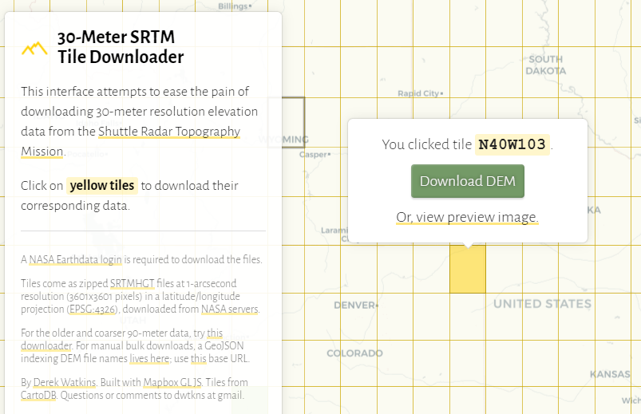
The numbering on each tile refers to the southwest corner latitude-longitude value, in this case 40°N, 103°W. Remember that longitude values west grow smaller since they are negative, therefore 109° West is further west than 103°W.

You have to right-click on the ‘Downlod DEM’ button to get a download of a zip file with the tile name, e.g., ‘N40W103.SRTMGL1.hgt.zip’. Contents:
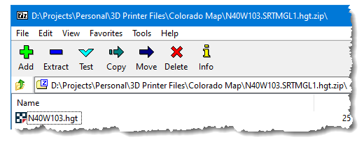
Although FME can read a hgt zip file directly and convert it to a GeoTIFF, it’s easier just to open the zip archive and drag/drop the .hgt file into a folder. The .hgt file can then be dragged and dropped into QGIS. The coordinate system DIES NOT have to be 4326—the lat-long tiles will project into whatever the QGIS map frame is.
A handy calculator for distances at specified lat-long values is at http://www.csgnetwork.com/degreelenllavcalc.html.

Using the DEMto3D plugin to create an STL file (in Raster menu)
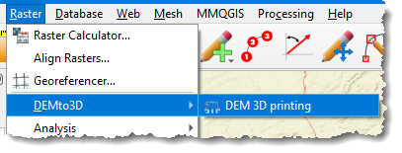
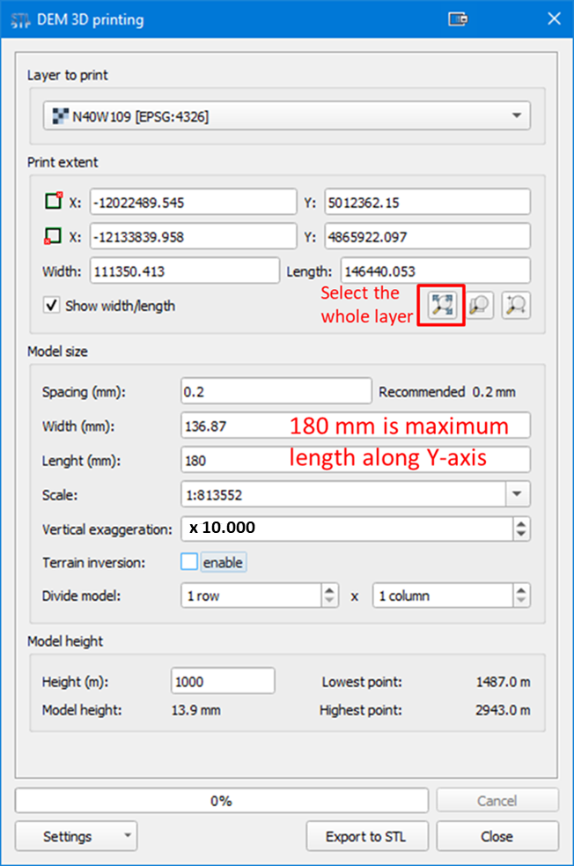
Post-processing the STL File
The STL produced by QGIS needs to be reduced in Meshmixer:
Reducing the STL File Size
- Click on “Select”, then double-click on the model to select it all (it will turn orange):
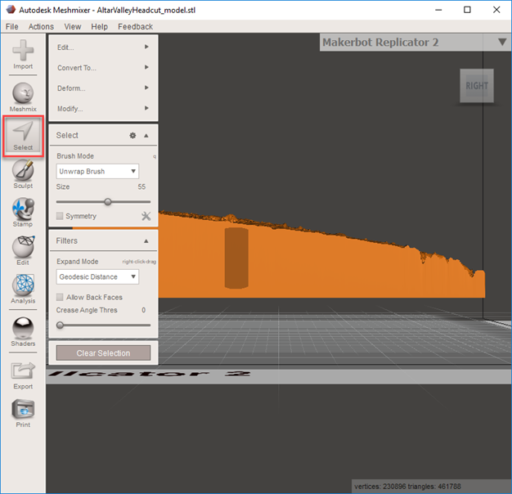
- Edit > Reduce (don’t double-click—it takes time to construct the model):
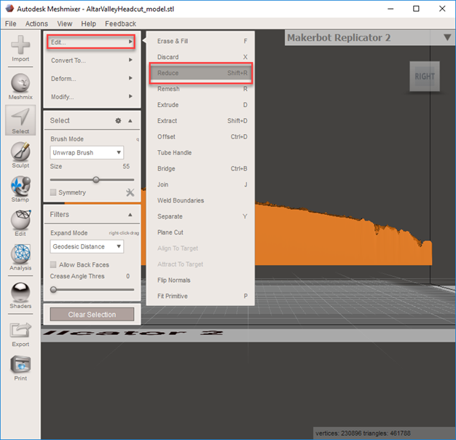
- In the Reduce dialog, set the slider to 50% for terrain models. Press ‘Accept’ when the re-slicing is finished.
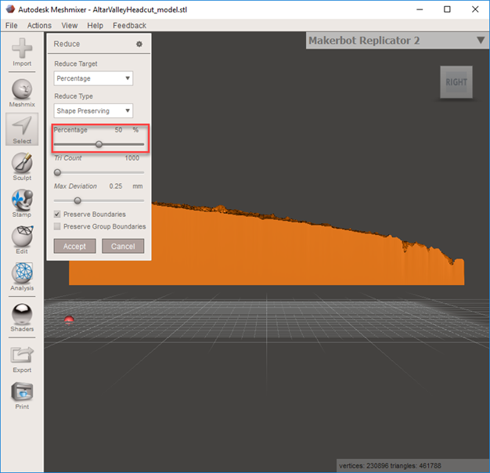
- Click on ‘Export’ to save the processed STL file (large files will take a few minutes):
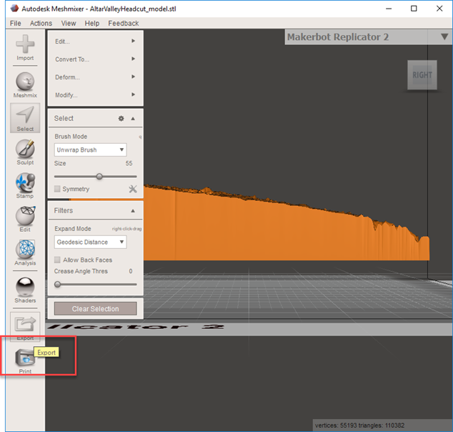

Qidi Printing
When you open a model in the Qidi print application, it appears in an offset position. To move it to the center of the bed, right-click on the model and select the ‘Center Selected Model’ option to re-position it.
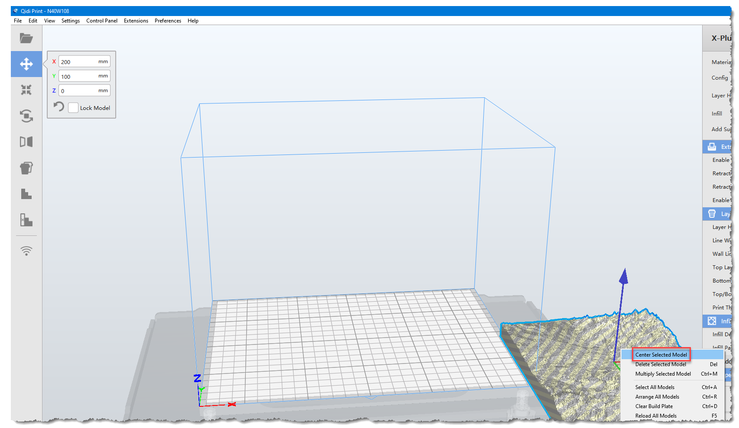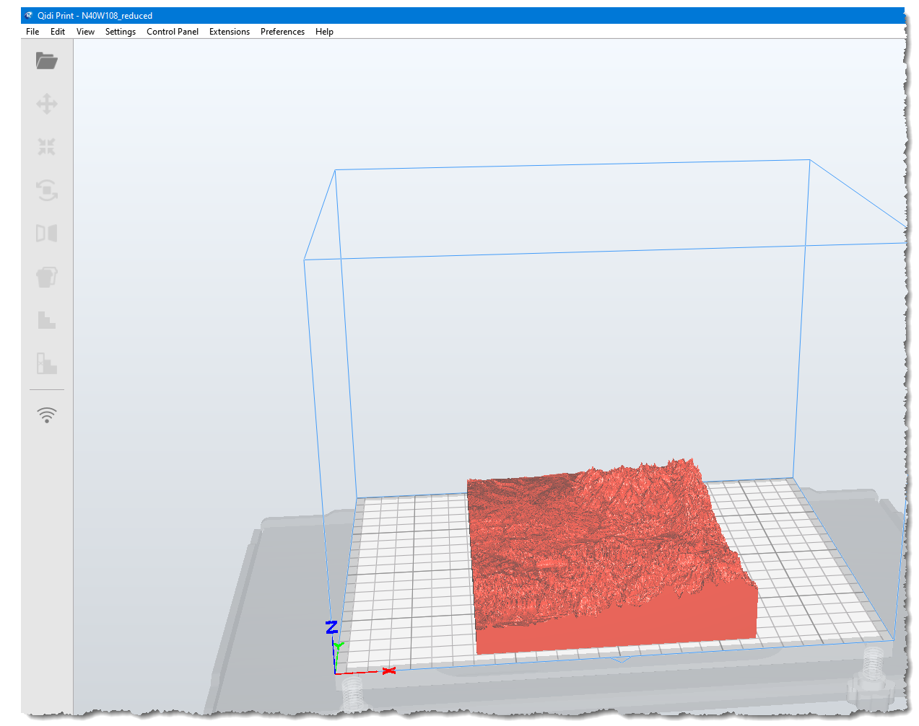

You can rotate the model to go length-wise in the X-axis
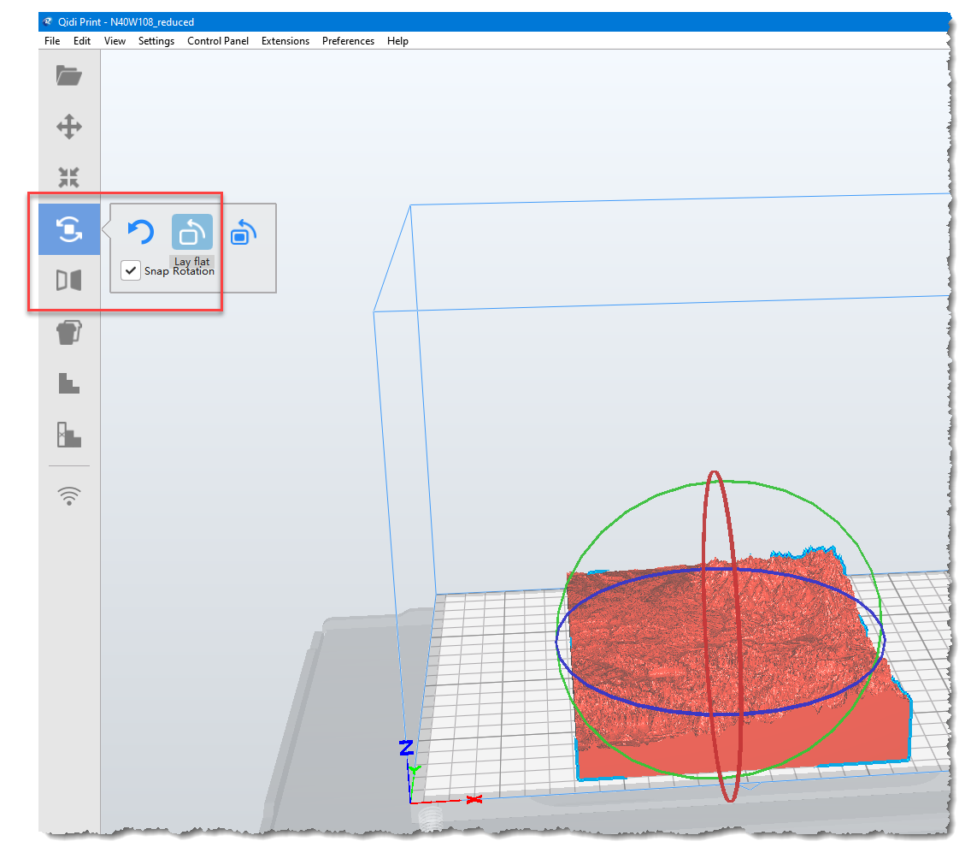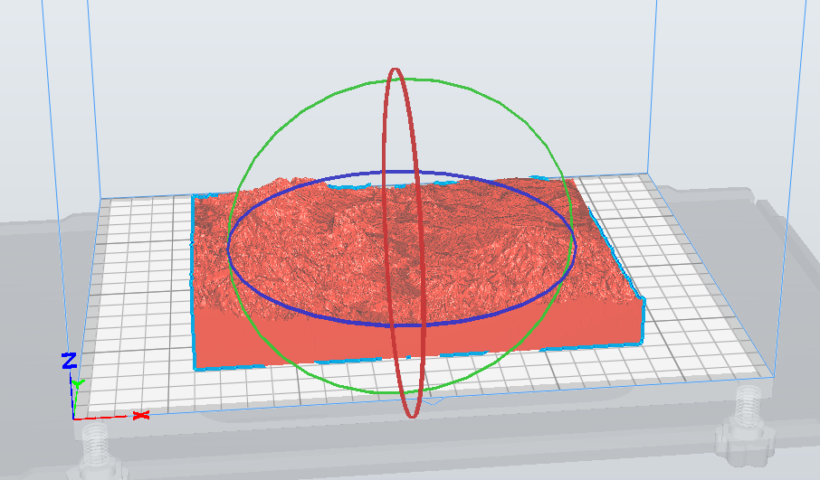

Settings:
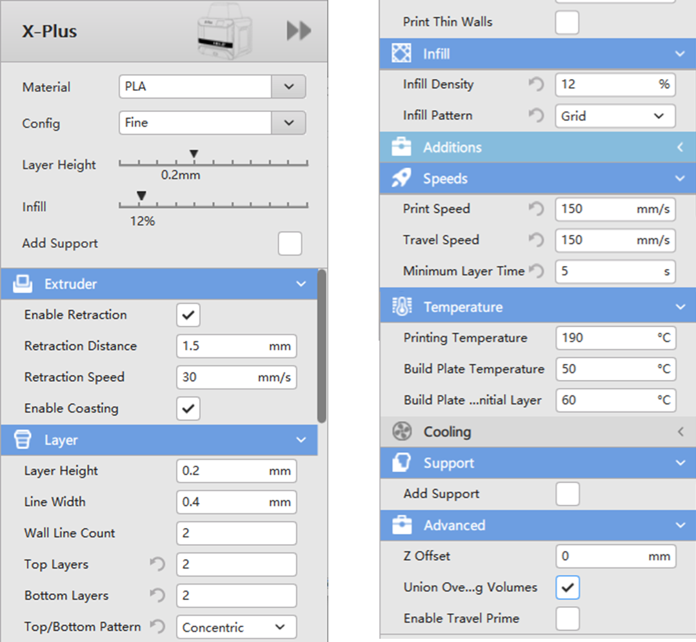

To load in a new model: Edit > Clear Build Plate.

