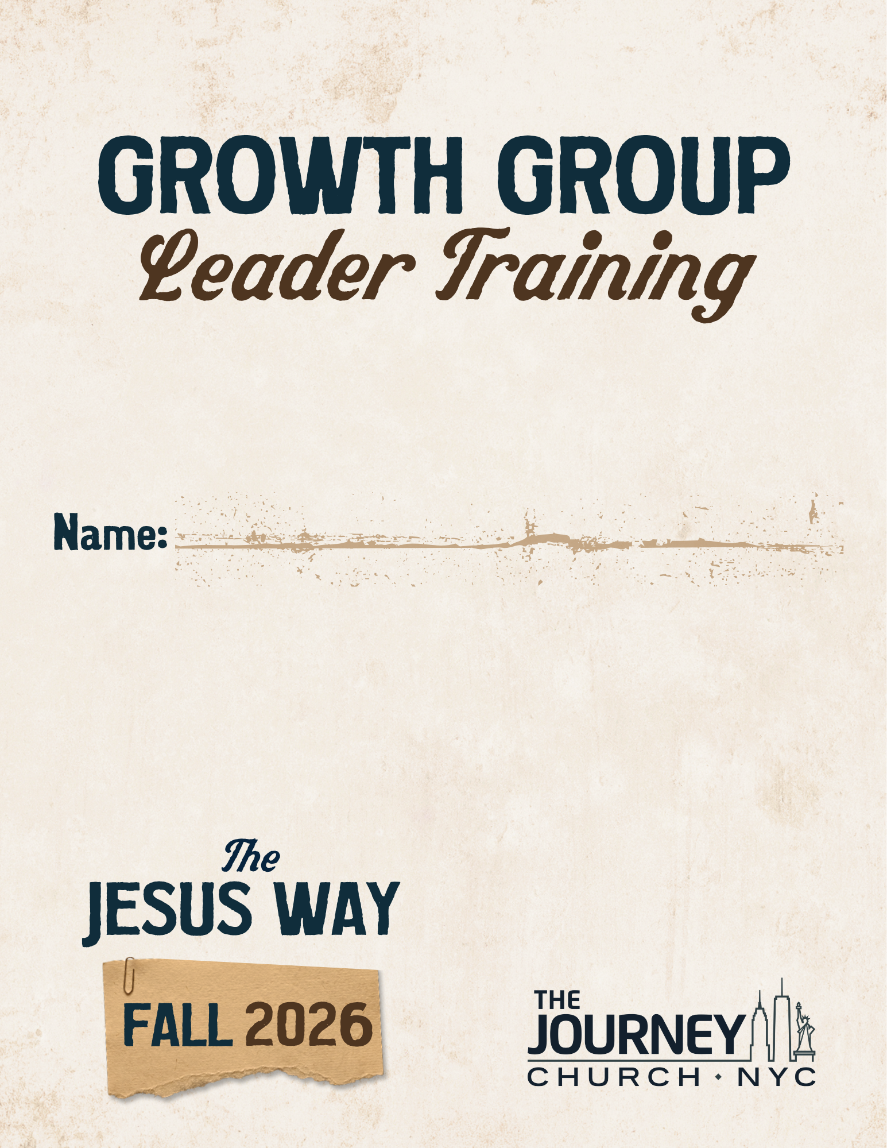

HOW TO MAXIMIZE THE SPIRITUAL GROWTH CAMPAIGN

(Jesus) “Anyone who listens to my teaching and follows it is wise,
like a person who builds a house on solid rock. Though the rain comes in torrents and the floodwaters rise and the winds beat against that house, it won’t collapse because it is built on bedrock. But anyone who hears my teaching and doesn’t obey it is foolish, like a person who builds a house on sand. When the rains and floods come and the winds beat against that house, it will collapse with a mighty crash.”
- Matthew 7:24-27

1. Understand the Power of a ____________________________________

and __________________________________________________________.

A Spiritual Growth Campaign Challenges the Entire Church to:

- Attend The Jesus Way teaching series on Sundays

- Participate in a Growth Group weekly

- Read the Sermon on the Mount

- Engage a Daily Devotion every morning

(Jesus) “Pray like this: Our Father in heaven,
may your name be kept holy. May your Kingdom come soon.
May your will be done on earth, as it is in heaven.
Give us today the food we need, and forgive us our sins,
as we have forgiven those who sin against us.
And don’t let us yield to temptation, but rescue us from the evil one.”
- Matthew 6:9-13
2. Take Responsibility to ______________________ My Growth Group.

- Invite those I know at The Journey and members of previous Growth Groups.

- Invite friends and family who do not attend church and post details about my Growth Group on social media.

- Serve at the Growth Group Table as many times as I can and come on stage with other group leaders to promote my group.

*Take time right now to confirm the services you will serve at the Growth Group Table.

(Jesus) “Do to others whatever you would like them to do to you.
This is the essence of all that is taught in the law and the prophets.”
- Matthew 7:12

3. ____________________________________________ My Growth Group.

As soon as someone signs up, email them the details for your Growth Group. (Sample email included on page 11).

Within a few days of the initial sign-up, text and/or call them to introduce yourself.

- Before your first meeting:
  - Email a one-week-out reminder
  - Call the week of your first meeting
  - Email the day before your first meeting
  - Text the day before your first meeting

- Two weekly emails:
  - Meeting reminder (1 or 2 days before meeting)
  - Prayer requests (day after meeting)

- Continue following up with those in your group – even if they don’t attend the first few meetings.

(Jesus) “And why worry about your clothing? Look at the lilies of the field and how they grow. They don’t work or make their clothing,
yet Solomon in all his glory was not dressed as beautifully as they are. And if God cares so wonderfully for wildflowers that are here today and thrown into the fire tomorrow, he will certainly care for you. Why do you have so little faith? So don’t worry about these things, saying, ‘What will we eat? What will we drink? What will we wear?’ These things dominate the thoughts of unbelievers, but your heavenly Father already knows all your needs. Seek the Kingdom of God above all else, and live righteously, and he will give you everything you need.
So don’t worry about tomorrow, for tomorrow will bring its own worries. Today’s trouble is enough for today.” – Matthew 6:28-34
4. Challenge My Growth Group to Attend ________________________.

- Be at every service on kickoff Sunday.

- Check-in at the Growth Group Table when you arrive to pick up your sign that you’ll hold while onstage and a stack of Gift Cards that you will distribute during your Meet-up at each service.

- At a designated point in each service, we’ll bring all our Growth Group Leaders onstage so we can pray for you.

- Then, every person who has signed up for a Growth Group will break away with their Group Leader for a 7-minute Growth Group Meet-Up during the service.

- You’ll gather in a designated area to lead your group Meet-Up where you will:

  - Introduce yourself and meet others in the group
  - Answer any questions people have
  - Give everyone the key information they need for your first group meeting.
  - At the end, give everyone in your group who joins you for the Meet Up a $10 Starbucks gift card.

*Take time now to confirm that you and/or your Co-Leader / Coordinator can be at every service on kickoff Sunday.

(Jesus) “Just say a simple, ‘Yes, I will,’ or ‘No, I won’t.’
Anything beyond this is from the evil one.” - Matthew 5:37

5. Utilize the __________________________ to Lead My Growth Group.

- Growth Group Members will receive an email on Mondays with their reading assignment for the week.

- Each week utilize the Discussion Guide to lead your group.

(Jesus) “Don’t store up treasures here on earth, where moths eat them and rust destroys them, and where thieves break in and steal. Store your treasures in heaven, where moths and rust cannot destroy, and thieves do not break in and steal. Wherever your treasure is, there the desires of your heart will also be.”
- Matthew 6:19-21

6. _______________________________________ from My Growth Group.

- Secure a Coordinator for your Growth Group.
- Invite others to participate in the leadership of the group. For example, Snack Coordinator, sending out Prayer Requests, Christmas Party Planner, etc.

- Identify potential Growth Group Leaders for the Spring semester and share with our staff and Team Leaders.

- Include the Pastors on the weekly group reminder and prayer request emails each week.

(Jesus) “You are the light of the world – like a city on a hilltop that cannot be hidden. No one lights a lamp and then puts it under a basket. Instead, a lamp is placed on a stand, where it gives light to everyone in the house. In the same way, let your good deeds shine out for all to see, so that everyone will praise your heavenly Father.”
- Matthew 5:14-16
7. Lead My Growth Group to Fully Participate in Our Assigned

_________________________________________________________.

- Commit to be at all my Growth Group serving and outreach dates.

- Take responsibility to lead my Growth Group to serve at all my Growth Group serving and outreach dates.

*Take time now to confirm you can be at your assigned serving and outreach dates (see pages 14 and 15).

(Jesus) “God blesses those whose hearts are pure,
for they will see God.” - Matthew 5:8

Fall 2026 Growth Group Dates
Sunday, October 4 – Kickoff of The Jesus Way

Week of Monday, October 5 – Fall 2026 Growth Groups Begin!

Sunday, October 18 – Membership Class

Saturday, October 24 – Growth Group Outreach (Assigned Groups)

Saturday, December 5 – Growth Group Outreach (Assigned Groups)

Week of Monday, December 14 – Final Week of Fall Growth Groups
Growth Group Responsibilities

What does my Growth Group Do?

- Meets together once a week.

- Serves together once a month.

- Reaches out together once a semester.

WHAT DOES A GROWTH GROUP LEADER DO?

- Pray for group members once a day.

- Lead the group once a week.

- Lead my Growth Group to serve once a month.

- Identify potential future leaders from my current Growth Group.

WHAT DOES A GROWTH GROUP COORDINATOR DO?

- Prepares to become a Growth Group Leader by serving as an apprentice who supports and assists the Group Leader.

- Sends out group reminders and prayer requests.

- Facilitates group discussion multiple times during the semester.

- Prays for the group.

Each week the coordinator sends 2 emails to the group:

- Record prayer requests and email them to everyone in the group the day after the group meets.

- Send an attendance reminder email to everyone in the group each week a day or two before the group is scheduled to meet (and before group events).

My Growth Group Checklist:

FILL-UP CHECKLIST:

__ Secure a Coordinator for your Growth Group.

__ Serve at the Growth Group Table and ask people on Sunday to join my group.

__ Invite friends, neighbors, and co-workers to join my group.

FOLLOW-UP CHECKLIST:

__ Email every person who signs up for my group immediately with all the important information: day/time/location, start date, syllabus, contact info, etc.

__ Call/text everyone who signs up for my group at least once before Oct 6.

__ Send an email reminder two days before my group begins.

__ Follow up personally with those who don’t show up for Growth Group at least 3 weeks into the group (don’t remove their name from the list until they request it).

FOCUS CHECKLIST:

__ Pray daily for those who have signed up for my group.

__ Secure a place for my group to meet.

__ Have the Syllabus and GG Covenant ready at the 1st group meeting.

FACILITATE CHECKLIST:

__ Send 2 weekly emails to my Growth Group: Group Reminder Email (one or two days before group meeting) and Prayer Requests (day after group meets).

__ Write down my group’s Sunday serving dates and communicate those dates to my group. Be faithful in leading my group to serve.

__ Continually identify potential leaders from my group and give them the opportunity to serve/lead within my group.

Sample Follow-up Email

Subject: Welcome to our Fall Growth Group…Details + Free Starbucks Gift Card on Oct 4!
To: Everyone who signs up for your group

Hi <<First Name>>,

My name is <<Leader Name>> and I’m so excited that you’re going to be part of our Fall Growth Group! I wanted to shoot you a quick email to introduce myself and give you some details about our group.

As part of The Jesus Way series, our group will be reading the Sermon on the Mount and discovering what Jesus’ most famous teaching means for our everyday lives.

Our group will meet weekly on {Insert your day}, starting {Insert date of your first meeting – week of October 5} and ending the week of December 14. So, be sure to reserve the date of our first group on your calendar!

Here are the details…

Day: {Insert your day}
Time: {Insert your time}
Location: {Insert location, or if online include your Zoom link}

PLUS…make sure you’re at The Journey on Sunday, October 4 for the kickoff of The Jesus Way! During the service, we’ll have a special Growth Group Meet-Up where our group connects for a few minutes to get to know each other and go over the details for our first group meeting.

And there’s a bonus: everyone who attends the kickoff and participates in the Growth Group Meet-Up will receive a $10 Starbucks Gift Card!

I’m really looking forward to our Growth Group and I hope you are as well! Reply to this email and let me know if you’ll be at our first meeting.

See you on Sunday and I am praying for you!

<<Leader Name>>

PS - If you know of others who would be interested in joining our group – feel free to invite them. Here is the link where they can find out more and sign up: www.JourneyNYC.com/Groups.
THE JESUS WAY: THE PATH TO A BLESSED LIFE
Fall 2026 Growth Group Syllabus

Welcome to your Fall 2026 Growth Group. Your group will meet weekly beginning the week of October 5 and will conclude the week of December 14.

Each week we will read and discuss specific passages from Jesus’ Sermon on the Mount (Matthew 5-7) – and learn from God’s Word how to live THE JESUS WAY – the path that leads to a blessed life. Come to the group each week prepared to participate in the discussion. Below is a week-by-week syllabus for your group.

Week #1: Week of Oct 5 – Introduction: Welcome, Intros, Overview, Covenants

Week #2: Week of Oct 12 – Read & Discuss Matthew 5:1-16

Week #3: Week of Oct 19 – Read & Discuss Matthew 5:17-32

Week #4: Week of Oct 26 – Read & Discuss Matthew 5:33-48

Week #5: Week of Nov 2 – Read & Discuss Matthew 6:1-15

Week #6: Week of Nov 9 – Read & Discuss Matthew 6:16-24

Week #7: Week of Nov 16 – Read & Discuss Matthew 6:25-34

Week #8: Week of Nov 23 – NO GROUP THIS WEEK – HAPPY THANKSGIVING!

Week #9: Week of Nov 30 – Read & Discuss Matthew 7:1-11

Week #10: Week of Dec 7 – Read & Discuss Matthew 7:12-23

Week #11: Week of Dec 14 – Read & Discuss Matthew 7:24-29 & Christmas Party!

SUNDAY SERVING DATES:

________________ ________________ ________________ ________________

GROWTH GROUP OUTREACH DATE: ________________________________________
The Journey Fall 2026 Growth Group Covenant

Welcome to your Fall “The Jesus Way” Growth Group at The Journey. Congratulations on your desire to grow deeper in your relationship with God through this weekly study and the relationships you will form in this group.

As a member of this group, you will be asked to enter into a covenant with the other members to make this Growth Group a priority. To be a part of the group, you are asked to make the following commitments:

- I will make this group a priority by attending each week, keeping up with my assignments, and participating in group discussions.

- I will regularly attend The Journey services and contribute to the ministry of the church through my attendance, giving, service, and inviting of others.

- I will strive to build authentic relationships with those in this group by showing care, providing encouragement, and praying for their needs.

- I will intentionally share my faith with those around me by reaching out to lost and unchurched friends by praying, giving a verbal witness, and inviting them to The Journey.

- I will serve at church together with my group once a month.

- I will honestly explore my next steps for spiritual growth.

________________________________ _______________
Sign Your Name Date

________________________________
Print Your Name

Growth Group Members can also complete the Covenant here:
JourneyNYC.com/Covenant
Fall 2026 GG Welcome Team Serving Schedule
GROWTH GROUP | DATE 1 | DATE 2 | DATE 3 | DATE 4 | SERVICE
Rhotocia - Wednesdays 7PM | Oct. 18 | Nov. 1 | Dec. 13 | Jan. 3 | 10:00 AM
Joanne - Tuesdays 6PM | Oct. 25 | Nov. 15 | Dec. 6 | Jan. 17 | 10:00 AM
Richy & Josh - Thursdays 6PM | Oct. 11 | Nov. 8 | Dec. 20 | Jan. 10 | 10:00 AM
David & Ish - Tuesdays 6:30PM | Oct. 25 | Nov. 29 | Dec. 6 | Jan. 24 | 10:00 AM
Cristian - Fridays 7PM | Oct. 18 | Nov. 15 | Dec. 13 | Jan. 31 | 10:00 AM
Laura, Destiny, & Andrea - Tuesdays 7PM | Oct. 11 | Nov. 22 | Dec. 20 | Jan. 17 | 10:00 AM
Jael & Jeremy - Thursdays 8PM | Oct. 25 | Nov. 1 | Dec. 13 | Jan. 10 | 10:00 AM
Connie - Mondays 6PM | Oct. 18 | Nov. 29 | Dec. 6 | Jan. 24 | 10:00 AM
Ude - Mondays 6PM | Oct. 11 | Nov. 15 | Dec. 20 | Jan. 3 | 10:00 AM
Brigitte - Fridays 6PM | Oct. 25 | Nov. 8 | Dec. 6 | Jan. 17 | 10:00 AM
Annabell - Wednesdays 7PM | Oct. 18 | Nov. 1 | Dec. 20 | Jan. 10 | 10:00 AM
Haley & John - Thursdays 7PM | Oct. 11 | Nov. 22 | Dec. 13 | Jan. 24 | 10:00 AM
Ross & Sandy - Thursdays 6:30PM | Oct. 25 | Nov. 15 | Dec. 6 | Jan. 31 | 10:00 AM
Rachel & Peter - Tuesdays 6PM | Oct. 18 | Nov. 29 | Dec. 20 | Jan. 3 | 10:00 AM
Nate & Paul - Wednesdays 7PM | Oct. 11 | Nov. 8 | Dec. 13 | Jan. 10 | 11:30 AM
Jeremy & Hillary - Tuesdays 7PM | Oct. 18 | Nov. 1 | Dec. 20 | Jan. 31 | 11:30 AM
Amanda & Jennifer - Thursdays 12PM | Oct. 25 | Nov. 15 | Dec. 6 | Jan. 17 | 11:30 AM
Helen B. & Rae - Thursdays 6:30PM | Oct. 11 | Nov. 22 | Dec. 13 | Jan. 24 | 11:30 AM
Elliyah - Wednesdays 6:30PM | Oct. 25 | Nov. 29 | Dec. 20 | Jan. 3 | 11:30 AM
Katrina & Henriette - Saturdays 12PM | Oct. 18 | Nov. 8 | Dec. 6 | Jan. 31 | 11:30 AM
Pastor Michael, Julia, Connie - Wed 5:30PM | Oct. 25 | Nov. 1 | Dec. 13 | Jan. 24 | 11:30 AM
Eric & Tom - Wednesdays 7PM | Oct. 18 | Nov. 29 | Dec. 6 | Jan. 17 | 11:30 AM
Prisca - Mondays 7:30PM | Oct. 11 | Nov. 22 | Dec. 20 | Jan. 3 | 11:30 AM
Abi & Rashida - Fridays 6PM | Oct. 25 | Nov. 8 | Dec. 13 | Jan. 10 | 11:30 AM
Helen S. & Vivienne - Thursdays 7PM | Oct. 18 | Nov. 15 | Dec. 6 | Jan. 31 | 11:30 AM
Silvestre & Henry - Tuesdays 7PM | Oct. 25 | Nov. 29 | Dec. 20 | Jan. 17 | 11:30 AM
Algeny, Keith, & Silvestre - Fridays 12PM | Oct. 11 | Nov. 1 | Dec. 6 | Jan. 24 | 1:00 PM
Amber S. - Saturdays 11AM | Oct. 18 | Nov. 8 | Dec. 13 | Jan. 3 | 1:00 PM
Pastor Michael & Nathan - Wed. 7PM | Oct. 25 | Nov. 15 | Dec. 20 | Jan. 10 | 1:00 PM
Michele - Wednesdays 7PM | Oct. 11 | Nov. 22 | Dec. 6 | Jan. 17 | 1:00 PM
Pastor Kerrick & Rebekah - Tuesdays 7PM | Oct. 18 | Nov. 29 | Dec. 13 | Jan. 31 | 1:00 PM
Wayne & Hector - Tuesdays 8PM | Oct. 25 | Nov. 8 | Dec. 20 | Jan. 3 | 1:00 PM
Amber G. - Mondays 5:15PM | Oct. 11 | Nov. 15 | Dec. 6 | Jan. 24 | 1:00 PM
Ryan & Dennis - Mondays 7PM | Oct. 18 | Nov. 1 | Dec. 13 | Jan. 17 | 1:00 PM
Lorie - Wednesdays 12PM | Oct. 25 | Nov. 22 | Dec. 20 | Jan. 10 | 1:00 PM
Matt & Ariana - Mondays 6:30PM | Oct. 11 | Nov. 29 | Dec. 6 | Jan. 31 | 1:00 PM
Sharon & Robin - Thursdays 7PM | Oct. 18 | Nov. 8 | Dec. 13 | Jan. 3 | 1:00 PM
Tony - Thursdays 6PM | Oct. 25 | Nov. 15 | Dec. 20 | Jan. 24 | 1:00 PM
Pastor Kerrick & Jazen - Fridays 7:30AM | Oct. 11 | Nov. 22 | Dec. 6 | Jan. 17 | 1:00 PM
The Journey’s Fall Outreach

Saturday, October 24 from Noon-1:00pm in Union Square

- Tony Wilson
- Richy / Josh
- Sharon / Robin
- Helen / Rae
- Hayley / John
- Ross / Sandy
- Amanda / Jennifer
- Jael / Jeremy
- Helen / Vivienne

- Cristian V.
- Algeny / Keith / Silvestre
- Silvestre / Henry
- Michael / Nathan
- Michael / Connie / Julia
- Connie
- Amber Gonsalves
- Abi / Rashida
- Amber Stevens
- Rhotochia A.

Saturday, December 5 from Noon-1:00pm in Union Square

- Prisca Oye
- Brigitte Mercado
- Matt / Ariana
- Ryan / Dennis
- Ude Chikez
- Joanne Webb
- Laura / Andrea / Destiny
- Jeremy / Hillary
- Katrina / Henriette
- Wayne / Hector
- Peter / Rachel
- Kerrick / Rebekah
- Kerrick / Jazen
- David / Ismael
- Annabell Lee
- Michele Ricart
- Tom /Eric
- Lorie Thomas
- Elliyah Lee
- Nate / Paul
Growth Group Leader/Coordinator Covenant
Fall 2026

Thank you for serving as a Growth Group Leader/Coordinator at The Journey. As a Growth Group Leader/Coordinator you will be viewed by those in your group as a leader in the church. As a result, we ask that you enter into covenant with the other Growth Group Leaders/Coordinators by making the following commitments:

- I will embody and reflect the values and principles of The Journey and will follow the leadership of the staff team.

2. I will faithfully attend The Journey on Sundays and:
- Participate in the church by becoming a member and giving in a measurable way.
- Leading my group in serving together once a month.

3. I will make my Growth Group a priority by:
- Faithfully attending my Growth Group.
- Preparing beforehand for my group each week.
- Inviting/welcoming others to join my group.
- Identifying new leaders in my Growth Group.

4. I understand I am responsible for the care of my Growth Group. As a result, I will:
- Pray for the individuals in my group.
- Follow up with each person in my group.
- Lead my group in providing care for one another.

5. I will strive to create an environment of growth in my group by:
- Involving as many people as possible in group discussion.
- Creating a safe, comfortable, and welcoming environment.
- Beginning and ending on time.

6. I will intentionally share my faith with those around me by:
- Reaching out to lost and unchurched friends and inviting them to The Journey.
- Encouraging my Growth Group members to reach out to lost and unchurched friends and inviting them to The Journey.

________________________________________________ __________________________
Sign Your Name Date

_____________________________________
Print Your Name

