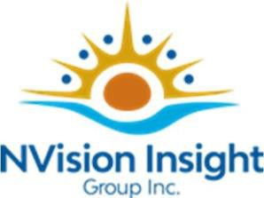

Robin Jones, Indigenous Relations Consultant

Robin Jones is Otter Clan, Anishinaabe (Ojibway and Potawatomi) from the Chippewas of Nawash Unceded First Nation, where she grew up and continues to live as an active community member.

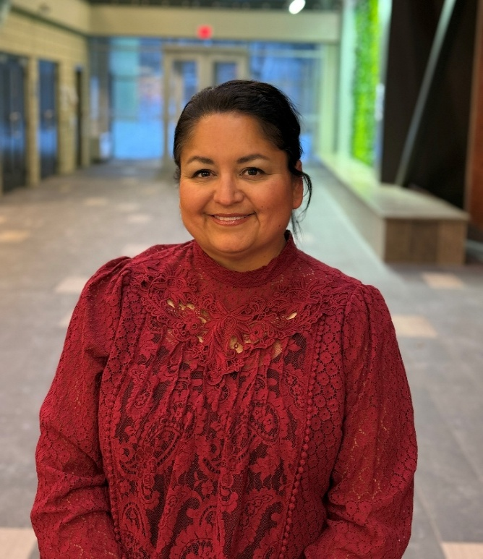
She brings diverse experience in Indigenous relations, engagement, facilitation, strategic planning, governance, Indigenous HR strategies, and organizational development.

Robin has worked with Indigenous communities, organizations, governments, and institutions across Canada to support reconciliation, relationship-building, and meaningful organizational change. She also volunteers in a variety of Indigenous-focused board, advisory, and community leadership roles, where she provides guidance on governance, community engagement, strategic priorities, and Indigenous perspectives.

Her approach is grounded in relationship-centred philosophy that bring together Indigenous and Western ways of knowing to support meaningful and lasting outcomes.

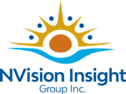
rjones@Nvisiongroup.ca

