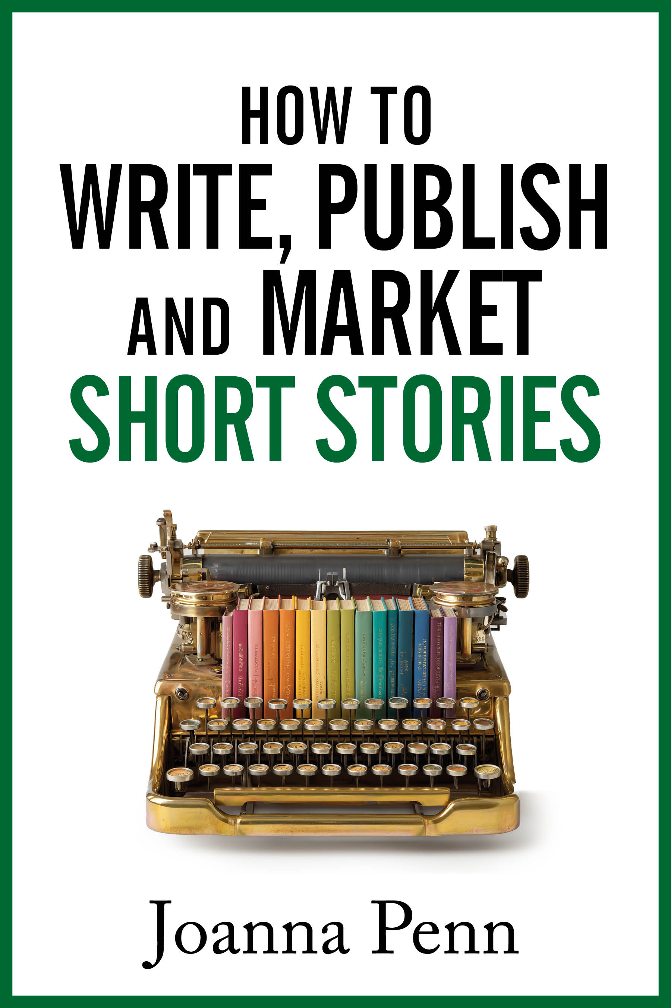
How to Write, Publish, and Market Short Stories — Joanna Penn
Appendix 2: Questions
1.1 Why readers love short stories
· What do you love as a reader of short stories?
· Consider a short story that still remains with you. What elements particularly resonated with you and why?
1.2 Why writers love short stories
· Why do you write short stories, or want to write them?
· Are there ideas, genres, or topics you’ve always wanted to explore without committing to a full-length novel?
· How might short stories fit into your author business?
1.3 What is a short story?
· Are you aiming for a certain length of story or are you just writing it and seeing how it turns out?
· Do your ideas feel small enough to be contained in a short story or expansive enough that you need many more words to explore them?
· Does your potential story idea include a concrete change between the beginning and the end?
1.4 From story seeds to stories
· Where do you find your story seeds? How can you make time to tune into your curiosity and discover more of them?
· How are you saving your story seeds?
· Can you open up time to revisit your seeds and see what might take root as a story?
1.5 Tips for writing a short story
· Are you getting your words done? How can you improve your process if you’re not happy with it?
· Take a story you’ve drafted: how much can you cut from the beginning and still have it make sense?
· Is your ending working? How can you improve it?
· How can you experiment more with your shorts to deepen your writing craft?
· How can you improve your editing process?
1.6 The author’s note
· As a reader, do you love author’s notes? What do you like them to include?
· For whatever story you’re working on, what are the elements you could include in an author’s note?
· If readers want to do further reading on the topics of your short story, do you have sources from your own research you could share?
· How could you connect with readers on a personal level through your author’s note?
2.2 Self-publishing short stories
· Is self-publishing the right choice for your story?
· Ebook, audio, and/or print: what formats do you want to explore?
· Have you labelled your story clearly as a short, so the reader knows what they are getting?
· How will you price your story, and how could you use bundling or a collection later?
· Which story could you give away free to introduce readers to your work or grow your newsletter mailing list?
· Could a subscription model work well for you if you have a big enough platform or backlist?
2.3 Audio short stories and podcasting
· Would your short stories work well in audio?
· How will you handle the narration?
· How and where will you distribute the audio?
· Is there a fiction podcast that’s a good fit for your story?
· Have you licensed the audio rights already or are they yours to use as you like?
2.4 Traditional markets
· What do you want to achieve with your short story?
· What kinds of magazines or anthologies do you already read or listen to? Which might be a good fit for your own stories?
· Which opportunities will be most worthwhile for your own work or career?
· How could you network within your genre and build up authentic relationships over time?
2.5 Rights and contracts
· What are the different ways that you can license a short story?
· What suits you in terms of how you want to publish?
· Have you thoroughly read and considered the rights involved in any contract you have been offered?
2.6 Anthologies
· How can you find anthologies you might like to write for?
· What kind of themes excite you?
· If you are considering an anthology opportunity, are the terms fair, and do the rights revert to you within a reasonable period?
· Which readers will this anthology put you in front of, and are they a good fit for you?
· Do you already have a story that fits, or would you be writing to the theme from scratch?
· Do you have the time and energy to write a new story, or is this an opportunity you need to let pass by?
· Does your author bio point new readers towards your wider work?
2.7 Collections
· Why do you want to produce a collection?
· What’s the thread or the theme that links your stories? Could you leave some stories out and/or write some new ones to enhance the theme?
· Which stories will headline or anchor the collection, and which ones are deep cuts?
· How will you edit the collection?
· If this collection is for your super fans, what would make the physical book something they might treasure?
3.1 Short stories as part of your author marketing ecosystem
· How can you position your short stories as part of your wider author marketing ecosystem?
· Which of your existing characters or story worlds could spin off a short story?
· Where could your next story create a new doorway — a playlist, an anthology, a podcast?
3.2 Reader magnets and your email list
· Which of your stories might make the best entry point to your paid work? Or what could you write specifically for this reason?
· If you already have a lead magnet, does it match the genre and voice of the books you want readers to buy next?
· Does every story you publish end with a clear call to action?
· Are you building your email list in a sustainable way for the long term?
3.3 Ideas for marketing short stories
· How could you focus on the experience of your short story rather than its length in your marketing materials?
· How could you use free pricing as a marketing tool?
· Could any of your shorts work in audio, and would a Spotify or YouTube playlist help readers find them?
· Which marketing assets that you would make for a novel could you make for your short?
· How could you turn your marketing into an event, like a Kickstarter campaign, that enables a broader spectrum of marketing options?
4.1 How to use AI tools to help with your creative and business processes
· Where’s your line in the sand around AI usage? What tasks can you happily hand over to an AI tool and which will you retain?
· How can you use AI tools more effectively in the areas you want to outsource?
· If you’re submitting to any professional paying market or contest, have you checked its guidelines on AI?
· Whether you use AI tools or not, how can you double down on being human?

